Year 4 – Autumn – What is more precious, water or gold?  - use research and develop design criteria to inform the design of innovative, functional, appealing products that are fit for purpose, aimed at particular individuals or groups  - generate, develop, model and communicate their ideas through discussion, annotated sketches, cross-sectional and exploded diagrams, prototypes, pattern pieces and computer-aided design  - select from and use a wider range of tools and equipment to perform practical tasks [for example, cutting, shaping, joining and finishing], accurately  - select from and use a wider range of materials and components, including construction materials, textiles and ingredients, according to their functional properties and aesthetic qualities  - investigate and analyse a range of existing products  - evaluate their ideas and products against their own design criteria and consider the views of others to improve their work  - understand how key events and individuals in design and technology have helped shape the world  - apply their understanding of how to strengthen, stiffen and reinforce more complex structures  Big Ideas: R1, R6, DC2, DC4, E1, E3 |  |  | End Product:  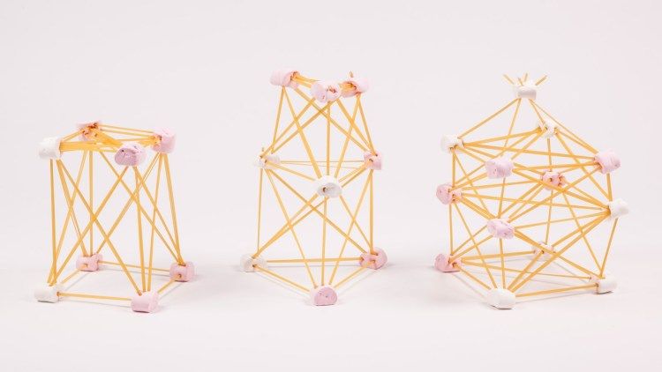  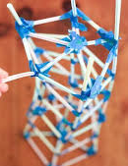  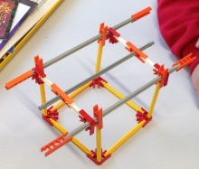  Children have researched Egyptian pyramid structure and why they are so stiff, strong and stable. They have researched to find out which materials they can use to make a structure. Children have designed their structures using what they have found out and created them with resources of their choice. E.g.:  Straws and blue tac  Spaghetti and marshmallows  K’nex
Objective and Success Criteria | Coverage | Key Questions | Children should be able to | Resources
To find out how structures have been made stiff and strong throughout history.  (context – focus on Egyptians, but explore other time-frames and materials. E.g. bridges.) | - Find out about Egyptian pyramids. Focusing specifically on structure, stability and stiffness.  - You could look into structures from other time periods also.  - Find out about the internal structure of Egyptian pyramids.  - Investigate the materials used to make stiff structures such as the Egyptian pyramids or long-standing bridges. | - What have you found out about the Egyptian pyramids?  - What makes this structure stable, stiff and strong?  - Which materials are used on this structure?  - Are they important for making it stiff and strong? | - Research and find out about stable, stiff and strong structures in history.  - Find out which materials were used on these structures and how they helped to reinforce them. | - Laptops for research, used to inform design.  - A range of materials – chosen by children and based on research/investigation process. E.g. K'Nex, straws and tape, spaghetti and marshmallows, etc.  - A range of joining materials such as tapes and glues - chosen by children and based on research process.  - Weights for testing stability and stiffness of structure.
To find and choose materials that are fit for a particular purpose.  (context – which materials are fit for making a stiff and stable structure). | - Investigate which materials can be used to make a stiff and stable structure.  (context – children could attempt to find out online or you could give them a range of materials to investigate).  - Children categorise materials into those that are stiff and strong and those that aren’t.  - Discuss ways to make the non-stiff materials stiffer and stronger.  - In teams children decide which materials to use. Encourage them to choose the materials that will need some reinforcing.  - Children should justify their choices to their team and to the class teacher. | - What did your research/investigation tell you about the materials that you could use?  - Is this a stiff and strong material? How do you know?  - Is there a way that we can we make this material stiff and strong?  - Why do you think that would be a good material to use?  - What are the final materials that you and your team have chosen? Why? | - Choose materials based on research and investigation.  - Categorise materials when given specific criteria.  - Choose materials that are fit for purpose.  - Identify ways to reinforce a material to make it stiffer and stronger.  - Justify their material choices.
To work as a team to decide on which criteria are essential for a stiff and stable structure, using our research findings.  (context – e.g. Egyptians used triangular shape, layers etc). | - After finishing the research process, collect together all of the children’s findings.  - Children work in teams to choose specific criteria for their structures. E.g. using triangles, height specifications etc.  - Focus on lots of discussion around the criteria choices.  - Children could pitch and justify their criteria to the rest of their teams before the whole team decides. | - What are criteria?  - Why are criteria important?  - What do you think the important criteria are for this design?  - Which criteria do you and your team choose? Why? | - Use their research to choose specific criteria for their structures.  - Justify their criteria choices.
To create a labelled design of a stiff and stable structure using our research findings.  (context – label with chosen materials as well as measurements where possible).  (context – first complete with sketches and then design in TinkerCAD). | - Using pencil and paper, children sketch their designs (A4 or A3 depending on size of structure).  - Children must include specific measurements as we will make these to scale so must use a ruler.  - Children label their design sketches with their measurements and materials.  - Children check that their design includes the design criteria specified as a team.  - They could then pitch their design ideas to the rest of the team, before the team create one final design sketch, taking the best parts from everyone’s designs.  - Children should practice building their structures from their designs using TinkerCAD. | - Have you included your criteria? Show me where.  - How tall/long is your structure going to be?  - Have you included the measurements on your design?  - Have you included the materials on your design?  - Why is it important to include materials and measurements on our designs?  - Can you show me your design on TinkerCAD?  - Do you still think it will work after designing it on TinkerCAD? | - Use their agreed criteria in their designs.  - Label designs with key information.  - Explain why it is important to label designs.  - Draft a final design from parts of many designs.  - Draft their designs both on paper and computer.  - Evaluate their designs before moving on to making.
To make a stiff and stable structure using materials of our choice, including joining materials.  To evaluate our products and discuss ways to reinforce them to make them even stiffer and more stable.  (context – discuss reinforcing materials and give children time to improve their structures). | - Children are given their chosen materials, including joining materials and use these to create their sketches.  - Children check regularly that their creation matches their design and evaluate its stiffness and strength.  - Children have time to evaluate and improve their structures.  - You could have a competition at the end to see which structure can bear the most weight or is the stiffest. | - Are your materials functioning the way that you hoped they would? How do you know?  - Would you use these materials again for the same purpose? Why/why not?  - Did your structure do what you expected when we added the weight?  - How could you reinforce your structure to make it more stable? | - Create a stiff, stable and strong structure.  - Explain why their structure is stiff, stable and strong.  - Evaluate their use of materials.  - Evaluate how well their structure fulfilled its primary function.  - After making their design, evaluate and improve it by reinforcing it.
Assessment Questions
How can you make a stiff and strong structure?
Was your structure fit for purpose? How do you know?
Were your materials fit for purpose? How do you know?
Can you explain how I might reinforce a non-stiff material?

Year 4 – Spring – What did the Romans ever do for me?  - use research and develop design criteria to inform the design of innovative, functional, appealing products that are fit for purpose, aimed at particular individuals or groups  - generate, develop, model and communicate their ideas through discussion, annotated sketches, cross-sectional and exploded diagrams, prototypes, pattern pieces and computer-aided design  - select from and use a wider range of tools and equipment to perform practical tasks [for example, cutting, shaping, joining and finishing], accurately  - select from and use a wider range of materials and components, including construction materials, textiles and ingredients, according to their functional properties and aesthetic qualities  - investigate and analyse a range of existing products  - evaluate their ideas and products against their own design criteria and consider the views of others to improve their work  - understand how key events and individuals in design and technology have helped shape the world  Big Ideas: R1, R2, R3, DC2, DC4, E2 |  |  | End Product:  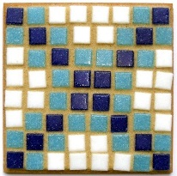  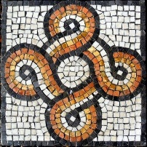  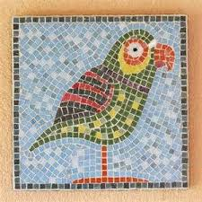  Children have researched Roman mosaic design and materials before designing and creating their own.
Objective and Success Criteria | Coverage | Key Questions | Children should be able to | Resources
To find out about historic designs and the materials that were commonly used.  (context – Roman mosaics.) | - Find out about Roman mosaics.  - Create a mood board of mosaics.  - The children could be given different criteria for their mood boards. E.g. animal mosaics, symmetrical mosaics, colourful mosaics etc.  - Look at all of the different mood boards and discuss the children’s favourite ones.  - Children find out what Roman mosaics were commonly made from.  - Discuss what we could make them from today and which materials the children think would be appropriate. | - What have you found out about Roman mosaics?  - Why have you included these on your mood board?  - Which materials were used to make Roman mosaics?  - Which materials would you use to make a mosaic? Why? | - Use a range of sources to find out about Roman mosaics.  - Search for products based on criteria.  - Research the materials used during a particular historical period. | - Laptops for research for design ideas.  - Grid paper  - Coloured pencils  - Coloured paper – of child’s choice.  - Glue sticks  - Mosaic bases such as: MDF moasic bases  - Mosaic tiles. A cheap option is here: mosaic tiles  - A tile adhesive, such as grout. E.g: Grout  (Context- Only mix enough grout to be used in a 20-30minute time frame. Otherwise it may solidify in the container.)
To choose and justify criteria for our designs.  (context – e.g. symmetrical.) | - Look back at mood boards. Choose favourite designs.  - Discuss the children’s favourite designs and why they have chosen them.  - Each child chooses specific criteria for their own designs. E.g. curves, symmetry, shapes etc.  - Children explain why they have chosen that criteria. | - Which design is your favourite? Why?  - Which criteria are you going to choose for your design? Why? | - Make choices for their own designs and products, based on research.  - Justify their choices of:  - Favourite designs  - Criteria
To design a pattern piece using colour pencils and CAD.  (context – Design a Roman inspired mosasic design using grid paper and colour pencils and the computer.) | - With their mood boards printed out in front of them, children use colour pencils and grid paper to design their own Roman inspired mosaics.  - Designs should include their chosen criteria.  - Children should sketch their mosaic in pencil before applying coloured pencils. This may need to be demonstrated.  - Once designs are completed, they could be made on the computer, either using TinkerCAD or Purple Mash. See seatwell example on TinkerCAD public space. | - Can you explain where I can see your criteria in your design?  - Why have you chosen those colours?  - Have you tried to make a particular shape/picture? Why?  - How can you show your design electronically on the computer? | - Create a design using pencil, paper and coloured pencils.  - Choose colours appropriate to the time period.  - Make their designs electronically.
To make our design into a prototype of the finished product.  (context – Use our designs to create a prototype using coloured paper and glue.) | - Once children have completed their designs electronically, discuss the term ‘prototype’ and gather their ideas for ways to make a prototype of their design.  (Context- lead the children to the idea of using coloured paper, glue and grid paper to make their prototype.)  - Children select their coloured sheets of paper to match their designs and cut them into small squares after measuring the size of the squares on the grid paper.  (Context- maths link – measures and ruler skills.)  - Children stick their coloured paper on their grid paper to match their designs. They should stop regularly to evaluate the likeness between the design and the prototype.  - Discuss how their prototypes meet the specified criteria. | - What is a ‘prototype’?  - How could we make an accurate prototype of your mosaic?  - What size are the grid squares on your paper? How can you check? Can you prove it?  - Where will you start sticking first? Why?  (Context- children should be taught to stick their squares systematically to ensure accuracey.)  - Does your prototype match your design?  - Does your prototype have your criteria? Show me where. | - Explore ideas for ways to make a prototype.  - Measure accurately to ensure that their prototype has a high finish.  - Evaluate the likeness of the prototype to their designs and make changes where needed.  - Discuss their finished prototypes with support.
To change our designs were necessary after attempting a prototype.  (context – the prototype may show where design flaws are. E.g. not symmetrical or too complex) | - Once prototypes are complete, discuss any challenges the children faced. E.g. too complex.  - Give children time to adjust their designs. You could do this by tinkering with their TinkerCAD designs or simply by sketching another design (time dependent). | - What did you find challenging about making your prototype (if anything)?  - Do you need to make any changes to your designs? Why?  - What changes will you make? | - Identify where they may need additional support.  - Identify where they may need to change a design.  - Make adjustments to their designs before moving on to the making process.
To make our product, using our prototype for guidance.  (context – Make their Roman inspired mosaics. They must look like the prototype) | - Discuss the resources that children feel would be appropriate for actually making our mosaics.  - Where possible use their ideas.  (context – Only use the children’s ideas if they build upon the materials used in previous units and year groups. Materials should not be repeated.)  - Ideally children would choose to use tiles and grout to make their mosaics.  (context – See links to products and important notes in the resources section)  - Remind children about their criteria and that it should look like the prototype.  - Discuss the materials (bases, tiles and grout) and their functions.  - Demonstrate how to begin making their mosaics. They must sketch on their MDF boards first before sticking tiles. | - Which materials do you think we could use to make our mosaics?  - Why would they be appropriate materials?  - Which adhesive products could we use?  - What will be your first step in making your mosaic?  - Why are grout and tiles appropriate for our mosaics?  - Why is it important to sketch our designs first? | - Make their final product, using their prototype as a guide.  - Use appropriate resources and know why they are fit for purpose.  - Use materials that they have not yet experienced using.  - Make an appealing design that would fit a particular historical period.
To evaluate our products against our designs and prototypes and discuss how we would improve them next time. | - Children look at and evaluate each other’s prototypes and final designs.  - Children get feedback on their designs, thinking about the key questions.  - Discuss how they could improve their designs if they were to do them again. This could mean better meeting their criteria or matching the final product to the prototype. | - Are you happy with your final product? Why/why not?  - If you could do this again, what would you change? Why?  - Can you explain how your mosaic meets your criteria?  - Can you show me the best part of your mosaic? | - Evaluate their finished product.  - Discuss ways they would make improvements if they were to do them again.  - Identify where they have done well. E.g. by including all criteria.
Assessment Questions
Can you explain how the tools and equipment you used are fit for making mosaics?
Can you tell me how you met your criteria?
How did you make sure that your final product was accurate?

Year 4 – Summer – Why don’t all beaches have sand?  - use research and develop design criteria to inform the design of innovative, functional, appealing products that are fit for purpose, aimed at particular individuals or groups  - generate, develop, model and communicate their ideas through discussion, annotated sketches, cross-sectional and exploded diagrams, prototypes, pattern pieces and computer-aided design  - investigate and analyse a range of existing products  - evaluate their ideas and products against their own design criteria and consider the views of others to improve their work  - understand how key events and individuals in design and technology have helped shape the world  - understand and use mechanical systems in their products [for example, gears, pulleys, cams, levers and linkages  Big Ideas: R1, R3, R4, DC1, DC2, DC3 |  |  | End Product:  Children have researched features of castles, before designing and creating their own castle, which includes a movable drawbridge using a pulley and a wheel.  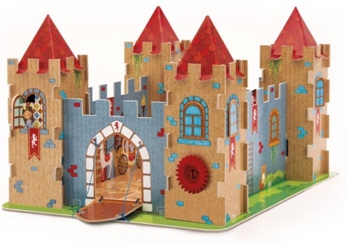  Note: This unit is focused on using mechanisms, not on using new materials.  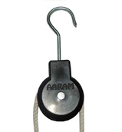
Objective and Success Criteria | Coverage | Key Questions | Children should be able to | Resources
To find out about designs in history and explore their structure and the materials that were used.  (context – Castles. Children should find out about the mechanics of drawbridges). | - Find out about famous castles.  - Explore the structure of castles.  - Research drawbridges and the mechanics used.  - Discuss how we could make a functional drawbridge. Pre-assess understanding.  - Information on drawbridges can be found here: All about castle drawbridges  - Find out about the materials used to build castles and how they help support the structure. | - What can you tell me about castles?  - What are drawbridges for?  - How do drawbridges work?  - What have you found out about the materials that are used to build castles? | - Use a range of sources to find out about castles and drawbridges.  - Find out about the materials used to make castles and drawbridges. | - Laptops for research, used to inform design.  - Cardboard – perhaps cardboard boxes.  - Paint  - Marker pens – for detailing after painting  - Small, plastic pulleys. E.g: plastic pulley  - String  - Drawing pins
To know how pulleys work.  (context – Castles, simple pulleys and wheels). | - First, see if children have any prior knowledge of the objective or found out anything about it during their research in the last lesson.  - Explain how pulleys work. Information found here: All about pulleys.  (context – this article explains a range of pulley systems. Children are only expected to understand simple, single pulleys).  - Watch a video about simple pulleys to help explain how they work. E.g: How pulleys work  - To demonstrate understanding, children could practice making a simple pulley system using a paper clip (as the wheel) and string and use them to lift up classroom objects such as pencils or glue sticks etc. | - What do you already know about pulleys?  - Can anyone explain how a pulley works?  - Can you show me a pulley system using a paper clip and string?  - Why are pulleys helpful?  - Can you think of any other products which use pulleys? | - Explain how a simple pulley works.  - Demonstrate how a pulley works with paper clips and string.  - Explain why pulleys are used and how they are helpful.  - Identify how we use pulleys in everyday life.
To decide which materials would be fit for purpose and design with these materials in mind.  (context – Castles. Decide which materials would fit for our creations. Keep materials simple. E.g. Cardboard). | - Explore which materials children would like to use to make their castles.  (context – these should be simple materials such as cardboard, Sellotape and glue, as the focus is on mechanisms).  - Encourage children to justify their choices, drawing upon their learning about materials for stiff and stable structures at the beginning of the year.  - In teams, children choose their final materials. They could pitch ideas to each other before making the final decision as a team. | - Which materials could we use for our castles?  - How can we make our castles stiff, stable and strong?  - Can you explain to your team which materials you would choose for a castle and why?  - What are the final materials that your team have chosen to use? Why? | - Choose appropriate materials for construction.  - Draw on previous learning.  - Justify their choices to their team.  - Explain why they have chosen particular materials, including joining materials. E.g. sellotape, glue etc.
To design our products, based on research, in an exploded diagram and using software.  (context – Castles. Diagrams should show the key parts used, particularly for the drawbridge). | 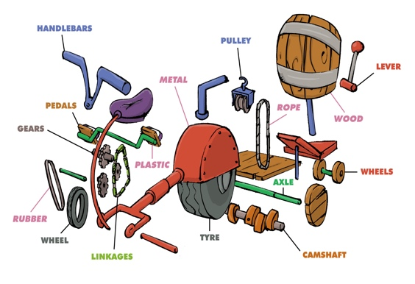  - Show children examples of exploded diagrams. E.g: Below is a bike diagram.  - Explain to the children that an exploded diagram shows all of the parts/components and materials which together make the complete product.  - In teams, children write a list of all of the parts and materials which will be used in their castles. Make sure the pulley is on their lists as well as materials.  - Once they have made a list, children sketch their exploded diagrams in their sketch books and label the parts and materials.  - Afterwards, children create their finished design in 3D using TinkerCAD. See seatwell example in the TinkerCAD public space. | - Can you explain what an exploded diagram is?  - Which materials/components have you listed?  - Can you explain your exploded diagram to me?  - Can you create your design in 3D using TinkerCAD? | - Explain what an exploded diagram is and why we might use it.  - Draw their own exploded diagram and include labels.  - Create their designs using software to help visualise the finished product.
To make a functioning product which uses a pulley system.  (context – Castles with drawbridges). | - Children build their castles out of their materials by following their designs.  - You may need to demonstrate how to attach the rope to the drawbridge, attach the pulley correctly to either side of the castle, feed the rope through and into the castle. Perhaps you can build your own working example before the lesson. Use drawing pins on either side of the castle walls on the inside to wrap the strings around to keep the bridge open.  - Focus on a very high standard of finish as in the example ‘end product’ picture.  - Children could paint their castle pieces before putting them together. They could draw and colour embellishments, such as bricks, flowers etc., on paper, cut them out and glue them onto their castles. | - Where will you and your team begin when making your design?  - Can you explain how you plan to attach your pulley?  - Which tool will you use to make the holes for the string?  - Thinking about angles, where do you think is a good place to position your pulley? Why?  - Can you explain how you expect your pulley to work? | - Create a plan with their team to make their design.  - Work well with a team, with each person taking on a role within the team.  - Choose and use appropriate tools.  - Use their understanding of mathematics within their creations.  - Explain how their product should work. This shows that they have a clear vision of their product.
To evaluate our finished product.  (context – Castles. Evaluate whether fit for purpose). | - Once castles are complete, children could test each other’s drawbridges.  - As a class, choose the best functioning drawbridge and evaluate why it is so successful.  - Discuss any particular challenges that children faced during this unit.  - Make sure that children fully understand the purpose of a drawbridge (castles surrounded by a moat).  - You could make some questions for children to assess their castles against for self-evaluation of their castles. | - Does their drawbridge work how you expected it to? Why/why not?  - Is there a way that they could make their drawbridge function more smoothly? E.g. angles.  - Can you explain how you know your castle and drawbridge are fit for purpose?  - Can you self-assess the functionality of your product against these questions? (give the children questions to evaluate). | - Self-assess against specific questions/criteria, given by the teacher.  - Offer suggestions to help improve products.  - Explain how they know that their final product is/is not fit for purpose.
Assessment Questions
Can you explain what an exploded diagram is and why they are used?
Can you explain how a pulley works?
Can you tell me how to make a simple pulley system?

