Year 6 – Autumn – Does change always lead to progress?  - use research and develop design criteria to inform the design of innovative, functional, appealing products that are fit for purpose, aimed at particular individuals or groups  - generate, develop, model and communicate their ideas through discussion, annotated sketches, cross-sectional and exploded diagrams, prototypes, pattern pieces and computer-aided design  - select from and use a wider range of materials and components, including construction materials, textiles and ingredients, according to their functional properties and aesthetic qualities  - investigate and analyse a range of existing products  - understand and use electrical systems in their products [for example, series circuits incorporating switches, bulbs, buzzers and motors]  Big Ideas: R1, R2, R3, DC3, DC4, E3 |  |  | End Product:  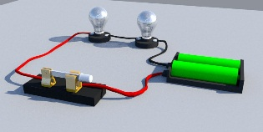  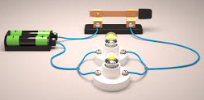  Science link – children have found out about circuits and their uses. They have designed a range of parallel and series circuits, including some with switches, LEDs, bulbs and buzzers. They have created one of their circuits using their designs.
Objective and Success Criteria | Coverage | Key Questions | Children should be able to | Resources
To find out about how electrical products function.  (Context – circuits – series and parallel – Science link)  To be able to explain how individual components work.  (Context – circuits – series and parallel – Science link) | - Research to find out about circuits and how they work in simple technology.  - Find out about the key components of a circuit, including:  - Switches  - Buzzers  - LEDs  - Bulbs  - More able – find out about resistors and how they work.  - Find out about how circuits help us in everyday life. E.g.: the lights in the house run on a parallel circuit. | - Can you explain how a parallel circuit works?  - Can you explain how a series circuit works?  - Can you explain what these are and how they work? (Component parts).  - How do we use circuits in everyday life?  - Can you find something in the classroom that uses a parallel/series circuit? | - Explain how electrical systems work in products.  - Understand the key component parts required in an electrical circuit.  - Know and give examples of how we use circuits in everyday life. | - Laptops for research and to make our designs using CAD.  - Wire  - Bulbs  - Batteries  - Switches  - Buzzers  - LEDs
To design series and parallel circuits using annotated sketches and computer aided design to test functionality.  (Context – to include switches, LEDs, bulbs and buzzers) | 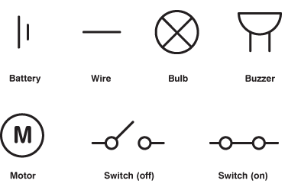  - Teach children about the different symbols used to represent the components in a circuit.  - Children could practice by sketching pre-made circuits in diagrams. Give them photos of circuits similar to the ones in the ‘end product’ section above.  - Children design a range of circuits. You could set them a challenge of designing 2 parallel and 2 series circuits.  (Context – Children should have learnt what a parallel and series circuit are in their science lessons.)  - They could start by designing a basic circuit with just a battery and a bulb. Then you could challenge them to add components to their design each time. E.g., next draw a circuit with a battery, a bulb and a switch, until they have a more complex circuit design.  - Children should share their sketches with others and explain how they will work.  - Children make their circuits using the circuit design function on TinkerCAD. They can use this to test whether their design will function as expected. | - Can you tell me what this symbol means?  - Can you label your components on your sketch?  - Can you show me this circuit as a sketch?  - Can you label your sketch with the component part names?  - How can you show me this on TinkerCAD?  - How can you use TinkerCAD to check that your circuit works how you expect? | - Know the symbols used for the components when sketching a circuit.  - Be able to explain the functions of different circuit components.  - Sketch a circuit from a real-life circuit using symbols.  - Design their own circuits to include the key components and say how they would be used.  - Demonstrate their designs using computer aided design such as TinkerCAD.  - Test their designs using computer aided design.
To make circuits which have a specific function by following our designs.  (Context – to include switches, LEDs, bulbs and buzzers) | - Once children have checked their designs on TinkerCAD, they can make them.  - Children should be encouraged to evaluate whether their circuits are fit for purpose and imagine how they would be used within a product. | - Have you gathered all of your equipment and components before you start? Why is that important?  - Is your circuit fit for purpose? How do you know?  - Is there a way that you can make your circuit function better? (e.g. a brighter bulb or louder buzzer).  - How could we use your circuit in a product?  - What kind of product would use your circuit? | - Understand the importance of keeping a work space tidy and organised.  - Use a range of components to make a functioning circuit.  - Evaluate the effectiveness of their circuits and suggest improvements where needed.  - Explain how their circuits could be used in real life.
Assessment Questions
Did you make a functioning circuit?
Can you explain how and why your circuit worked?
Can you explain how we use circuits in everyday life and technology?

Year 6 – Spring – What would a world without war look like?  - use research and develop design criteria to inform the design of innovative, functional, appealing products that are fit for purpose, aimed at particular individuals or groups  - generate, develop, model and communicate their ideas through discussion, annotated sketches, cross-sectional and exploded diagrams, prototypes, pattern pieces and computer-aided design  - investigate and analyse a range of existing products  - evaluate their ideas and products against their own design criteria and consider the views of others to improve their work  Big Ideas: R1, R2, R3, DC2, DC4, E3 |  |  | End Product:  Children have researched famous propaganda from the world wars. They have taken inspiration from them to design and create their own propaganda style posters (about a topic that is relevant to the class, either chosen by children or teacher).  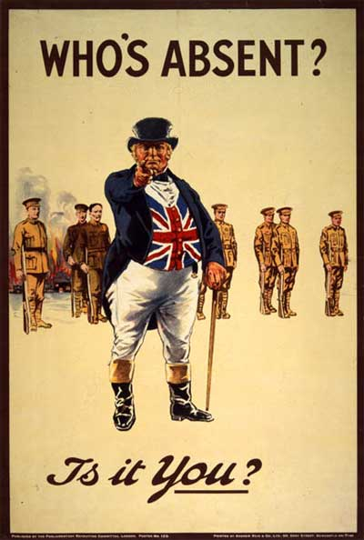
Objective and Success Criteria | Coverage | Key Questions | Children should be able to | Resources
To find out about how products were used in historical time periods.  (Context – World Wars. Propaganda posters). | - Research to find out about War propaganda, including posters.  - Find out why they were so appealing to their intended audience and their purpose. | - What can you tell me about War posters?  - Do you notice any key characteristics that are on most of them?  - Who is the intended audience?  - How do they appeal to their intended audience? |  | - See Art resources for:  - Paper and Paste  - Painting  - Drawing  - Printing
To use ideas from existing designs in their own designs to appeal to a particular audience.  (Context – World Wars. Propaganda posters). | - After researching persuasive propaganda posters, children take time to consider the cause that they would like to make their posters for (or this could be given by the class teacher).  - After the intended audience has been chosen, children discuss what that person would find appealing in a poster.  - Children spend time designing their posters with their intended audience in mind.  - Design using sketching.  - After sketching, children discuss their ideas and their poster designs. | - What do you think your cause should be? Why?  - Who is your intended audience?  - How can you appeal to them?  - How do you know they will find that appealing?
To create their designs using an appropriate art medium.  (Context – World Wars. Propaganda posters). | - Children choose an Art medium in which to make their posters. As all have been covered, they should be able to do this. Choose from:  - Paper and Paste  - Painting  - Drawing  - Printing  If you do not want children to choose, allocate a medium for them to use.  - Children create their posters using their chosen Medium. | - Which Art medium are you going to use? Why?  - How do you think that will affect your finish?  - Will that appeal to your intended audience? How do you know?
To ensure that their final product has a good standard of finish and get feedback about ways to improve their product next time.  (Context – World Wars. Propaganda posters). | - Take time to discuss the mediums they have chosen and whether that has had the desired effect.  - Discuss the finished achieved and whether they are as high as expected.  - Children could take turns to be the intended audience and critique their peers’ posters to give them advice on how to make it more persuasive or appealing.  - If any of the Art mediums have not gone to plan, discuss the process and how we could do it differently to make the outcome better next time. | - Did your poster come out how you had hoped?  - If not, why not?  - How could you make this poster more persuasive?  - If you were the audience, how would you respond to this poster? Why?
Assessment Questions
How is your poster appealing to your audience?
Which medium have you chosen? Why?
Does your product have a high quality finish? How do you know?

Year 6 – Autumn – What is the secret to success?  - use research and develop design criteria to inform the design of innovative, functional, appealing products that are fit for purpose, aimed at particular individuals or groups  - generate, develop, model and communicate their ideas through discussion, annotated sketches, cross-sectional and exploded diagrams, prototypes, pattern pieces and computer-aided design  - select from and use a wider range of tools and equipment to perform practical tasks [for example, cutting, shaping, joining and finishing], accurately  - select from and use a wider range of materials and components, including construction materials, textiles and ingredients, according to their functional properties and aesthetic qualities  - investigate and analyse a range of existing products  - evaluate their ideas and products against their own design criteria and consider the views of others to improve their work  - understand and apply the principles of a healthy and varied diet  - prepare and cook a variety of predominantly savoury dishes using a range of cooking techniques  - understand seasonality, and know where and how a variety of ingredients are grown, reared, caught and processed.  Big Ideas: R1, R2 R3, DC2, E1, E2 |  |  | End Product:  Children have researched a range of packaging. They have researched recipes and have designed packaging with the intended audience in mind. They have created their packaging using a mixture of materials for construction and CAD for printing labels.  
Objective and Success Criteria | Coverage | Key Questions | Children should be able to | Resources
To find out about the intended audience and use this to inform product research.  (Context – the audience are the class teachers – sit down end of year meal. Children research simple savoury dishes). | - Explain that our intended audience is the class teachers and support staff that have been helping you throughout your time at Highwood.  - Decide as a class, who you would like to invite to the dinner and make invitations.  - Research simple savoury recipe ideas. Children select their favourite recipes.  - Children create a bank of their favourite recipes. – ICT link – saving webpages.  - Decide as a class which savoury dishes you would like to make. Everyone must do the same. | - Who is the intended audience?  - Which simple savoury dishes do you know?  - Which recipes have you saved? Why?  - As a class, which dish are we going to make for our main course? Why? | - Identify and research about their intended audience.  - Research simple recipes for their intended audience. | - Laptops for research  - Laptops for design  - Small cardboard rectangular boxes: boxes  - Paint  - Wrapping paper  - Savoury ingredients – chosen by the children.  - Tiramisu ingredients – Please order when you need it and know amounts required.  - Cooking equipment.
To research appropriate ingredients that are fit for the intended purpose.  (Context – Shopping for ingredients for our chosen recipes in groups). | - Children spend time shopping for ingredients online, comparing prices across shops. Maths link – money  - As a whole class, agree where would be the best places to buy ingredients from and why and order the ingredients necessary.  - Explain that as our dessert, we are going to make tiramisu.  - Buy all of the ingredients for the savoury dish and the tiramisu. | - Which ingredients do we need to find?  - Where can we get them from?  - How can I compare prices?  - How can we be safe online? | - Research their ingredients and make sure that they are fit for the dishes they hope to prepare.  - Compare prices for a range of products and choose the best product for the best price.
To design packaging that is fit for purpose and suits the product inside.  (Context – Designing packaging for a tiramisu). | - Research tiramisu packaging. Discuss the significance of the labelling for nutrition, ingredients list etc.  - You could agree as a class exactly what the labels will say so that the children can focus solely on the packaging design.  - After researching, children design their packaging in teams.  - They should design the labels on the computer using word or something similar.  - They can design a 3D version of their finished packaging in TinkerCAD. | - Why are labels important on food?  - What should our labels say?  - How will you design your packaging? Why?  - How will your packaging appeal to your intended audience?  - Can you make your packaging on TinkerCAD?  - What will you use to make your packaging look like your design? | - Research a range of packaging and identify key criteria that makes it fit for purpose.  - Use this information in their own designs.  - Use CAD design to show the finished product and to design parts of the product for printing.
To create packaging that is fit for purpose and suits the product inside.  (Context – Creating packaging for a tiramisu). | - Children work in teams to make their packaging. The boxes could be given, but children will be responsible for decorating their boxes to look like their designs. They could use any of the resources listed in the resources section.  - Children should then print their nutrition/packaging labels and stick these onto their tiramisu boxes. | - What will you use to make your packaging look like your design?  - Where would be the best places to stick your nutrition labels on your box? Why? | - Create packaging that is fit for purpose.  - Work well in a team.  - Choose appropriate resources from a given range.  - Choose where to put information about their products to ensure that it is clearly visible without ruining the look of the product.
To prepare dishes safely using a range of cooking techniques.  (Context – Children should be preparing at least a 2-course meal, main and dessert). | - With adult support for cooking safety, children cook their savoury dish using the ingredients that they ordered.  - With adult support for cooking safety, children cook their tiramisu.  - If possible, children put their tiramisu into their packaging. | - How can you be safe when using the oven?  - How can you prepare food safely?  - How can you prepare food hygienically? | - Prepare food safely and hygienically.  - Cook safely using the oven and cooker.  - Use their packaging for its intended purpose.
Assessment Questions
How can we make sure we are being hygienic when preparing food?
How can you be safe when cooking?
How do you know that your product is fit for purpose?

