Academic Year 2020 - 2021
Matt Hickey
Highwood Primary school
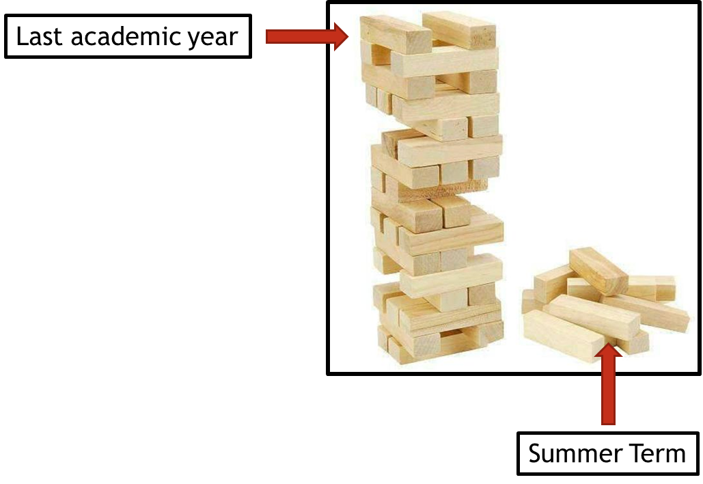
Curriculum Adjustments
Highwood’s plan to adapt the 2020 – 2021 curriculum plan.

Despite the disruption that took place during the summer term of 2019 – 2020, learning will have still taken place for the vast majority of children, both through the first two terms of the year and through the home learning provided during the summer term. Although the exact content of the summer term curriculum may not have been covered in some of our home learning tasks, Highwood’s approach is going to focus on the key concepts that need to be taught and any key knowledge that is not repeated in other areas of the curriculum

To express this, at Highwood we have taken the analogy of a Jenga tower – the tower has been built but there are missing parts. In the same way that order to carry on building the tower is possible, the fact that gaps have appeared may cause issues further into the learning journey. This Curriculum Adjustments document identifies where we plan to support the children’s learning going forward, so that new knowledge from the Autumn term is built on secure foundations. This has been planned carefully to extend the focus on prior learning and look at where previous skills and knowledge can be taught in the new curriculum content – we have linked it through the ‘Big Ideas’ themes in order for the transition to be a smooth as possible.

English
Year Groups & Key Questions | Missed Summer Term objectives | Autumn Term objectives | Implementation
Year 1 = Which animals would you invite to tea?  Year 2 = Was the Great Fire of London a total disaster? | Writing a letter [writing to inform]  Writing an informative report. [writing to inform]  - Securely use capital letters for names, place names and days of the week and the personal pronoun ‘I’.  - Write from memory simple dictated sentences using the BPCs and common exception words  - Using the prefix “un” and knowing how it changes verbs and adjectives.  - Spell the days of the week.  - Spell common exception words.  - Make inferences based on what has been said or done. | - Capital letters, full stops, question marks and exclamation marks to demarcate sentences [writing to inform: recount & entertain: story]  - Discussing and clarifying the meanings of words, linking new meanings to known vocabulary. [reading]  - Make inferences based on what is said and done. [reading] | Spelling the day of the week can be recapped when pupils are asked to write the date in their books.  WCR should cover in Y2 the skill of making inferences based on speech and action but this may be the first skill focused on to get pupils familiar with inferring and linking those inferences to what is read.  The class could write an informative report about The Great Fire or the topic of wildfires and their place in ecosystems using dictated sentences to write some of this. Alternatively, Y2 Aut 2 sees pupils write a recount of the fire when writing to inform which could also cover these objectives or build upon them.
Year 2 = What could go in our Best British Banquet?  Year 3 = What did the pre-historic people yabba-dabba do? | Writing a non-chronological report. [writing to inform]  - Use subordination (using because, when, that and if).  - use the progressive form in the past and present tense.  - Use precise expanded noun phrases. [also can be taught through Y3 AUT1 writing to entertain: story]  - Make inferences based on what is said/done and linking reasons to what they read.  - Being introduced to non-fiction books that are structured in different ways.  - Retrieve information from what they read. | - In narratives, create and describe settings and characters [writing to entertain: character description/story]  - Recognise and use conjunctions. [inform: recount & explanation]  - Recognise and use clauses and subordinate. [inform: explanation]  - Draw inferences about feelings thoughts and motives and link to the text using simple evidence. [reading] | When writing their explanation [writing to inform – Y3 AUT2] of how Stone Age people survived, the teaching can draw upon the stylistic and grammatical conventions of a Non-Chronological report when creating an introduction – subordination also lends itself to an explanation text for adding parenthesis to topic sentences so the 3 curriculum should also address this gap – grammar starters may be useful though to recap and revise.  Use of precise and deliberate expanded noun phrases is a logical teaching point when creating characters and settings which will be covered in the Y3 Autumn writing to entertain tasks.  Likewise, WCR in Y3 will include the teaching of linking inferences to details in the text and this skill is perhaps best priorities in teaching – looking at character motivation and how their thoughts and feelings are evident beyond the literal.
Year 3 = How can we help protect our planet?  Year 4 = What is more precious – water or gold? | Write a speech raising awareness of an issue. [writing to inform]  - Choose nouns appropriately for clarity, cohesion & avoid repetition.  - Conjunctions (e.g. when, before, after, while, so, because) adverbs (e.g. Then, next, soon) and prepositions (e.g. Before, after, during) expressing time or cause [can be covered in Y4 AUT 2 Writing to inform: newspaper recount].  - Direct speech and inverted commas.  - checking that the text makes sense to them, discussing their understanding and explaining the meaning of words in context | - Use a wider range of conjunctions inc. when, if, because, although to write sentences with more than one clause. [inform: report]  - Punctuating direct speech. [entertain & inform: narrative and newspaper].  - Pronoun and noun variation for cohesion e.g. Replacing noun with pronoun, noun with alternative e.g. pyramid/ancient wonder – river/life-giver castle/fortification [inform: newspaper] | To cover the speech writing loss of Y3 Summer, pupils could study a speech in non-fiction WCR coverage – an extract from MLK Jr’s I Have A Dream would be a good example – pupils could also look at writing and speeches by Greta Thunberg. Pupils will be writing to persuade in Summer term but a reading study would lay the foundations for this in Autumn term.  The newspaper article in Autumn Term of Y4 lends itself to the teaching of direct speech (quotation) and pronoun/noun variation i.e. Howard Carter/Mr. Carter/the ambitious archaeologist.  With the continued focus on vocabulary in WCR, pupils will be able to continue to discuss the meanings of words in context but it will be worth looking at homonyms.
Year 4 = How have our coasts made Britain great?  Year 5 = Has our planet finished evolving? | [Writing to persuade]: advert and/or letter.  - Deliberate and purposeful vocabulary choices (persuasion context: repetition, hyperbole, emotive language).  - Using expanded noun phrases, preposition phrases, adverbials and similes. [persuade context: emotive language]  - Identify determiner, possessive pronoun.  - Infer character’s thoughts, feelings and motives using evidence and explanation.  - Identify themes and conventions in a range of books [Y5 Spring/Summer: Reading Beowulf/Writing to Entertain: Greek myths] | - selecting appropriate grammar and vocabulary, understanding how such choices can change and enhance meaning [entertain & inform: narrative & report]  - Use expanded noun phrases to convey complicated information concisely. [inform & entertain]  - Linking ideas across paragraphs using adverbials of time [for example, later], place [for example, nearby]  - Indicating degrees of possibility using adverbs [writing to persuade: modals e.g.” will”] | Pupils have missed their first foray into writing to persuade and so will need a writing unit on this. Pupils’ are very familiar with the subject of The Romans from Spring of Y4 and so a persuasive letter from the Romans to the Celts persuading them to willingly submit to their rule is one way you could implement study of the text type.  WCR will cover the objectives about inferring feelings and thoughts but an emphasis on explanation of evidence would be ideal (the E in APE).  “Themes and conventions” would be well suited to the Spring study of Beowulf (looking at tradition of Norse sagas) and Summer study of Greek Myths (tropes and conventions and parallels with Roman mythology).
Year 5 = How do you build an Empire?  Year 6 = Does progress always lead to change? | [Writing to persuade]: a speech in defence or an advertisement.  - Use commas to avoid ambiguity.  - Converting nouns or adjectives into verbs using suffixes.  - Use the perfect form to mark time and cause.  - Use colons.  - Use semicolons when listing. | - Use semicolons between independent clauses.  - Use colons between clauses.  - Use commas to clarify meaning.  - Identify how language and structure contribute to meaning. | The Y5’s lost a persuasive writing unit that they will need in Autumn term in preparation for Y6 Summer term. An ironic/farcical job advert for a Victorian child labour opportunity or a letter to Queen Victoria raising awareness of the working conditions of children would be a good starting point (also see Tony Robinson’s Worst Jobs In History).

