Academic Year 2020 - 2021
Matt Hickey
Highwood Primary school
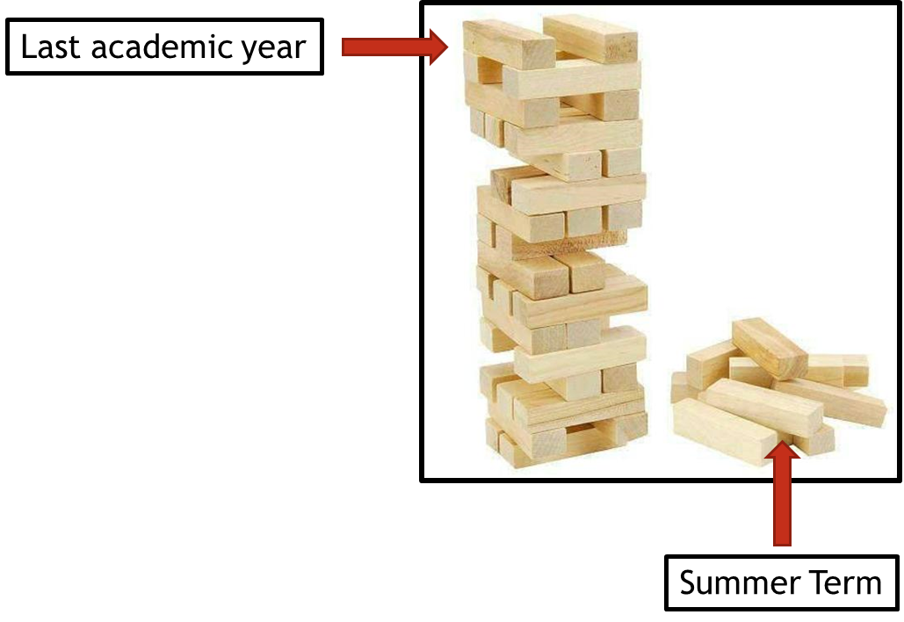
Curriculum Adjustments
Highwood’s plan to adapt the 2020 – 2021 curriculum plan.

Despite the disruption that took place during the summer term of 2019 – 2020, learning will have still taken place for the vast majority of children, both through the first two terms of the year and through the home learning provided during the summer term. Although the exact content of the summer term curriculum may not have been covered in some of our home learning tasks, Highwood’s approach is going to focus on the key concepts that need to be taught and any key knowledge that is not repeated in other areas of the curriculum

To express this, at Highwood we have taken the analogy of a Jenga tower – the tower has been built but there are missing parts. In the same way that order to carry on building the tower is possible, the fact that gaps have appeared may cause issues further into the learning journey. This Curriculum Adjustments document identifies where we plan to support the children’s learning going forward, so that new knowledge from the Autumn term is built on secure foundations. This has been planned carefully to extend the focus on prior learning and look at where previous skills and knowledge can be taught in the new curriculum content – we have linked it through the ‘Big Ideas’ themes in order for the transition to be a smooth as possible.

Art
Year Groups & Key Questions | Missed Summer Term objectives | Autumn Term objectives | Implementation
Year 1  Which animal would you invite to tea?  Printing | Artist: William Morris  - Make a clean print and print a repeated pattern  - Be able to choose materials to print own picture and explain reasons for their choices. | Year 1 children should have explored making a simple repeating pattern using polystyrene to make a print. They should have used a pencil to emboss their design into the polystyrene board. | Autumn Term: Year 3  - To explore cutting techniques using lino  - To explore layering colours using lino press block  - To design a complex pattern made up of 2 or more motifs  - To print a tiled version
Year 2  Can we grow our own Picnic?  Drawing | Artist: Giuseppe Arcimboldo  - To explore ways to use a pencil to create different effects  - To explore how to add tone and depth using pencils | Year 2 children Should have explored how to use a pencil to sketch. They should have looked at how to create short quick lines/ shapes, using light pressure on the pencil. They also should have looked at how to create tone when using pencil and coloured pencils. They should have looked how to blend colours when using pencils. | Spring Term: Year 3  - To explore using pastels to add tone  - To draw from a view point  - Explore taking a line for a walk  - To combine images to make a new image  - To use a view finder to select a view
Year 3  How can we help to protect the planet?  Painting | Artist: Van Gogh  - To explore the effect on paint of adding water, glue, sand and saw dust  - To mix colours using knowledge of primary and secondary colours  - To use different types of brushes for a specific effect | Year 3 children should have recapped secondary colours then learnt about tertiary colours and how to make them. They should have explored different ways of applying paint with different brushes and tool to create different colours. They should have explored adding texture to paint by adding things like sawdust, sand, glue etc | Autumn Term: Year 5  - Explore different painting techniques to express mood or emotion  - Use a range of tools to apply paint to different surfaces  - Investigate the effect of light and colour, texture and tone on natural and manmade objects
Year 4  Why don’t all beaches have sand?  Drawing | Artist: Turner  - To draw in scale applying rules of perspective  - To draw using coloured media with increasing accuracy  - To make quick studies from first hand observation | Year 4 children should have learnt about drawing things in scale. They should have built on previous learning about adding tone and depth and using first hand observations to increase the accuracy of their drawing. They should have looked at using light and dark within their piece. | Autumn Term: Year 6  - To explore how blending can add tone, shadow and depth to a picture  - To select appropriate media to achieve a specific effect

