Academic Year 2020 - 2021
Matt Hickey
Highwood Primary school
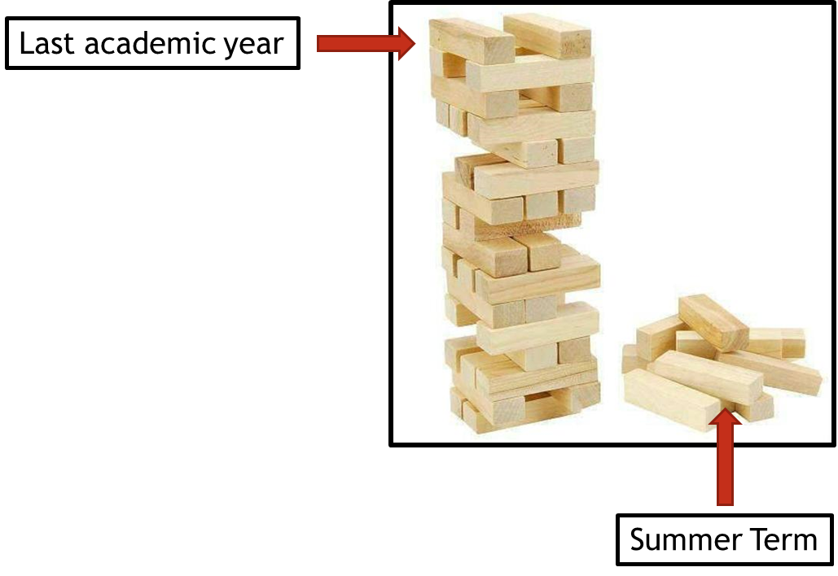
Curriculum Adjustments
Highwood’s plan to adapt the 2020 – 2021 curriculum plan.

Despite the disruption that took place during the summer term of 2019 – 2020, learning will have still taken place for the vast majority of children, both through the first two terms of the year and through the home learning provided during the summer term. Although the exact content of the summer term curriculum may not have been covered in some of our home learning tasks, Highwood’s approach is going to focus on the key concepts that need to be taught and any key knowledge that is not repeated in other areas of the curriculum

To express this, at Highwood we have taken the analogy of a Jenga tower – the tower has been built but there are missing parts. In the same way that order to carry on building the tower is possible, the fact that gaps have appeared may cause issues further into the learning journey. This Curriculum Adjustments document identifies where we plan to support the children’s learning going forward, so that new knowledge from the Autumn term is built on secure foundations. This has been planned carefully to extend the focus on prior learning and look at where previous skills and knowledge can be taught in the new curriculum content – we have linked it through the ‘Big Ideas’ themes in order for the transition to be a smooth as possible.

Computing
Year Groups & Key Questions | Missed Summer Term objectives | Autumn Term objectives | Implementation
Year 1 (Summer)  Year 2 (Spring) | Digital Literacy – IT beyond school  - Know what technology is commonly used for communication  - Know common types of communication used with technology | GEOGRAPHY  use world maps, atlases and globes to identify the United Kingdom and its countries, as well as the countries, continents and oceans studied at this key stage. | Bring in concept of digital communication across the planet using satellites whilst learning about different countries.  AGREED WITH YEAR 2 – separate staff meeting has taken place to plan.
Year 2 (Summer)  Year 3 (Autumn) | Digital Literacy – IT beyond school  - Evaluate the effect communication has had upon the world  - Use communication to achieve a goal | Information Technology – Using a range of software  - Record and upload image  - Navigate website for information | Explore websites for ordering items off the internet (supermarkets, Amazon etc.) and discuss the impact digital communication has had upon the world.  Link this to the section on sharing information online and how this impacts the world.
Year 3 (Summer)  Year 4 (Spring) | Computer Science – Programming  - Identify commands needed to create the algorithm  - Debug algorithm  Computer Science – Logical reasoning  - Explain what a command will achieve  - Explain what the algorithm will achieve  - Adapt the algorithm based on an understanding of errors | Computer Science – Programming  - Create a playable game for an audience  - Create loops of commands within algorithms  - Debug the algorithm | Both of these units are based on programming KUBO.  Program the route using year 3 commands, moving onto year commands if children are able.
Year 4 (Summer)  Year 5 (Spring) | Computer Science – Networks  - Understand information is sent in packets  - Understand how requests are made to web pages  - Create non-digital packet delivery using addresses | Computer Science – Networks  - Upload digital content explaining ideas  - Review reply comments  - Respond to reply comments | Teach year 4 unit on how the internet sends information as packets.  Lead into posting digital content online, thinking about how the information is being sent as packets.
Year 5 (Summer)  Year 6 (Summer) | Computer Science – Programming  - Create algorithm with repetition and sequences  - Create an aim and scoring system | Computer Science – programming  - Create an algorithm to control an external device  - Create an algorithm that allows the reader to play a game with the device  Computer Science – Input and Output  - Understand the inputs and outputs needed for the device  - Understand how to relay this information to the user | Both of these units are based on programming KUBO.  Teach and use repeated commands (year 5) before moving onto year 6 commands.

