Academic Year 2020 - 2021
Matt Hickey
Highwood Primary school
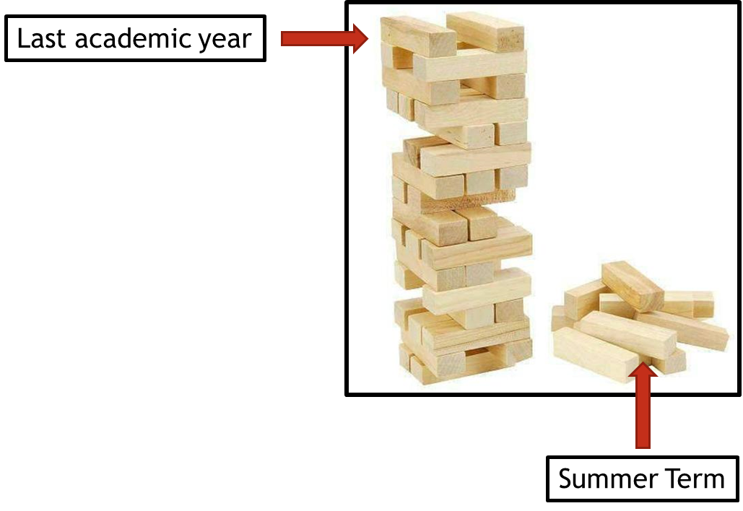
Curriculum Adjustments
Highwood’s plan to adapt the 2020 – 2021 curriculum plan.

Despite the disruption that took place during the summer term of 2019 – 2020, learning will have still taken place for the vast majority of children, both through the first two terms of the year and through the home learning provided during the summer term. Although the exact content of the summer term curriculum may not have been covered in some of our home learning tasks, Highwood’s approach is going to focus on the key concepts that need to be taught and any key knowledge that is not repeated in other areas of the curriculum

To express this, at Highwood we have taken the analogy of a Jenga tower – the tower has been built but there are missing parts. In the same way that order to carry on building the tower is possible, the fact that gaps have appeared may cause issues further into the learning journey. This Curriculum Adjustments document identifies where we plan to support the children’s learning going forward, so that new knowledge from the Autumn term is built on secure foundations. This has been planned carefully to extend the focus on prior learning and look at where previous skills and knowledge can be taught in the new curriculum content – we have linked it through the ‘Big Ideas’ themes in order for the transition to be a smooth as possible.

DT
Year group/ key question | Missed skill/technique | Term to be revised | Implementation
Year 2= What could go in our Best British Banquet?  Year 3 (Spring) = Could we exist without water? | Children have researched British dishes. They have chosen a traditional British recipe to prepare and have learnt about a healthy diet and healthy plate.  Research:  - Find out which ingredients can be grown.  Design:  - Design and sketch a dish which could be made using at least 1 grown ingredient.  Create:  - Cook a dish which uses at least 1 grown ingredient.  - Measure the ingredients using electronic scales.  - Understand how to cut, peel and grate foods safely.  Evaluate:  Discuss which tools were most useful for making the product | Doesn’t fit in with DT – see implementation box | Find a tie with another subject, such as science or PSHE where we can discuss making healthy choices and what makes a healthy diet.
Year 3 = How can we help protect our planet?  Year 4 = What is more precious – water or gold? | Children have researched, designed and created a large waterproof shelter made from mostly natural materials. Their designs should have specific criteria, chosen by them and informed by the research process.  Research:  - Research water-proof shelters and camping equipment.  - Find out about the equipment used to create water-proof shelters.  Design:  - Design a water-proof shelter, given specific set of criteria.  - Label designs with materials and measurements.  Create:  - Build a water-proof shelter using chosen materials and tools.  - Use non-electric tools safely.  Evaluate:  - Evaluate effectiveness of our shelters in rainy conditions.  - Propose improvements if necessary. | AUTUMN TERM:  Children have researched Egyptian pyramid structure and why they are so stiff, strong and stable. They have researched to find out which materials they can use to make a structure. Children have designed their structures using what they have found out and created them with resources of their choice. E.g.: K’nex  Research:  - Find out about the Egyptian pyramids and their structure.  Design:  - Design a stable, weight-bearing structure inspired by Egyptian pyramid design.  - Label designs with own materials and measurements.  Create:  - Make a stable structure using own designs and chosen materials.  Evaluate:  - Apply weight to finished structures and evaluate ways to make them more stiff and stable. | Prior to looking at Egyptian structures and why they’re so stiff/ stable but prior to that look at structures as a whole in the wider world, including natural structures and discuss what materials they are made of/ what makes materials waterproof.
Year 4 = How have our coasts made Britain great?  Year 5 = Has our planet finished evolving? | Chronology of events  - Timeline of the history of Swanage  Change and continuity  - Discuss how the past has influenced the present and how the present will shape the future | Comparing and contrasting periods and happenings  - Analyse why there was a shift in acceptance of the plates tectonic theory  Change and continuity  - Discuss how the past has influenced the present and how the present will shape the future | Study the changes to Swanage – both natural and man-made. Link to changes in landmass and it’s possible causes and effects.  Continue with planned Spring curriculum.
Year 5 = How do you build an Empire?  Year 6 = Does progress always lead to change? | Children have researched features of castles, before designing and creating their own castle, which includes a movable drawbridge using a pulley and a wheel.  Note: This unit is focused on using mechanisms, not on using new materials  Research:  - Find out about how castle drawbridges work.  - Find out about how gears, levers and pulleys work.  Design:  - Design a castle with a drawbridge, labelling the gears, levers and pulleys.  Create:  - Create a 3D model castle of own designs.  - Use gears, levers and pulleys to include a functioning drawbridge.  Evaluate:  - Compare finished castles and discuss best mechanism for drawbridge. | Children have learnt about a range of types of CAMs and how they can be used in toys for different effects. They have designed their own rotating Earth toy and created it in teams.  Research:  - Find out how linear and cylindrical CAMS work.  Design:  - Design and sketch an orbit of the Sun, Moon and Earth and label the CAMs used for rotation around each other.  Create:  - Make a small scale planetary orbit which includes the Sun, Moon and Earth.  - Include a linear or cylindrical CAM in the model.  Evaluate:  - Throughout the process, test if the CAM is functioning correctly and adapt if necessary. | When discussing mechanisms such as CAMs in Y5, spend the lesson prior looking at other mechanisms, including pulleys, and explore the different ways that they are mad/ what they are used for.

