Academic Year 2020 - 2021
Matt Hickey
Highwood Primary school
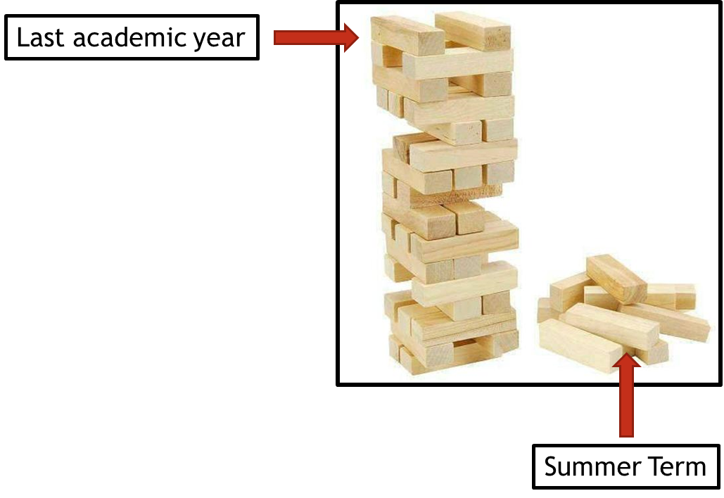
Curriculum Adjustments
Highwood’s plan to adapt the 2020 – 2021 curriculum plan.

Despite the disruption that took place during the summer term of 2019 – 2020, learning will have still taken place for the vast majority of children, both through the first two terms of the year and through the home learning provided during the summer term. Although the exact content of the summer term curriculum may not have been covered in some of our home learning tasks, Highwood’s approach is going to focus on the key concepts that need to be taught and any key knowledge that is not repeated in other areas of the curriculum

To express this, at Highwood we have taken the analogy of a Jenga tower – the tower has been built but there are missing parts. In the same way that order to carry on building the tower is possible, the fact that gaps have appeared may cause issues further into the learning journey. This Curriculum Adjustments document identifies where we plan to support the children’s learning going forward, so that new knowledge from the Autumn term is built on secure foundations. This has been planned carefully to extend the focus on prior learning and look at where previous skills and knowledge can be taught in the new curriculum content – we have linked it through the ‘Big Ideas’ themes in order for the transition to be a smooth as possible.

Geography
Year Groups & Key Questions | Missed Summer Term objectives | Autumn Term objectives | Implementation
Year 1  (Spring)= Will we still play with the same toys when we are older? (Geography part was planned for the end of the unit which was missed due to Covid-19)  (Summer) =What would be the best animal to invite to tea?  Year 2  (Autumn)= Was the Great Fire of London  (Spring) = Where in the world would you like to explore? | Location  - Name and locate 4 capital cities of the UK.  Relationships  - Identify key physical features of the UK including coasts and mountains.  - Identify human features unique to capital cities.  Location and Environment  - Discuss how weather changes throughout the year.  - Look at seasonal and daily weather patterns across the UK. | Autumn -Location  - Name, locate and identify characteristics of four countries and capital cities of UK  Spring – Relationships  - To compare physical and human features of two places | You will need to look at the 4 capital cities and study them in greater depth than you would have done.  When you are looking at physical and human features, you will need to extend the vocabulary used to include the vocabulary from Year 1 that they have missed.
Year 2  (Spring) = What could we put in our best British banquet?  Year 3  (Spring) = Could we exist without water?  (Summer) = How can we help protect our planet? | Relationships  - To consider how humans impact the environment around them.  - Key human feature vocabulary. | Spring – Relationships  - To understand the difference between man-made and physical features.  Summer – Relationships  To understand different human and physical characteristics of places. | Children will have missed out on the local area study of Reading in Year 2  So, for both Year 3 units that focus on Henley it would be useful to include information about Reading particularly in terms of physical and human geography.  Perhaps start with a small comparative study of Reading and Henley.
Year 3 (Summer) = How can we help protect our planet? (Mayan topic)  Year 4 (Spring)= What did the Romans ever do for me?  Year 4 (Summer) = Why don’t all beaches have sand?  Year 5 (Autumn) Has our planet finished evolving? | Location & Skills  - Locating countries in North and South America.  - Identify position and significance of Equator and time zones.  Relationships/Environment  - Comparing human and physical geography in two different regions (UK and South America).  - Recognise features of tropical climate zones.  - To understand the importance of natural resources. | Yr 4 Spring –Location & Skills  - Locating world countries with a focus on Europe.  Yr 4 Summer – Relationships  - Comparing human and physical geography (including weather) in two different regions (Swanage and European costal area)  Year 5 Autumn – location  - Locating countries in North and South America  - Identify position and significance of Equator and time zones. | Children will have missed out on developing their map skills and identifying countries and continents across the world. Although locating countries in North and South America is revisited in Year 5 it would be good to spend some time developing the children’s understanding of the wider world and locating different places in Spring alongside looking at the Roman empire.  Children will not have undertaken a comparative study between UK and South America so will not have developed vocabulary and skills related to human/physical geography. Before comparing Swanage and a European costal region it would be good to look at the vocabulary that will be needed to make this comparison.
Year 4 (Spring)= What did the Romans ever do for me?  Year 4 (Summer) = Why don’t all beaches have sand?  Year 5 (Spring) = Is invasion ever justified?  Year 5 (Summer) = How do you build an empire? | Spring –Location & Skills  - Locating world countries with a focus on Europe during spread of Roman empire.  - Location of Roman towns and cities in UK.  Spring – Relationships  - Understanding human and physical features of a Roman settlement.  Summer – Relationships  - Comparing human and physical geography (including weather) in two different regions (Swanage and European costal area) | Spring- location and skills  - Locating countries in Europe  - Locating areas of the UK including Roman and prehistoric settlements.  Spring – relationships  - Notice changes in land use and study Anglo- Saxon settlements.  Summer – location and skills  - Locating countries in Europe and specifically Greece. | Due to the impact of Covid 19 from March (Spring term) Year 4 may have missed out on gaining a solid understanding of the Roman empire and settlements as well as not using their mapping skills to investigate European countries (Summer).  Because of this when starting the Spring topic Year 5 will need to spend a lesson looking back at the Roman empire to help put the Anglo Saxons in better context geographically.  This will be the same when studying Anglo-Saxon settlements as it would be beneficial to compare Roman and Anglo-Saxon settlements.
Year 5 (Summer) = How do you build an empire?  Year 6 (Autumn) = Does change always lead to progress? | Location and skills  - Locating countries in Europe and specifically Greece. | Location and skills  - Look at the location of places that the Victorian Empire spread too. | Although missing the Greek topic in Year 5 will not have a significant impact on the Year 6 curriculum. It is important that the children understand how the Greek empire grew and its location. This will be useful when looking at the Victorian Empire to make comparison and also to compare to the Roman Empire.  As is stated above in History – a discreet look at the development of the Greek Empire would be beneficial.

