Academic Year 2020 - 2021
Matt Hickey
Highwood Primary school
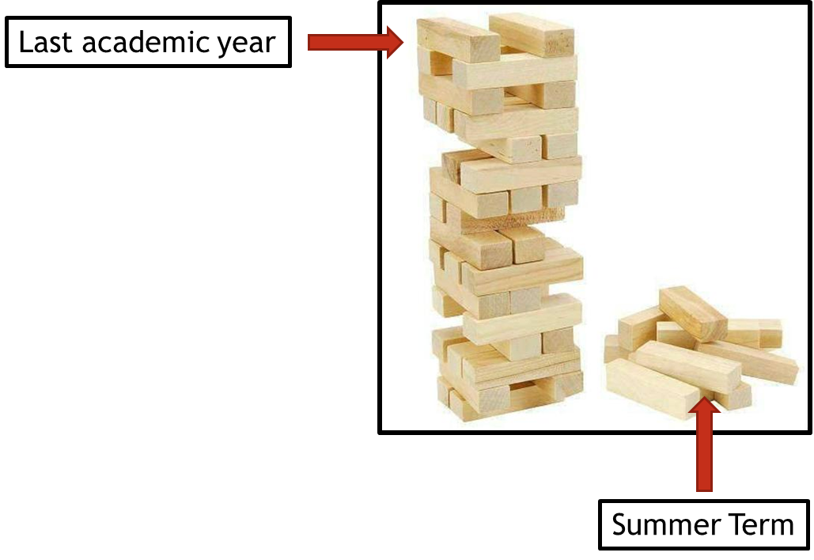
Curriculum Adjustments
Highwood’s plan to adapt the 2020 – 2021 curriculum plan.

Despite the disruption that took place during the summer term of 2019 – 2020, learning will have still taken place for the vast majority of children, both through the first two terms of the year and through the home learning provided during the summer term. Although the exact content of the summer term curriculum may not have been covered in some of our home learning tasks, Highwood’s approach is going to focus on the key concepts that need to be taught and any key knowledge that is not repeated in other areas of the curriculum

To express this, at Highwood we have taken the analogy of a Jenga tower – the tower has been built but there are missing parts. In the same way that order to carry on building the tower is possible, the fact that gaps have appeared may cause issues further into the learning journey. This Curriculum Adjustments document identifies where we plan to support the children’s learning going forward, so that new knowledge from the Autumn term is built on secure foundations. This has been planned carefully to extend the focus on prior learning and look at where previous skills and knowledge can be taught in the new curriculum content – we have linked it through the ‘Big Ideas’ themes in order for the transition to be a smooth as possible.

History
Year Groups & Key Questions | Missed Summer Term objectives | Autumn Term objectives | Implementation
Year 2 = What could go in our Best British Banquet?  Year 3 (Spring) = Could we exist without water? | Chronology of events  - Significant historical events, people and places in their own locality – Huntley and Palmers  - Timeline of changes to Reading from the formation of Huntley and Palmers to present day | (Year 3 Spring Term)  Chronology of events  - Analyse photographs and maps of Henley from the past  - Research and create a timeline detailing the history of boats, their purpose and why they are significant to Henley | Begin with looking at how Reading has garnered success (Huntley and Palmers) and how Reading has changed because of it.  Link to the Henley Regatta and Henley. Continue with planned Spring curriculum.
Year 3 = How can we help protect our planet?  Year 4 = What is more precious – water or gold? | Chronology of events  - Timelines detailing the creation and decline of the Mayan civilisation  Comparing and contrasting periods and happenings  - Identify what was considered significant to the Mayan society –how has this changed to modern society?  Empathy and understanding  - Critique the end of the Mayan civilisation – what lessons can we learn from this?  Historical enquiry and forming conclusions from a variety of sources  - Debate and collate evidence to explain what could have caused the decline of the Mayan civilisation | Chronology of events  - Timeline detailing Ancient Egypt and its achievements  Comparing and contrasting periods and happenings  - Identify what was considered significant to the Egyptian society –how has this changed to modern society?  Change and continuity  - Ask and answer questions which underline the importance of the Egyptians – what would have happened if Ancient Egypt did not exist? Would our lives be the same?  - Assess the modern reliance upon many Ancient Egyptian inventions | Study Mayans first – highlighted Summer term objectives only.  Continue with Ancient Egypt planned curriculum. Use as comparison to the Mayans – early civilisations, creation and decline, sustainability, warfare, natural structures (rainforests/pyramids).  Both work towards covering the objective;  Change and continuity  - Discuss how the past has influenced the present and how the present will shape the future
Year 4 = How have our coasts made Britain great?  Year 5 = Has our planet finished evolving? | Chronology of events  - Timeline of the history of Swanage  Change and continuity  - Discuss how the past has influenced the present and how the present will shape the future | Comparing and contrasting periods and happenings  - Analyse why there was a shift in acceptance of the plates tectonic theory  Change and continuity  - Discuss how the past has influenced the present and how the present will shape the future | Study the changes to Swanage – both natural and man-made. Link to changes in landmass and it’s possible causes and effects.  Continue with planned Spring curriculum.
Year 5 = How do you build an Empire?  Year 6 = Does progress always lead to change? | Chronology of events  - Research the time of 776BC-146BC to create a timeline  - Plot key dates, events and significant individuals on the timeline  Comparing and contrasting periods and happenings  - Analyse art, vases, sculptures, poems and texts (Homer and the Illiad)  - Identify what was considered significant to the Ancient Greek society –how has this changed to modern society  Change and continuity  - Examine the importance of Ancient Greece and its influence upon the modern world | Chronology of events  - Timeline of the Industrial Revolution 1712-1908 (from the invention of the steam engine to the first car)  Comparing and contrasting periods and happenings  - Analyse first models and newer models of machinery  Historical enquiry and forming conclusions from a variety of sources  - Analyse the significance of the Industrial Revolution | Begin with an explicit look at the National Curriculum unit of study: Ancient Greece – a study of Greek life and achievements and their influence on the western world. Highlighted objectives only.  Link elements as a comparison to the Industrial Revolution planned curriculum;  - Creation and expansion of Empires (both Greek and British)  - Inventions  - Hierarchy and human rights (democracy, living conditions, inequality, trade unions etc)  Both work towards covering the objective;  Change and continuity  - Discuss how the past has influenced the present and how the present will shape the future

