Academic Year 2020 - 2021
Matt Hickey
Highwood Primary school
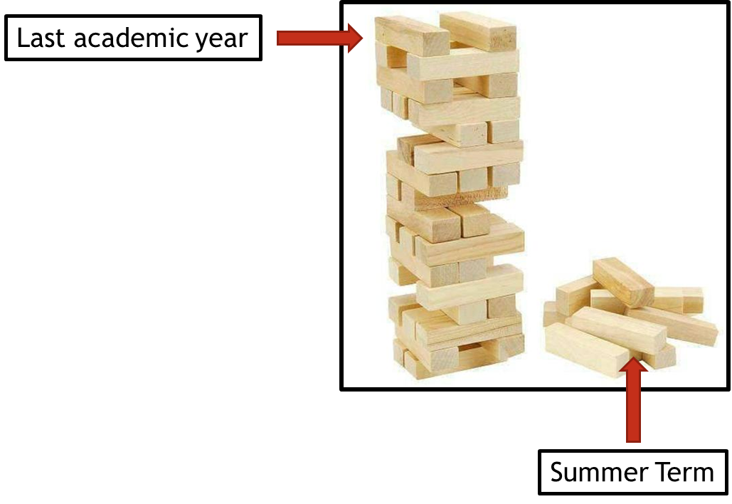
Curriculum Adjustments
Highwood’s plan to adapt the 2020 – 2021 curriculum plan.

Despite the disruption that took place during the summer term of 2019 – 2020, learning will have still taken place for the vast majority of children, both through the first two terms of the year and through the home learning provided during the summer term. Although the exact content of the summer term curriculum may not have been covered in some of our home learning tasks, Highwood’s approach is going to focus on the key concepts that need to be taught and any key knowledge that is not repeated in other areas of the curriculum

To express this, at Highwood we have taken the analogy of a Jenga tower – the tower has been built but there are missing parts. In the same way that order to carry on building the tower is possible, the fact that gaps have appeared may cause issues further into the learning journey. This Curriculum Adjustments document identifies where we plan to support the children’s learning going forward, so that new knowledge from the Autumn term is built on secure foundations. This has been planned carefully to extend the focus on prior learning and look at where previous skills and knowledge can be taught in the new curriculum content – we have linked it through the ‘Big Ideas’ themes in order for the transition to be a smooth as possible.

MFL
Year Groups & Key Questions | Missed Summer Term objectives | Autumn Term objectives | Implementation
Years 4, 5 and 6  French is not linked to Key Questions. Our new French curriculum already includes a catch-up programme, due to it now being fixed on our KS2 timetable, for increased focus. | Oracy:  - Perform simple communicative tasks using single words, phrases and short sentences  Literacy:  - Experiment with the writing of simple words  Intercultural understanding:  - Identify social conventions at home and in other cultures | Oracy  - Listen for specific words and phrases  Literacy  - Read and understand a range of familiar written phrases  Intercultural understanding  - Locate country/countries where the language is spoken | Children need to learn numbers from 11 to 20 by singing songs, doing rhymes, reciting etc, at the start of each MFL lesson until the children are confident.  Start the year with the unit on ‘family’ so that the children build up their vocabulary in preparation for units later in the year. This unit lasts for 2 weeks.  Use the end of year assessment booklet so that the children can record simple words related to family.  Continue to play games involving classroom commands (this does not need to be in the MFL session).  Intercultural understanding objective can be covered during the units: Christmas and Easter.

