Academic Year 2020 - 2021
Matt Hickey
Highwood Primary school
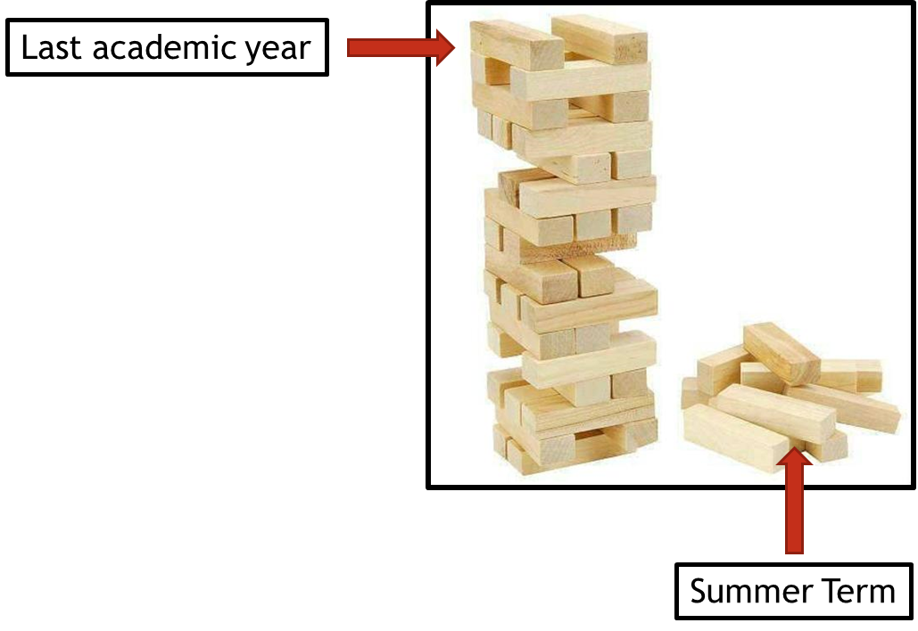
Curriculum Adjustments
Highwood’s plan to adapt the 2020 – 2021 curriculum plan.

Despite the disruption that took place during the summer term of 2019 – 2020, learning will have still taken place for the vast majority of children, both through the first two terms of the year and through the home learning provided during the summer term. Although the exact content of the summer term curriculum may not have been covered in some of our home learning tasks, Highwood’s approach is going to focus on the key concepts that need to be taught and any key knowledge that is not repeated in other areas of the curriculum

To express this, at Highwood we have taken the analogy of a Jenga tower – the tower has been built but there are missing parts. In the same way that order to carry on building the tower is possible, the fact that gaps have appeared may cause issues further into the learning journey. This Curriculum Adjustments document identifies where we plan to support the children’s learning going forward, so that new knowledge from the Autumn term is built on secure foundations. This has been planned carefully to extend the focus on prior learning and look at where previous skills and knowledge can be taught in the new curriculum content – we have linked it through the ‘Big Ideas’ themes in order for the transition to be a smooth as possible.

Music
Year Groups & Key Questions | Missed Summer Term objectives | Autumn Term objectives | Implementation
Year 2 = What could go in our Best British Banquet?  Year 3 “What did the Prehistoric people Yabba Dabba Do?” | Play, Sing and Create  - Compose music to accompany a traditional tale (eg. The Enormous Turnip) by creating simple rhythms and melodies.  - Be able to record their composition through written notation. | Appreciate  - Listen and respond to Saints Saens ‘The Carnival of the Animals’ -Fossils.  - Understand how to find pitch in natural objects (water in bottles, different size stones, different materials).  Play, Sing and Create  - Learn to read musical notation through learning to play the glockenspiel. | Compose music to accompany a traditional tale. This could be linked to an English unit. Traditional tales?
Year 3 = How can we help protect our planet?  Year 4 = What is more precious – water or gold? | Play, Sing and Create  - Experiment with, create and select different sounds that reflect the sounds of the rainforest  - Compose music to create a rainforest soundscape.  Appreciate  - Listen and respond to a rainforest soundscape.  - Listen to Kerry Andrew ‘No Place Like Home’ BBC 10 pieces | “What is more precious: Water or Gold?”  Appreciate  - Listen and respond to Smetana ‘The River Moldeau’.  Perform and Share  - Perform the song Mamma Mia from Charanga using voices and instruments  Play, Sing and Create  - Improvise using voices and/or instruments within the Charanga unit Mamma Mia  - Perform composition | Replace the Charanga Mamma Mia Unit with the soundscape composition unit. Adapt this unit to represent the flow of water instead of the layers of the rainforest.  Compare own composition with:  Kerry Andrew ‘No Place Like Home’  Smetana ‘The River Moldeau’
Year 4 = How have our coasts made Britain great?  Year 5 = Has our planet finished evolving? | Play, Sing and Create  - Learn to play a brass instrument with Berkshire Maestros | Appreciate  - Listen and respond to Holst’s The Planets Suite  - Listen and respond to the playlist that accompanies The Jamie Drake Equation (David Bowie etc)  Perform and Share  - Perform the song Livin on a Prayer from Charanga using voices and instruments  Play, Sing and Create  - Learn to sing the Charanga song ‘Livin on a prayer’  - Improvise using voices and/or instruments within the song. | Emphasis reading and playing of music using glockenspiels within this Charanga unit.

