Academic Year 2020 - 2021
Matt Hickey
Highwood Primary school
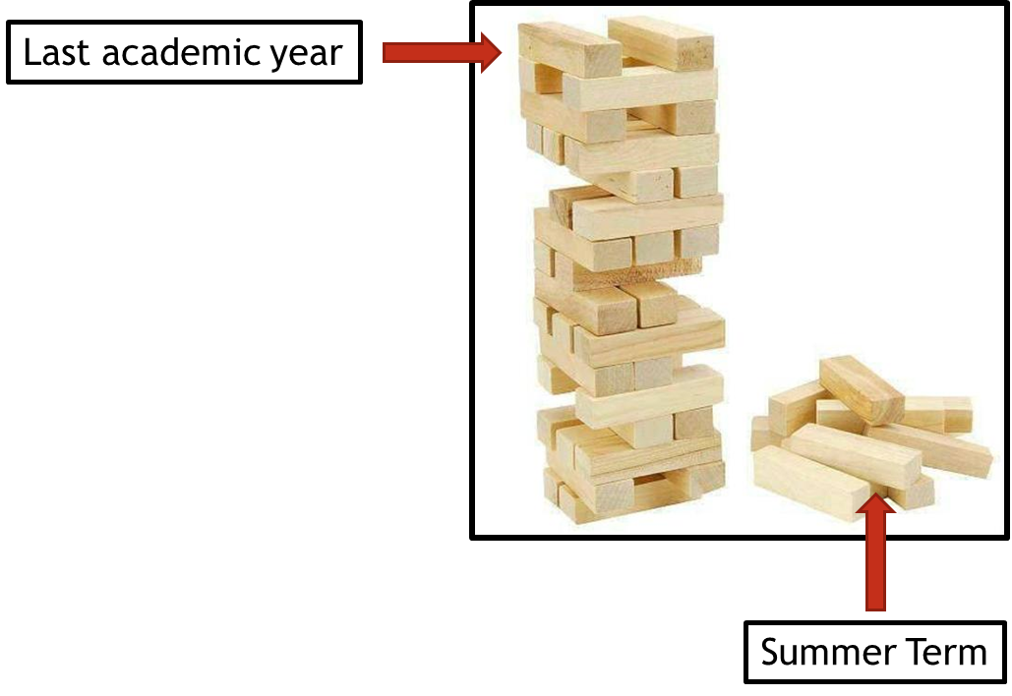
Curriculum Adjustments
Highwood’s plan to adapt the 2020 – 2021 curriculum plan.

Despite the disruption that took place during the summer term of 2019 – 2020, learning will have still taken place for the vast majority of children, both through the first two terms of the year and through the home learning provided during the summer term. Although the exact content of the summer term curriculum may not have been covered in some of our home learning tasks, Highwood’s approach is going to focus on the key concepts that need to be taught and any key knowledge that is not repeated in other areas of the curriculum

To express this, at Highwood we have taken the analogy of a Jenga tower – the tower has been built but there are missing parts. In the same way that order to carry on building the tower is possible, the fact that gaps have appeared may cause issues further into the learning journey. This Curriculum Adjustments document identifies where we plan to support the children’s learning going forward, so that new knowledge from the Autumn term is built on secure foundations. This has been planned carefully to extend the focus on prior learning and look at where previous skills and knowledge can be taught in the new curriculum content – we have linked it through the ‘Big Ideas’ themes in order for the transition to be a smooth as possible.

Science
Year Groups & Key Questions | Missed Summer Term objectives | Autumn Term objectives | Implementation
Year 1 = Which animal would you invite to tea?  Year 2 (Autumn) = Was The Great Fire of London a total disaster?  Year 2 (Summer) = What could go in our Best British Banquet? | Seasonal changes  - Observe and describe the weather associated with the seasons  - Record simple weather data by completing a weather diary  - Observe and explain why the day length varies depending on the season  - Observe and describe the changes to the landscape, including vegetation/trees across the seasons  Plants  - Identify and name local/native wild and common garden flowers in the surrounding area  - Identify, name and label the basic structure of a flowering plant and tree  - Describe the basic function of each structural part of a flowering plant  - Plant a seed to observe the process of germination | Autumn Term  Uses of everyday materials  - Identify and compare the suitability of a variety of everyday materials for a particular use based on their associated properties  - Perform a simple test to investigate and compare the suitability of wood versus brick to build a house – link to DT  - Record data from their material suitability test to answer questions  - Investigate which materials are suitable for weaving – link to Art  Summer Term  Plants  - Identify and name common plants  - Know the difference between a seed and a bulb  - Describe the basic life cycle of a plant  - Investigate, by conducting a comparative test, the right environment to ensure that all a plants needs are met – is it the same for all plants?  - Exploring how and when to grow plants that can be eaten | Autumn Term  Begin with observing the weather associated with the changing seasons (summer to autumn). Look at how the length of the day is changing - the sun is setting earlier and how the vegetation is changing.  Then move onto the Autumn term objectives.  Summer Term  Begin with identifying and naming local/native plants. Then cover the basic structure of a flowering plant and the functions of each part. Then move onto the Summer term objectives.
Year 2 = What could go in our Best British Banquet?  Year 3 (Spring) = Could we exist without water?  Year 3 (Summer) = How can we help protect our planet? | Plants  - Identify and name common plants  - Know the difference between a seed and a bulb  - Describe the basic life cycle of a plant  - Investigate, by conducting a comparative test, the right environment to ensure that all a plants needs are met – is it the same for all plants?  - Exploring how and when to grow plants that can be eaten  Animals, including humans  - Compare the basic needs of animals, including human to that of a plant. What do they all need to survive? | Spring Term  Animals, including humans  - Investigate various animals that live in and around rivers and water  - Explore why water is a suitable habitat for these animals  Summer Term  Plants  - Identify various rainforest plant species  - Investigate why these plants are suitable to grow in the rainforest  - Investigate the impact of deforestation on the environment | Spring Term  Begin with comparing the basic needs of animals to plants. Then continue with the Spring term objectives.  Summer Term  Begin with looking at the basic life cycle of a plant. Move onto the Summer term objectives, but when looking at how plants are suited to growing in the rainforest, compare the right environment of various plants to ensure that their needs are met.
Year 3 = How can we help protect our planet?  Year 4 (Autumn) = What is more precious – water or gold?  Year 4 (Summer) = How have our coasts made Britain great? | Plants  - Identify various rainforest plant species  - Investigate why these plants are suitable to grow in the rainforest  - Investigate the impact of deforestation on the environment  Light  - Know that light is a form of energy  - Understand that dark is the absence of light  - Notice that light is reflected from surfaces  - Explore light and darkness in a rainforest | Autumn Term  Living things and their habitats  - Explore and use classification keys to help group, identify and name a variety of living things  - Compare and contrast living things in the local area and the UK to those in Egypt  - Investigate why environments change and how that change can sometimes pose dangers to living things – link to Geography  - Explore how these environmental changes can be avoided or their impact minimised  Animals, including humans  - Describe the simple functions of the digestive system in humans  - Identify the different types of teeth and their functions  Summer Term  Electricity  - Identify common appliances that run on electricity  - Identify and name the basic parts of an electrical circuit  - Construct simple electrical circuits  - Investigate and recognise the role of a switch  - Recognise some common conductors and insulators  - Create circuits to be used in a lighthouse - link to DT  Sound  - Identify how sounds are made  - Recognise that vibrations from sounds travel through a medium to the ear  - Make links between the pitch of the sound and the object that produced it  - Make links between the volume of the sound and the strength of the vibrations  - Investigate the link between the volume of the sound and the distance from the sound source | Autumn Term  Begin with investigating the impact of deforestation on the environment and then move onto the Autumn term objectives.  Summer Term  Begin with looking at the bolded objectives of light before moving onto electricity and sound
Year 4 = How have our coasts made Britain great?  Year 5 (Spring) = Is invasion ever justified? | Electricity  - Identify common appliances that run on electricity  - Identify and name the basic parts of an electrical circuit  - Construct simple electrical circuits  - Investigate and recognise the role of a switch  - Recognise some common conductors and insulators  - Create circuits to be used in a lighthouse - link to DT  Sound  - Identify how sounds are made  - Recognise that vibrations from sounds travel through a medium to the ear  - Make links between the pitch of the sound and the object that produced it  - Make links between the volume of the sound and the strength of the vibrations  - Investigate the link between the volume of the sound and the distance from the sound source | Spring Term  Animals, including humans  - Describe the changes as humans develop to old age  - Create a timeline to represent growth and development of humans  - Describe the changes experienced in puberty  - Explore how age expectancy has changed through time – link to History | Spring Term  Start with the bolded objectives for both electricity and sound before moving onto the Spring term objectives.
Year 5 = How do you build an Empire?  Year 6 = Does progress always lead to change? | Living things and their habitats  - Describe the differences in the life cycles of a mammal, an amphibian, an insect and a bird  - Explore the life process of reproduction in some plants and animals | Living things and their habitats  - Explain how living things are classified into broad groups  - Provide reasons for classifying plants and animals into these groups  Evolution and inheritance  - Explore how living things have changed over time  - Understand how fossils provide information about prehistoric times  - Recognise that living things produce offspring of the same kind  - Investigate how animals and plants have adapted to their environment and how these adaptations can lead to evolution  Electricity  - Understand how a circuit works in order to build one  - Use recognised symbols to draw a simple circuit  - Compare and give reasons for variations in how components of a circuit function  - Research how Thomas Edison invented the light bulb in 1879 – link to History | Autumn Term  Start the term by first exploring the difference in the life cycles and reproduction of animals and some plants. Then continue with the Autumn term objectives.

