THE BIG IDEAS OF READING

At Highwood, our curriculum provision is designed to make sure children:
- read easily, fluently and with good understanding
- develop the habit of reading widely and often, for both pleasure and information
- expand their vocabulary through exposure to texts that are aspirational and chosen for their relevance to our pupils and their needs.

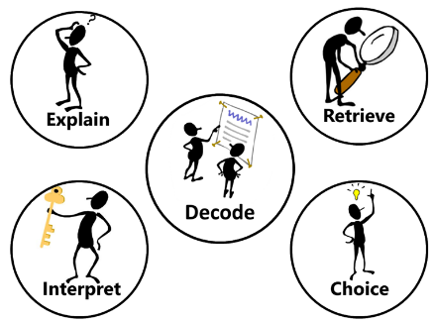
In order to succeed, children have to be proficient users of their phonetic knowledge and be able to read the text and then use their wider knowledge to comprehend the content of each book. Our whole school strategy has a consistent approach by focussing on 7 key strands to embed word reading and comprehension: Decode, Explain, Retrieve, Interpret, Choice, Perform and Review.
Reading Strand | Content
Decode | Using synthetic Phonics (Letters and Sounds) to segment and blend words together. Use knowledge of morphology and etymology to read aloud and understand new words.
Explain | Explaining new vocabulary and understanding its use in context.
Retrieve | Retrieving information using skimming and scanning techniques to locate key vocabulary.
Interpret | Interpreting information using clear evidence from the text.
Choice | Thinking about authorial intent including layout of text use of images and illustrations.
Perform | Performing poetry, fiction and plays as an individual or groups to their peers.
Review | Discuss and compare books they have read.

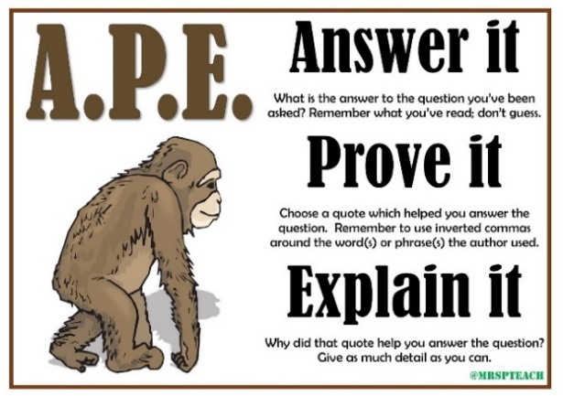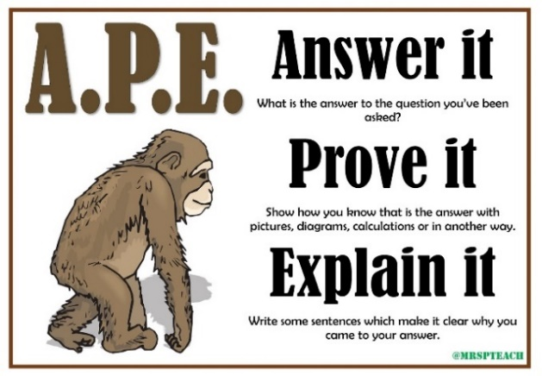
To aid comprehension, Highwood has adopted the acronym of APE – Answer it, Prove it, Explain it. This structure is designed to structure children’s thought process when explaining their thinking, particularly when asked to use evidence from the text. To help further embed this concept, we also use it to structure our mathematical reasoning explanations:

Reading is prioritised on the timetable across the whole school. Each morning from 9:00am to 9:30am, children have a reading slot on the timetable to practise Phonics (EYFS, Year 1, 2 and 3) and Whole Class Reading in (Year 4, 5 and 6). Year 2 and 3 also complete Whole Class Reading in the afternoon from 1.00/1.10pm to 1.30/1.40pm. Reading and Writing skills are then built upon and strengthen within topic lessons.

Year 1 National Curriculum Objectives
In Guided Reading sessions, all pupils are expected to:
- Participate in discussions about books by answering questions and exploring ideas.
- Read a range of books from fiction, poetry and non-fiction from range of cultures and traditions.
- Have the opportunity to re-read books to build up their fluency and confidence in word reading.
- With support from the teacher, summarise what they have read so far.
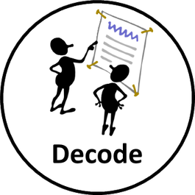  - Learn all of the sounds in phase 3, 4 and 5  - Speedily read all basic phoneme/graphemes at a rate of around 60 words per minute  - Read accurately by blending known GPCs (WRS&S)  - Read common exception words  - Read common suffixes -s, -es, -ing, -ed, -er, and -est  - Read contractions and understand use of apostrophe for omission  - Read multi-syllable words containing known GPCs  - By the end of the year read orange level texts fluently  - Correct inaccurate reading by checking for sense  - Identify and understand why words rhyme | 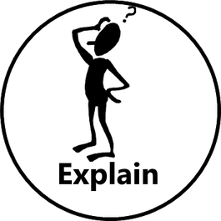  - Discuss the significance of title, front cover, blurb and events  - Understand texts based on prior knowledge or provided information  - Discuss word meaning, linking new meanings to those already known  - Become very familiar with key stories, traditional tales and their story structure.  - With support from the teacher, summarise what they have read so far. |   - Clearly explain their understanding of what is read to them.  - Answer questions by finding the information in the text.
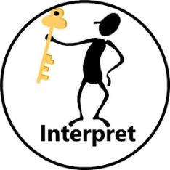  - Link what they read or hear read to their own experiences.  - Make inferences on the basis of what is said and done  - Make predictions based on reading so far  - Answer who, what, why, where, when, how questions based on the story, characters and setting. |   - Discuss the choice of title, front cover, blurb and events.  - Discuss the illustrations and their part in the story. | - Recognise and join in with predictable phrases  - Retell familiar stories and traditional tales through role-play  - Recite some poetry by heart
At the end of each text pupils have the opportunity to review the book, by:
- Discuss the book they have read or listened to.
- Making comparisons with other books they have read.

Year 2 National Curriculum Objectives
In Whole Class Reading sessions, all pupils are expected to:
- Listen to, participate and discuss views on a wide range of poetry, stories and non-fiction
- Read a range of books from fiction, poetry and non-fiction from range of cultures and traditions.
- With support from the teacher, summarise what they have read so far.
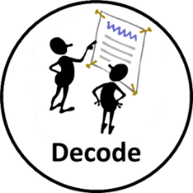  - Continue to apply phonetic knowledge to be able to read most words quickly and accurately without overt sounding and blending  - Read accurately by blending, including alternative sounds for graphemes  - Read accurately words of two or more syllables  - Read fluently using decoding skill at a rate of around 90 words per minute at white level  - Correct inaccurate reading by checking for sense.  - Read most exception words  - Read contractions and understand use of apostrophe for omission and possession  - Read most multi-syllable words containing known graphemes and suffixes  - Recognise simple recurring literary language in stories & poetry | - Apply prior knowledge to understand the text.  - Discuss and clarify the meanings of words, linking new meanings to know vocabulary  - Explain and discuss understanding of a range of reading  - Discuss the significance of title, front cover, blurb and events  - Discuss the sequence of events in books  - Become very familiar with key stories, traditional tales and their story structure.  - With support from the teacher, summarise what they have read so far. | - Sequence events in books by finding the evidence within the text and how items of information are related.  - Answer questions by finding the information in the text.
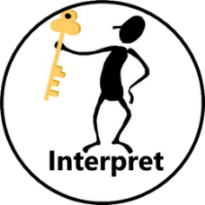  - Apply comprehension skills appropriately to white level texts.  - Apply prior knowledge to answer questions about the text.  - Make inferences on the basis of what is being said and done.  - Predict what might happen based on reading so far  - Answer and ask who, what, why, where, when, how questions based on the story, characters and setting. | - Discuss the choice of title, front cover, blurb and events.  - Discuss the illustrations and their part in the story.  - Discuss author’s purpose and choice for language and structure. | - Build up a repertoire of poems, performing them learnt by heart with appropriate intonation  - Be able to retell; a wide range of stories, including traditional tales.
At the end of each text pupils have the opportunity to review the book, by:
- Make links between the book they are reading and other books they have read.
- Discuss and explain views on a wide range of poetry, stories and non-fiction
Year 3 and 4 National Curriculum Objectives
In Whole Class Reading sessions, all pupils are expected to:
- Participate in discussions about books, building on and challenging ideas
- Read and discuss an increasingly wide range of fiction, poetry, non-fiction, and text books for varying purposes from a range of cultures and traditions.
- Provide reasoned justifications for their views (APE)
- Briefly Summarise what they have read at the end of every session
- Read aloud and understand words based on knowledge of root words, prefixes and suffixes  - Read further exception words, including those with unusual spelling/sound links  - Check that a text makes sense, including explaining the meaning of words in context | - Check that a text makes sense, including explaining the meaning of words in context  - Understand the meaning of words and phrases which capture the reader's interest  - Identify how structure, language and presentation contribute to meaning  - Identify themes and conventions in a range of books (context)  - Use age-appropriate dictionaries to check the meanings of words  - Increasing familiarity with a wide range of books, including traditional tales, myths and legends  - Recognise some different forms of poetry  - Briefly Summarise what they have read | - Retrieve and record information from non-fiction texts  - Answer questions by finding the information in the text.  - Identify and summarise the main ideas drawn from more than one paragraph
- Draw inferences such as infering characters feelings, thoughts and motives from their actions and justify inferences with evidence.  - Predicting what might happen from details stated and implied.  - Asking questions to improve their understanding of the text. | - Discuss words and phrases which capture the reader's interest and why the author chose them.  - Understand the meaning of words and phrases which capture the reader's interest  - Discuss choice of structure and format of text.  - Identify themes and conventions in a range of books (understanding the reason why for the choice made) | - Perform plays and poetry aloud using intonation, tone, volume and action  - Retell some fairy tales or traditional tales orally

At the end of each WCR text pupils have the opportunity to review the book, by:
- Make book recommendations, giving reasons for choices
- Participate in debates about reading

Year 5 and 6 National Curriculum Objectives
In Whole Class Reading sessions, all pupils are expected to:
- Participate in discussions about books, building on and challenging ideas
- Read and discuss an increasingly wide range of fiction, poetry, plays, non-fiction, reference and text books for varying purposes from a range of cultures and traditions.
- Provide reasoned justifications for their views (APE)
- Briefly Summarise what they have read at the end of every session
- Use knowledge of morphology and etymology to read aloud and understand new words. | - Understand what they read by checking the book makes sense to them, discussing their understanding and exploring the meaning of words in context.  - Identify and discuss themes and conventions across a wide range of writing (context)  - Summarise ideas drawn from more than one paragraph, identifying key details  - Use age-appropriate dictionaries to check the meanings of words  - Analyse structure – presentation and language – of different genres and their suitability for purpose |   - Answer questions by finding the information in the text.  - Retrieve, record and present information from non-fiction (happens within the writing and topic lessons)  - Summarise ideas drawn from more than one paragraph, identifying key details (particularly non-fiction)  - Distinguish between statements of fact and opinion
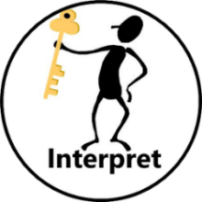  - Ask questions to improve understanding of texts  - Make comparisons within and across books  - Drawing inferences such as characters feelings, thoughts and motives from their actions.  - Drawing inferences from key themes within a book.  - Predict what might happen from details stated and implied. |   - Discuss how authors use language to affect the reader  - Make comparisons within and across books (from author’s point of view)  - Discuss how authors use figurative language to affect the reader  - Identify how the author uses language, structure and presentation contribute to meaning  - Identify and discuss themes and conventions across a wide range of writing (understanding the reason why for the choice made)  - Recognise and discuss authorial choice of the structure of a poem. | - Learn a wide range of poetry by heart  - Prepare poems and play-scripts to read aloud and perform, showing intonation, tone and volume so that the meaning is clear to the audience
At the end of each WCR text pupils have the opportunity to review the book, by:
- Make book recommendations, giving reasons for choices
- Participate in formal presentations and debates about reading

