MAY 2021
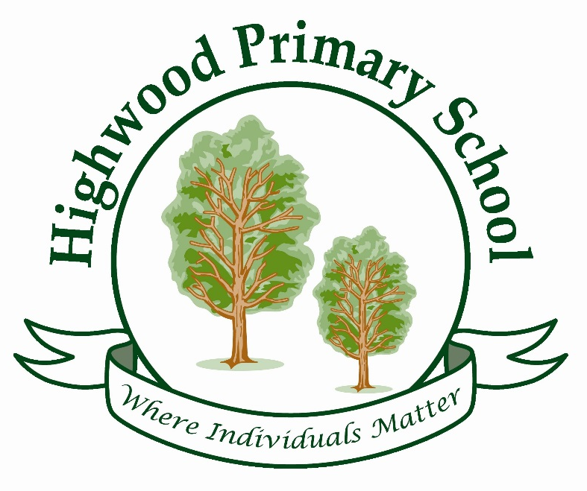
THE BIG IDEAS
HIGHWOOD PRIMARY SCHOOL CURRICULUM STATEMENT
Highwood Curriculum Intent Statement:

Our curriculum has been carefully designed so that knowledge is built upon term by term, year by year and between topics across a variety of year groups. Thus, enabling pupils to gain and retain more knowledge and understanding. We call this Highwood’s 3D curriculum*, which has three key strands:
- Horizontal Links – knowledge secured through repetition term by term
- Vertical Links – Knowledge linked and built upon across all subjects
- Diagonal Links – Knowledge deepened between year groups within subjects

Our aim is for all pupils to leave Highwood having achieved the ‘Big Ideas’ for every subject (see Big Ideas overview). Learning happens through significant Key Questions that allow pupils to look in-depth into topics and make meaningful links between all subjects. To ensure all pupils are successful the curriculum has been planned and organised into a progressive, sequenced model from F1 to year 6. The key questions are implemented through learning loops, logically linking all subjects across a term, year, and then built upon through a pupil’s whole school life at Highwood.
The curriculum content has been shaped by the school’s local surroundings, community and the diversity of individual pupils within the school. Hook events and school trips happen every term to ensure we can immerse the pupils into every key question. There is a key emphasis on broadening and deepening pupils understand of language and vocabulary linked to every subject. Words are pulled apart to understand the origin and provide meaning. There is space within the curriculum to be led by the children’s curiosity and current events happening worldwide.
Underpinning Highwood’s curriculum are our Learning Behaviours: curiosity, perseverance, independence, teamwork, creativity and reflection. These give pupil’s the skills to approach problems and tasks with confidence and enable us to develop lifelong learners.
*The 3D Curriculum model is based on the work by Clare Sealy.
This design of the curriculum will help children know more and remember more.


THE BIG IDEAS OF READING

At Highwood, our curriculum provision is designed to make sure children:
- read easily, fluently and with good understanding
- develop the habit of reading widely and often, for both pleasure and information
- expand their vocabulary through exposure to texts that are aspirational and chosen for their relevance to our pupils and their needs.

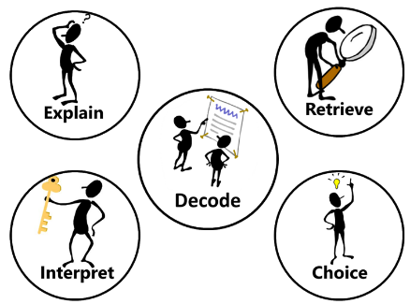
In order to succeed, children have to be proficient users of their phonetic knowledge and be able to read the text and then use their wider knowledge to comprehend the content of each book. Our whole school strategy has a consistent approach by focussing on 7 key strands to embed word reading and comprehension: Decode, Explain, Retrieve, Interpret, Choice, Perform and Review.
Reading Strand | Content
Decode | Using synthetic Phonics (Letters and Sounds) to segment and blend words together. Use knowledge of morphology and etymology to read aloud and understand new words.
Explain | Explaining new vocabulary and understanding its use in context.
Retrieve | Retrieving information using skimming and scanning techniques to locate key vocabulary.
Interpret | Interpreting information using clear evidence from the text.
Choice | Thinking about authorial intent including layout of text use of images and illustrations.
Perform | Performing poetry, fiction and plays as an individual or groups to their peers.
Review | Discuss and compare books they have read.

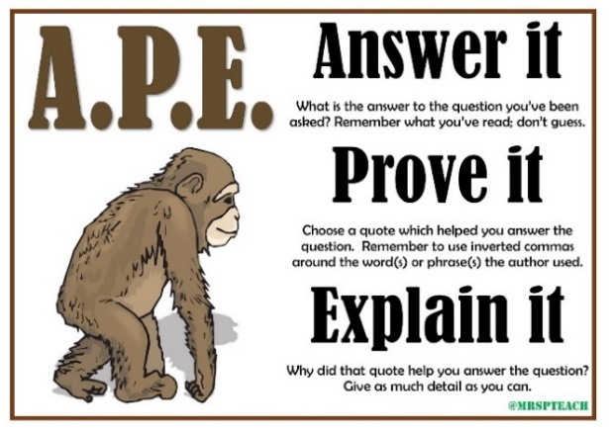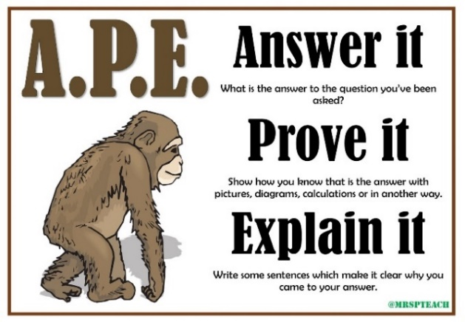
To aid comprehension, Highwood has adopted the acronym of APE – Answer it, Prove it, Explain it. This structure is designed to structure children’s thought process when explaining their thinking, particularly when asked to use evidence from the text. To help further embed this concept, we also use it to structure our mathematical reasoning explanations:

Reading is prioritised on the timetable across the whole school. Each morning from 9:00am to 9:30am, children have a reading slot on the timetable to practise Phonics (EYFS, Year 1, 2 and 3) and Whole Class Reading in (Year 4, 5 and 6). Year 2 and 3 also complete Whole Class Reading in the afternoon from 1.00/1.10pm to 1.30/1.40pm. Reading and Writing skills are then built upon and strengthen within topic lessons.
THE BIG IDEAS OF WRITING
At Highwood, our curriculum provision is designed to make sure children develop the knowledge and skills of:
- transcription (spelling and handwriting)
- composition (articulating ideas and structuring them in speech and writing).

Writing is inspired through the use of quality reading materials that are planned carefully across the school. Highwood’s philosophy is built on a focus of Writing for different purposes (Four in total: Entertain, Inform, Discuss and Persuade) which then contain individual text types within them. For example, writing to inform includes: Letters, Recounts, Explanations Biographies and Instructions etc. In order to transfer the knowledge and skills for each Purpose, irrespective of Text Type, we have identified the knowledge components that will build towards to the composite knowledge.
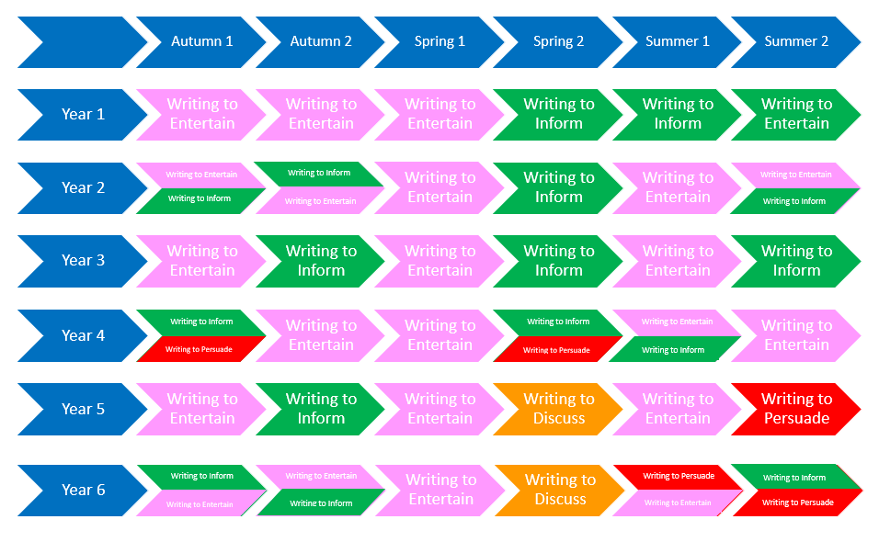
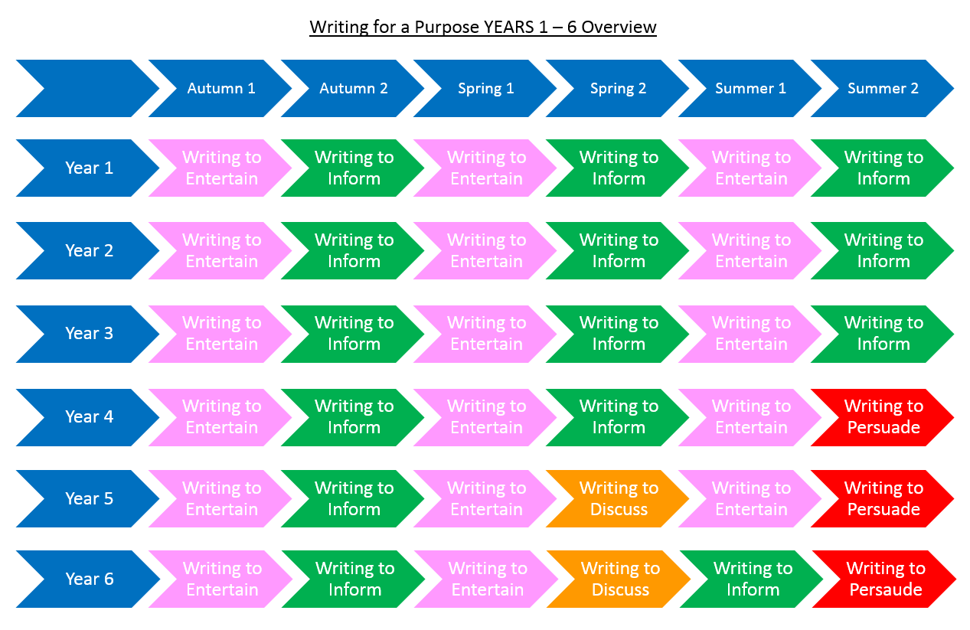
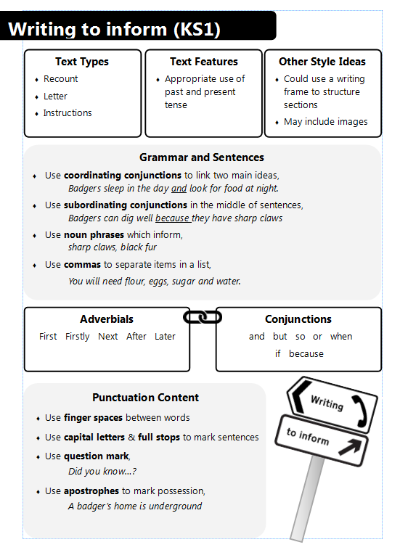

Each piece of writing is linked to the Key Question for the term. The units begin with a cold task relating to the writing purpose. Once the teacher has provided whole class feedback, they then plan the teaching cycle based on the analysis of the assessment data. Children are explicitly made aware of the purpose and audience so that their success criteria can be built around scaffolding high-quality writing with appropriate grammatical and sentence features.

THE BIG IDEAS OF MATHS
At Highwood, our Mathematics curriculum is designed to ensure that all pupils:
- become fluent in the fundamentals of mathematics, including through varied and frequent practice with increasingly complex problems over time, so that pupils develop conceptual understanding and the ability to recall and apply knowledge rapidly and accurately
- reason mathematically by following a line of enquiry, conjecturing relationships and generalisations, and developing an argument, justification or proof using mathematical language
- can solve problems by applying their mathematics to a variety of routine and non-routine problems with increasing sophistication, including breaking down problems into a series of simpler steps and persevering in seeking solutions.
We achieve this by sequencing our learning on a repetitive and progressive cycle, which is replicated in each year group:
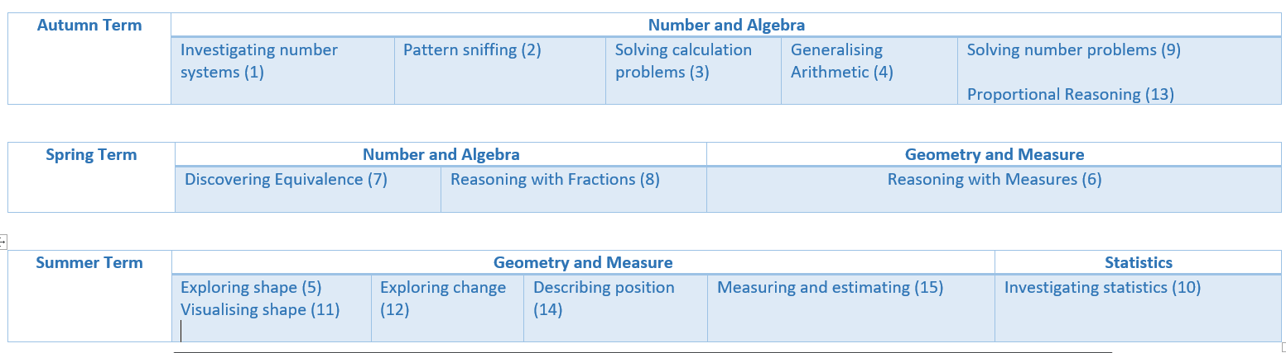
Our philosophy of Teaching for Mastery is achieved through the focus on deep learning of each concept by exposing children to the following lesson flow:

At all stages of the mastery flow, children have the opportunity to develop well thought mathematical reasoning.

Mental Maths is prioritised on the timetable for each year group by having Mental Maths slots in addition to their allocated daily Maths lesson. In EYFS, the focus is on number recognition and counting; KS1 developing a full grasp of number bonds and 2, 5 and 10 times table and KS2 a full grasp of all times tables as well as quick fire strategies to solve arithmetic style questions.

THE BIG IDEAS OF SCIENCE
At Highwood, our Science curriculum aims to ensure that all pupils:
♣ develop scientific knowledge and conceptual understanding through the specific disciplines of biology, chemistry and physics
♣ develop understanding of the nature, processes and methods of science through different types of science enquiries that help them to answer scientific questions about the world around them
♣ are equipped with the scientific knowledge required to understand the uses and implications of science, today and for the future.

This is developed through the planned and repeated coverage of the following key areas:

Physics
P1: The universe follows unbreakable rules that are all about forces, matter and energy.
P2: Forces are different kinds of pushes and pulls that act on all the matter that is in the universe. Matter is all the stuff, or mass, in the universe.
P3: Energy, which cannot be created or destroyed, comes in many different forms and tends to move away from objects that have lots of it.

Chemistry
C1: All matter (stuff) in the universe is made up of tiny building blocks.
C2: The arrangement, movement and type of the building blocks of matter and the forces that hold them together or push them apart explain all the properties of matter (e.g. hot/cold, soft/hard, light/heavy, etc).
C3: Matter can change if the arrangement of these building blocks changes.

Biology
B1: Living things are special collections of matter that make copies of themselves, use energy and grow.
B2: Living things on Earth come in a huge variety of different forms that are all related because they all came from the same starting point 4.5 billion years ago.
B3: The different kinds of life, animals, plants and microorganisms, have evolved over millions of generations into different forms in order to survive in the environments in which they live.

Earth science
E1: The Earth is one of eight planets that orbit the sun.
E2: The Earth is tilted and spins on its axis leading to day and night, the seasons and the climate.
E3: The Earth is made up of several layers, including a relatively thin rocky surface which is divided into tectonic plates, and the movement of these plates leads to many geologic events (such as earthquakes and volcanoes) and geographical features (such as mountains.)

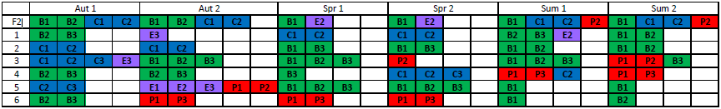
THE BIG IDEAS OF GEOGRAPHY
At Highwood, our Geography curriculum aims to ensure that all pupils have the knowledge and skills to:
- develop contextual knowledge of the location of globally significant places
- understand the processes that give rise to key physical and human geographical features of the world, how these are interdependent and how they bring about spatial variation and change over time
- collect, analyse and communicate with a range of data gathered through experiences of fieldwork that deepen their understanding of geographical processes
- interpret a range of sources of geographical information, including maps, diagrams, globes, aerial photographs and Geographical Information Systems (GIS)
- communicate geographical information in a variety of ways, including through maps, numerical and quantitative skills and writing at length.

This is developed through the planned and repeated coverage of the following key areas:
Location
L1: There are a variety of different countries within the World
L2: There are a variety of different places within the United Kingdom
L3: Places are different depending on their location in the world
Relationships
R1: Humans impact on the physical environment around them
R2: Physical geographical features impact the lives of people
R3: Scale impacts the relationship between human and physical environments
Skills
S1: Maps and atlases can be used to find the locations of places
S2: Compasses can be used to describe position and place
S3: Geographical observations can be made from the environment around us
Environment
E1: Weather and climate are not the same thing
E2: Everyone can have an impact on the environment around them
E3: Small changes can make a difference
 | Autumn |  |  |  |  |  |  |  |  | Spring |  |  |  |  |  |  |  |  | Summer
F2 | L2 | L3 | R1 | R2 | S3 | E2 |  |  |  | L1 | L3 | S1 | R2 | E1
1 | L2 | S1 | S2 | S3 | E1 |  |  |  |  | L2 | L3 | S1 | S2 | E1 |  |  |  |  | L3 | R1 | R2 | S3 | E1 | E2
2 | L2 | L3 | S1 | S2 | S3 | E1 |  |  |  | L1 | L3 | R1 | R2 | R3 | S1 | S3 | E1 |  | L3 | R1 | R2 | R3 | S1 | S2 | S3 | E2 | E3
3 | L2 | L3 | R1 | R2 | S1 | S2 | S3 | E2 |  | L2 | R1 | R2 | S1 | S2 | S3 | E2 | E3 |  | L1 | L2 | L3 | R1 | R2 | R3 | S1 | E1 | E2 | E3
4 | L1 | L3 | R1 | R2 | R3 | S1 | E1 | E3 |  | L1 | L2 | L3 | R1 | R2 | S1 | S3 |  |  | L2 | L3 | R1 | R2 | S1 | S2 | S3 | E1 | E2 | E3
5 | L1 | L3 | R2 | R3 | S1 | S2 | E1 | E2 | E3 | L2 | L3 | R1 | R2 | S1 | S2 | S3 | E2 | E3 | L1 | L3 | R2 | R3 | S1 | E1
6 | L1 | L2 | L3 | R1 | R2 | R3 | S1 |  |  | L1 | L3 | R1 | R2 | R3 | S1 | S2 | S3 | E2 | L1 | L3 | R1 | R2 | S1 | S2 | S3 | E1 | E2 | E3

THE BIG IDEAS OF HISTORY
At Highwood, our History curriculum aims to ensure that all pupils:
- know and understand the history of these islands as a coherent, chronological narrative, from the earliest times to the present day: how people’s lives have shaped this nation and how Britain has influenced and been influenced by the wider world
- know and understand significant aspects of the history of the wider world: the nature of ancient civilisations; the expansion and dissolution of empires; characteristic features of past non-European societies; achievements and follies of mankind
- gain and deploy a historically grounded understanding of abstract terms such as ‘empire’, ‘civilisation’, ‘parliament’ and ‘peasantry’
- understand historical concepts such as continuity and change, cause and consequence, similarity, difference and significance, and use them to make connections, draw contrasts, analyse trends, frame historically valid questions and create their own structured accounts, including written narratives and analyses
- understand the methods of historical enquiry, including how evidence is used rigorously to make historical claims, and discern how and why contrasting arguments and interpretations of the past have been constructed
- gain historical perspective by placing their growing knowledge into different contexts: understanding the connections between local, regional, national and international history; between cultural, economic, military, political, religious and social history; and between short- and long-term timescales
This is developed through the planned and repeated coverage of the following key areas:
Chronology
C1: Timelines can depict any unit of time (hours, days, decades, centuries etc).
C2: Events must be in chronological order to ‘tell a story’ of the past (non-fiction narrative) and are accurate to the time it happened.
C3: Chronological order shows how people’s lives have changed and how they have influenced the present and future.
Significance
S1: Important figures have contributed to society and continue to educate others.
S2: Events, individuals and periods of time have proven to be significant to history.
S3: Understand and use a variety of concrete terms (times, dates, locations etc) and abstract terms (civilisations, parliament etc).
Continuity and Change
CC1: All periods in history will share similarities and differences.
CC2: Events, individuals and periods of time have contributed to change and progress.
Cause and Effect
E1: The past has shaped the present and the present will shape the future.
E2: Understand how history can be applied to different contexts.
Perspective
P1: Events have an impact upon people and places.
P2: History has influenced their own lives and local area.
P3: Understand that sources can be reliable and unreliable and explain the reasons why.
 | Autumn Term |  |  |  |  |  | Spring Term |  |  |  |  |  | Summer Term
 | Chronology (C1, C2 and C3) is covered in each unit for every year group
1 | S2 | CC1 | E1 | P2 |  |  | S1 | S2 | CC1 | CC2 | E1 | P2 | RECAP OF PREVIOUSLY TAUGHT OBJECTIVES
2 | S1 | S2 | S3 | CC1, CC2 | E1 | P1 | S1 | S2 | CC1 | CC2 | E1 | P1 | S1 | S2 | CC2 | E1 | P2
3 | S1, S2 | S3 | CC1 | CC2 | E1 | P2 | CC1, CC2 | S2 | E1 | E2 | P1 | P2 | S2 | S3 | CC1 | CC2 | E1, E2 | P1
4 | S1, S2 | S3 | CC1 | CC2 | E1, E2 | P1 | S1, S2, S3 | CC1 | CC2 | E1, E2 | P1 | P2 | CC1 | E1
5 | S1 | S2 | S3 | CC2 | E2 | P2, P3 | S1, S2, S3 | CC1 | CC2 | E1, E2 | P1 | P2 | S1, S2 | S3 | CC1 | CC2 | E1, E2 | P1
6 | S1, S2 | S3 | CC1 | CC2 | E1, E2 | P1, P2 | S1, S2, S3 | CC1 | CC2 | E1, E2 | P1, P2 | P3 | S1, S2 | CC1 | CC2 | E1 | P1 | P2
THE BIG IDEAS OF COMPUTING
At Highwood, our Computing curriculum aims to ensure that all pupils:
♣ can understand and apply the fundamental principles and concepts of computer science, including abstraction, logic, algorithms and data representation
♣ can analyse problems in computational terms, and have repeated practical experience of writing computer programs in order to solve such problems
♣ can evaluate and apply information technology, including new or unfamiliar technologies, analytically to solve problems
♣ are responsible, competent, confident and creative users of information and communication technology.
This is developed through the planned and repeated coverage of the following key areas:
Computer science
CS1: Algorithms are a collection of commands to complete a task
CS2: Computer algorithms use precise and unambiguous commands (including debug, repetition) to achieve a goal
CS3: Computer algorithms follow a logical sequence
CS4: Computer systems receive information as inputs out return information to the user as outputs
Information technology
IT1: Technology can be used to create and store digital content
IT2: Technology can be used to retrieve, manipulate and organise digital content
IT3: Digital content from different technology can be combined to create new digital content
IT4: Different software is best suited to achieve given goals
IT5: To identify chosen information, you need to create specific search criteria and evaluate the effectiveness of found content
Digital literacy
DL1: Digital content can be shared using a variety of software
DL2: The way we communicate digitally is constantly changing
DL3: Information is passed between devices using networks
Staying safe online
SO1: Not all online content is appropriate
SO2: People will attempt to persuade you through digital content and communication
SO3: Online behaviour has consequences offline
SO4: How to evaluate the potential online risks of your actions
SO5: Where to find support

 | Autumn |  |  |  |  |  |  |  |  |  | Spring |  | Summer
1 | DL2 |  |  |  |  | CS1 |  |  |  |  | CS1 | CS2 | IT1 |  | IT2
2 | IT3 |  | DL1 |  |  | CS3 |  |  | CS1 |  | CS1 | CS2 | CS3 |  | CS4
3 | DL3 | CS3 |  |  | DL1 |  | IT2 |  |  | SO4 | IT3 | IT1 | DL2 | DL3 | CS1 | CS2
4 | CS4 |  |  |  |  | IT4 |  |  |  |  | CS2 | CS3 | CS3 |  | DL3
5 | IT5 |  |  | SO1 |  |  |  | SO5 |  |  | SO3 | DL2 | CS2 |  | CS4
6 | IT2 |  |  |  |  | IT5 |  |  |  |  | CS3 | CS4 | IT1 |  | CS4

THE BIG IDEAS OF ART
At Highwood, our Art curriculum aims to ensure that all pupils:
♣ produce creative work, exploring their ideas and recording their experiences
♣ become proficient in drawing, painting, sculpture and other art, craft and design techniques
♣ evaluate and analyse creative works using the language of art, craft and design
♣ know about great artists, craft makers and designers, and understand the historical and cultural development of their art forms

This is developed through the planned and repeated coverage of the following key areas:

Creativity
C1 express their ideas and explore ways to achieve it
C2 choose suitable effects for the desired outcome
Exploration of media
E1 there are 6 different mediums that can be used
E2 the different effects that can be created using the different mediums
E3 know different ways of using the different media
Analyse and evaluate
A1 identify what techniques have been used
A2 make links between own work and artists work
A3 to communicate their own opinions about their work and others
Significant artists
S1 to know well known artists for specific media
S2 know key facts about the artist and their influences
S3 know what techniques were used and what effects they made

Every skill is covered across every unit in each term (Autumn, Spring, Summer), in every year group.

THE BIG IDEAS OF MUSIC
At Highwood, our Music curriculum aims to ensure that all pupils:
♣ perform, listen to, review and evaluate music across a range of historical periods, genres, styles and traditions, including the works of the great composers and musicians
♣ learn to sing and to use their voices, to create and compose music on their own and with others, have the opportunity to learn a musical instrument, use technology appropriately and have the opportunity to progress to the next level of musical excellence
♣ understand and explore how music is created, produced and communicated, including through the inter-related dimensions: pitch, duration, dynamics, tempo, timbre, texture, structure and appropriate musical notations.

This is developed through the planned and repeated coverage of the following key areas:
Perform and Share
P1: Understanding that audience and purpose are vital to a performance
P2: Performance can be improved through practice, feedback and discussion
P3: To know the effects of performing as a solo or ensemble
Appreciation
A1: Know the name and features of different musical genres
A2: The names of key composers and musicians and the effect they have had on the musical world
A3: Recognise and name different instruments and the sounds they make
A4: Know the vocabulary needed to describe and evaluate music
Play, Sing and Create
PSC1: Understand how pitch, duration, dynamics, tempo, timbre, texture, structure impact on music
PSC2: Learn to sing and to use voices
PSC3: To understand how the sounds of instruments can create different musical outcomes
PSC4: Create sounds and music using the interrelated dimensions of music
PSC5: To know appropriate musical notations. (KS2)
Technology
T: To understand that music can be recorded and created in different ways

 | Autumn |  |  |  | Spring |  |  | Summer
1 | A1 A2 A3 A4 | PSC1 PSC2 PSC4 | P1 P2 |  | A1 A2 A3 A4 | PSC1 PSC2 PSC3 PSC4 | P1 P2 | A1 A2 A3 A4 | PSC1 PSC2 PSC4 | P1 P2
2 | A1 A2 A3 A4 | PSC1 PSC2 PSC3 PSC4 | P1 P2 P3 |  | A1 A2 A3 A4 | PSC1 PSC2 PSC4 | P1 P2 | A3 A4 | PSC1 PSC2 PSC3 PSC4 | P2
3 | A1 A2 A3 A4 | PSC1 PSC3 PSC4 PSC5 |  |  | A4 | PSC2 PSC3 PSC5 | P1 P2 P3 | A1 A2 A3 A4 | PSC2PSC3 PSC4 | P1 P2 P3 | T1
4 | A1 A2 A3 A4 | PSC1 PSC2 PSC3 PSC4 PSC5 | P1 P2 |  | A1 A2 A3 A4 | PSC2 PSC3 PSC5 | P1 P2 P3 | A1 A2 A3 A4 | PSC2 PSC3 PSC5 | P1 P2 P3
5 | A1 A2 A3 A4 | PSC1 PSC2 PSC3 PSC4 PSC5 | P1 P2 P3 |  | A1 A2 A3 A4 | PSC1 PSC3 PSC4 | P1 P2 | A1 A2 A3 A4 | PSC1 PSC2 PSC4 | P1 P2
6 | A1 A2 A3 A4 | PSC1 PSC2 PSC3 PSC4 | P1 P2 | T1 | A1 A2 A3 A4 | PSC1 PSC2 PSC4 PSC5 | P2 | A1 A2 A3 A4 | PSC1 PSC2 PSC4 | P1 P2 P3
THE BIG IDEAS OF DT
At Highwood, our DT curriculum aims to ensure that all pupils:
♣ develop the creative, technical and practical expertise needed to perform everyday tasks confidently and to participate successfully in an increasingly technological world ♣ build and apply a repertoire of knowledge, understanding and skills in order to design and make high-quality prototypes and products for a wide range of users
♣ critique, evaluate and test their ideas and products and the work of others
♣ understand and apply the principles of nutrition and learn how to cook.

This is developed through the planned and repeated coverage of the following key areas:
Research
R1. Research is important before developing a product
R2. Audience and purpose (for the end product) must be considered
R3. Ideas can be developed and re-drafted, using feedback from discussions
R4. Know where food comes from (KS1)
R5. Understand what makes a healthy and varied diet
R6. Understand how to reinforce a structure
Design and Create
DC1. There are a range of tools/ cooking tools can be used to create an outcome and these outcomes are different for each tool
DC2. Different materials have different functional properties and aesthetic qualities
DC3. Understand how mechanical systems works e.g. gears, pulleys, cams
DC4. Use knowledge from other subjects, e.g. circuits in science or ICT to control, to enhance products
Evaluate
E1. Understand the importance of evaluating products at all stages, using feedback when appropriate
E2. Know how to take on feedback in order to make a product better
E3. Key events and individuals have helped shape the world
 | Autumn Term |  |  |  |  |  | Spring Term |  |  |  |  |  | Summer Term
1 | R1 | R2 | R4 | DC1 | DC2 | DC4 | R1 | R3 | R6 | DC2 | E1 | E2 | See Art Big Ideas
2 | R1 | R3 | DC2 | E1 | E2 | E3 | R1 | R2 | R3 | DC1 | DC2 | E1 | R2 | R4 | R5 | DC1 | E1
3 | R1 | R2 | DC1 | DC4 | E3 |  | R1 | R3 | DC1 | DC2 | DC4 | E3 | R1 | R2 | R3 | R6 | DC1 | DC2
4 | R1 | R6 | DC2 | DC4 | E1 | E3 | R1 | R2 | R3 | DC2 | DC4 | E2 | R1 | R3 | R4 | DC1 | DC2 | DC3
5 | R2 | DC1 | DC2 | DC3 | DC4 | E1 | R1 | R2 | R3 | DC2 | DC4 | E3 | See Art Big Ideas
6 | R1 | R2 | R3 | DC3 | DC4 | E3 | R1 | R2 | R3 | DC2 | DC4 | E3 | R1 | R2 | R3 | DC2 | E1 | E2

THE BIG IDEAS OF PE
At Highwood, our PE curriculum aims to ensure that all pupils:
♣ develop competence to excel in a broad range of physical activities
♣ are physically active for sustained periods of time
♣ engage in competitive sports and activities
♣ lead healthy, active lives.
Performance-Skills developed using fundamental and sports specific activities.
Control-To develop skills that enable children to control objects using a range of equipment
Pass & receive-To develop abilities to pass and receive a range of objects including different types of balls, beanbags and quoits using various items of equipment
Target-To develop skills necessary to hit targets using a range of methods such as throwing and striking
Invasion-To develop key skills in small group games encouraging spacial awareness, strategy, positioning, stealing possession and competition.
Balance & Coordination-To develop movement, strength, shape and balance using Gymnastics, dance and strategy games
Competition
Children are given the opportunity to represent Highwood in a range of sporting competitions within the National School Games, Woodley Sports Week, Woodley Carnival & various invitational leagues (Football, Tag Rugby, Athletics & Cricket). This promotes both our gifted and talented children along with our “Activities For All” ethos.
Leading Healthy lives
Health & Fitness-At the beginning of each academic year, children are given a range of activities within a circuit’s suite, to test their overall strength, agility and fitness. Also covering the respiratory system, heart & muscle groups, keeping fit and choosing a healthy diet. KS2 record data to show progress over a 4-week period.
In Summer 1 the children are given a range of activities within the athletics suite to further show their progress in their Strength, agility and fitness. KS2 record the data and this forms the basis of our “Quadkids” team” at the Wokingham Schools Games.
Teamwork/Confidence/leadership/Communication Children are given the opportunity to work on these vital “life Skills” in preparation for life after education. This can occur during the warm up (children encouraged to lead their peers through the warm up thus building confidence and good communication, speaking in front of a group of people. House Captains are chosen which helps develop leadership skills. Within PE lessons, leaders are chosen within groups to help develop their own leadership style. Team work is a constant in our lessons right from getting changed into their PE kits improving changing times to increase learning time for rewards such as house points.
Swimming
KS2 children are given the opportunity to attend swimming lessons for half a term each working from non-swimmers to competition swimmers. The aim is to have all children leaving KS2 with the ability to swim 25 meters.
Dance
KS1 children are taught dance for a whole half term working on shape, poise, timing, creativity, tempo, rhythm and teamwork. Routines will be mastered in groups with individuality included with freestyle opportunity. These will be based on the current year groups topic subject i.e. “The Great Fire Of London” for year 2s.

This is developed through the planned and repeated coverage of the following key areas:

THE BIG IDEAS OF MFL
At Highwood, our PE curriculum aims to ensure that all pupils:
♣ understand and respond to spoken and written language from a variety of authentic sources
♣ speak with increasing confidence, fluency and spontaneity, finding ways of communicating what they want to say, including through discussion and asking questions, and continually improving the accuracy of their pronunciation and intonation
♣ can write at varying length, for different purposes and audiences, using the variety of grammatical structures that they have learnt
♣ discover and develop an appreciation of a range of writing in the language studied.

This is developed through the planned and repeated coverage of the following key areas:

Oracy
O1: there are a variety of different languages spoken across the World
O2: creating phrases and sentences help us to engage in simple conversations to obtain and provide information and exchange opinions.
O3: pronunciation and intonation and how these influence meaning.
O4: Strategies explored in language lessons can also be used for learning in other subjects.

Literacy
L1: the relationship between sounds and letters/characters can be applied to reading and writing.
L2: simple sentences and short texts are written for different purposes and audiences.
L3: rules and patterns inform the word order in sentences.

Intercultural understanding
IU1: different countries where other languages are spoken have different cultures and traditions.
IU2: there are similarities and differences between peoples, their daily lives, beliefs and values.
IU3: words used in other languages are incorporated into English.

 | Autumn |  |  |  | Spring |  |  |  | Summer
3 | O1 | O4 | IU1 | IU3 | L1 | O3 | L2 |  | O2 | IU1 | L3
4 | L1 | L2 | O1 | IU3 | O3 | L1 | L3 | IU2 | O2 | L2 | IU1
5 | O2 | O3 | L2 | IU1 | O2 | L1 | IU1 | O1 | L2 | IU2 | O2
6 | O2 | L1 | L3 | IU2 | O3 | O4 | L1 | IU1 | O2 | O3 | L2 | IU2

THE BIG IDEAS OF PSHE

At Highwood, our PSHE curriculum aims to ensure that all pupils develop an understanding of:

Health and wellbeing:
HW1: To know what foods make up a balanced diet.
HW2: To know that regular exercise contributes to a sense of wellbeing.
HW3: To know how to access support for emotional needs and mental health, including strategies to manage our own emotional responses safely.

Relationships
R1: To know what to do if contact with somebody makes me feel unsafe or uncomfortable.
R2: To know what constitutes a healthy relationship including; friendships, families and sexual relationships.
R3: To know how human reproduction works.

Living in the wider world
LWW1: To know the importance of managing money.
LWW2: To know that we have a responsibility to take care of our environment.

Managing risks- Also see computing coverage. This learning should happen in the context of ICT interaction.
MR1: To know how to keep safe online.
MR2: To know what to do if something unwanted appears online.
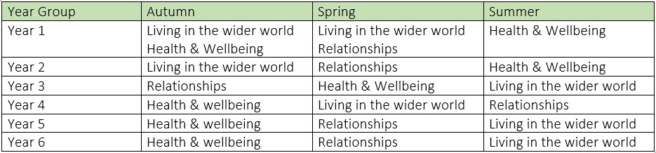
Rights and responsibilities
RR1: To know what democracy is.
RR2: To know that we are accountable for our actions.
RR3: To know that the UN Convention on the Rights of a Child protects our rights.

 | Aut 1 |  | Aut 2 |  | Spr 1 |  | Spr 2 |  | Sum 1 |  | Sum 2
1 | RR2 | LWW2 | MR1 | MR2 | LWW1 |  | R2 | HW3 | HW1 | HW2 | HW3
2 | LWW2 |  | LWW2 |  | R1 |  | R2 | RR2 | HW1 | HW2 | HW3
3 | R2 | RR2 | R1 |  | HW1 | HW2 | HW3 |  | LWW1 |  | LWW2
4 | HW1 | HW2 | HW3 |  | LWW2 |  | LWW1 |  | R2 | RR2 | R1
5 | HW1 | HW2 | HW3 |  | R2 | RR1 | R1 | RR3 | LWW1 | RR2 | LWW2
6 | HW1 | HW2 | HW3 |  | R2 | R1 | R3 |  | LWW2 |  | LWW1

