OCTOBER 2019
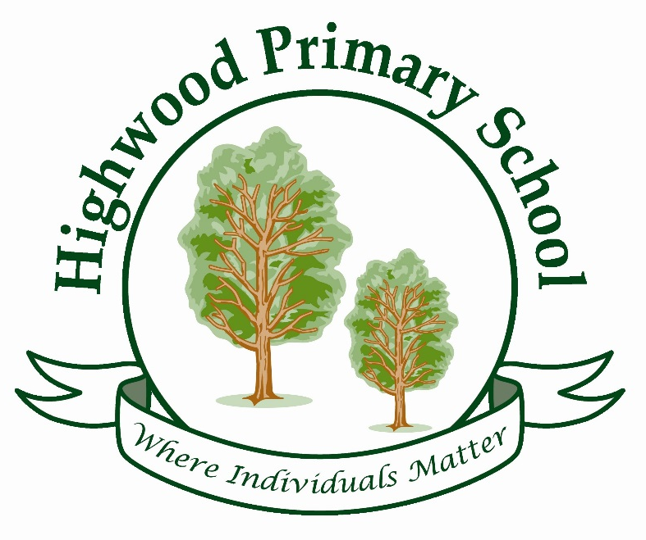
THE BIG IDEAS
HIGHWOOD PRIMARY SCHOOL CURRICULUM STATEMENT

Curriculum Design - Highwood’s school curriculum has been designed to make sure our children are able to meet the school’s vision using the concept that we collectively refer to as our 3D curriculum.

This concept is planned through:
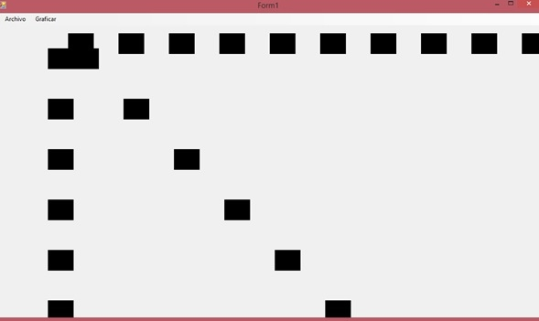
Vertical links - planned links between topics, concepts, vocabulary etc in each year group

Horizontal links - planned links between topics, concepts, vocabulary etc in subjects across the whole school.

Diagonal Links - planned links between topics, concepts, vocabulary etc in multiple subjects areas in multiple year groups.

In order to our curriculum to have an impact on learners’ long-term memory, at Highwood we focus on the ‘Big Ideas’ (the composite knowledge in each curriculum area), so that key components of learning are planned to be constantly revisited and the children’s conceptual understanding deepens as a result.
This design of the curriculum will help children know more and remember more.



THE BIG IDEAS OF ART
At Highwood, our Art curriculum aims to ensure that all pupils:
♣ produce creative work, exploring their ideas and recording their experiences
♣ become proficient in drawing, painting, sculpture and other art, craft and design techniques
♣ evaluate and analyse creative works using the language of art, craft and design
♣ know about great artists, craft makers and designers, and understand the historical and cultural development of their art forms

This is developed through the planned and repeated coverage of the following key areas in ALL year groups across ALL terms:
Significant artists
S1 to know well known artists for specific media
S2 know key facts about the artist and their influences
S3 know what techniques were used and what effects they made
Exploration of media
E1 there are 6 different mediums that can be used – painting, sketching, printing, paper and paste, sculpting, textiles
E2 the different effects that can be created using the different mediums
E3 know different ways of using the different media
Creativity
C1 express their ideas and explore ways to achieve it
C2 choose suitable techniques for the desired outcome
Analyse and evaluate
A1 identify what techniques have been used
A2 make links between own work and artists work
A3 to communicate their own opinions about their work and others using accurate language

Stage of learning | Big Ideas Covered
Appreciation of significant artist | S1 | S2 |  | S3 |  | A1 |  | A3
Exploring and developing ideas | E1 |  | E3 |  |  |  | S3
Investigating and making art | E2 |  | C1 |  |  |  | C2
Creating a contextualised final piece | C1 |  |  |  | C2
Evaluating and developing art | A1 |  | A2 |  |  |  | A3

