Year 1 – Autumn – Where in the world am I?  - To use a range of materials creatively to design and make products  - To use drawing, painting and sculpture to develop and share their ideas, experiences and imagination  - To develop a wide range of art and design techniques in using colour, pattern, texture, line, shape, form and space  - About the work of a range of artists, craft makers and designers, describing the differences and similarities between different practices and disciplines, and making links to their own work. |  |  |  | Artist: | Henri Mattise
 |  |  |  | Media: | Paper and paste
 |  |  |  | Technique: | Collage
 |  |  |  | Key Vocab: | Tissue paper, texture, smooth, layered, transparent, shape form, technique, torn, cut,
 |  |  |  | 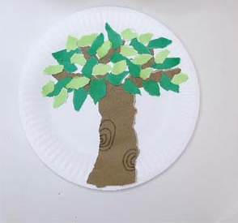
Objective and Success Criteria | Coverage | Key Questions | children should be able to |  |  | Resources
Appreciation  (context –Henri Mattise)  To describe what techniques an artist has used  To explore some of the artist’s techniques in my own work  Big Ideas: S1, S2, S3, A1, A3 | - Discuss what is an artist with the children  - Find out about the artist’s background.  - Find out what materials and techniques the artist mainly used  - Look at a variety of the artists art work and discuss similarities and differences between the pieces  - Children to discuss what they like and dislike about the art. | - Can anyone be an artist?  - What does an artist do?  - What materials did the artist mainly use?  - Are there any themes within the work?  - What is similar about the art?  - What is difference between the pieces?  - What do you like about the art? Why? | - Say what art medium the artist used  - Say what themes run through the art  - Say what they like about the art giving a reason |  |  | Twinkl Henri Mattise powerpoint  Selection of Henri Mattise art work  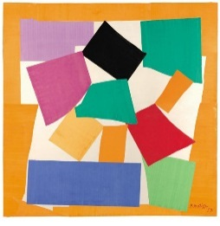
Exploring and developing ideas:  To explore some of the artist’s techniques in my own work  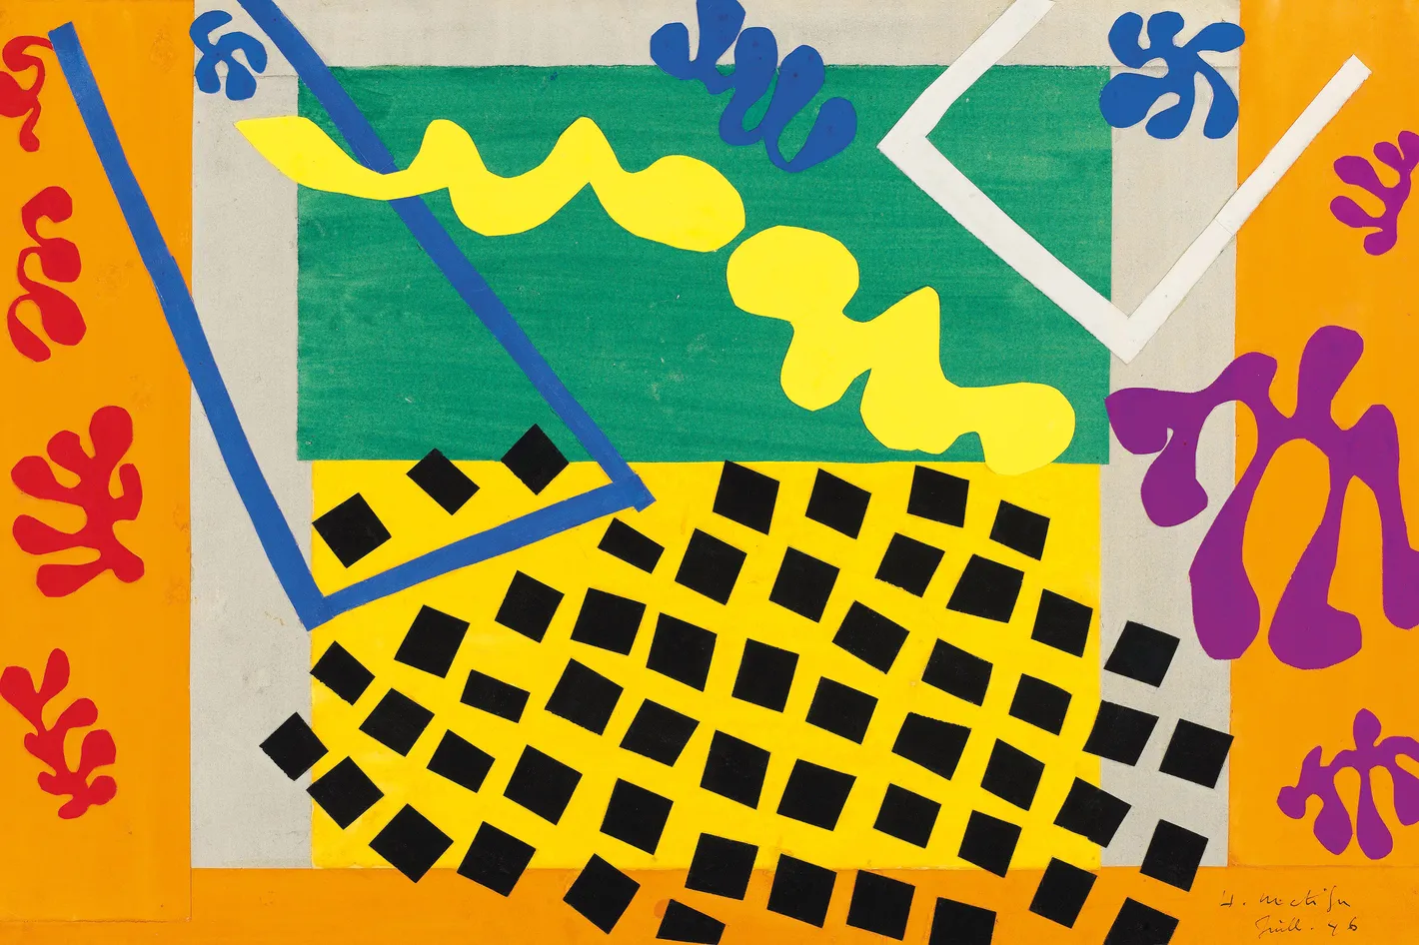  To create different shapes with torn paper  Big Ideas: E1, E3, S3 | - Look at Henri Mattise snail collage. Discuss how paper has been used by the artist to create the piece  - Using coloured paper children to explore different effects that can be created using torn paper e.g. scrunching, folding, layering,  - Discuss what effect the different methods create (think about texture and the way it looks)  - Explore different types of paper and use the same methods. Discuss if the effect is different depending on the paper | - What different effects can be creating by using paper in different ways  - Which methods are easy to use? Which ones are harder?  - How would you attach the paper to a background?  - Does the effect change depending on the type of paper?  - Which paper is best for each method? Why? | - Say what different methods they have investigated  - Explain what effects can be created by using the different methods  - Explain which method they would use for a specific effect |  |  | Tissue paper  Crepe paper  textured paper  glue  paper background
Investigating and making art:  To discuss and develop ideas about how to create and attach torn tissue paper  Big Ideas: E2, C1, C2 | - Explore different ways of attaching paper to background e.g. tape, prit stick, PVA glue  - Decide which method would be best to use and why  - Introduce the idea of making a tree collage. Explore what a tree looks like. Look at different types of trees and look for similarities and differences. Discuss what the main feature are of a tree  - Children to choose a type of tree to make a collage of. Children to sketch the outline of their tree ensuring they are including the key features identified. Children to plan what type of paper they will use and explain why they have chosen it. Children plan what method of attaching paper they will use and which technique of tearing paper they will use. | - Which method of attaching the paper worked best? Why?  - What are the key features of a tree?  - Which techniques of paper tearing would be best to use? Why?  - What type of paper will you use? Why? | - Say what methods have been explored to attach paper  - Say what method of attachment is best and why  - Say what key features should be included in their design  - Sketch the outline of a tree using sketch pencils  - Plan a piece of art before starting considering what material are best to use and why
To create a paper collage  (Context – Tree)  Big Ideas: C1, C2 | - Children to use their plan to make their tree collage  - Use their initial sketch to draw their outline on their background  - Use the different types of paper identified on their plan for the different parts of the tree  - Use their chosen attachment method throughout the process  - Ensure that correct colours and textures are used for the different parts of the tree. | - What materials do I need for each part of my tree?  - What attachment method will I use?  - What background colour will I use?  - What method of paper shaping will I use? | - Produce a realistic collage tree  - Say what materials and attachment methods they used  - End product should be of high quality
Evaluating and developing art:  To discuss how you feel about your art work  Big Ideas: A1, A2, A3 | - Discuss what reflection is  - Talk partner work to discuss what things went well, why are you proud of your work?  - Encourage the children to think about why they like a particular aspect of their work relating to what impact it has had on their finished product.  - Discuss how in order to get better at something we now have to reflect on what we could change for next time.  - Talk partner work to discuss one thing that they would do differently next time. Encourage the children to think but why they would change that aspect and impact it would have on their finished product | - What do you like about your finished product? Why?  - What would you do differently next time?  - Would you use the same types of paper? Why?  - Would you use the same attachment method? Why? | - Say what they like about their work and why  - Say with they would do differently next time to improve it and why
Assessment Questions
What Media and techniques is Henri Mattise known for?
What different techniques can be used for using paper?
What different effects do the techniques create?
How can you create a detailed collage using tissue paper?

Year 1 – Spring – Will we still play with the same toys when we are older?  - To use a range of materials creatively to design and make products  - To use drawing, painting and sculpture to develop and share their ideas, experiences and imagination  - To develop a wide range of art and design techniques in using colour, pattern, texture, line, shape, form and space  - About the work of a range of artists, craft makers and designers, describing the differences and similarities between different practices and disciplines, and making links to their own work. |  |  | Artist: | Kandinsky
 |  |  | Media: | Painting
 |  |  | Technique: | Colour mixing
 |  |  | Key Vocab: | Brushes, effect, mixing, secondary, technique, colour, tone
 |  |  | 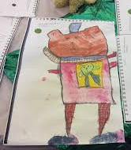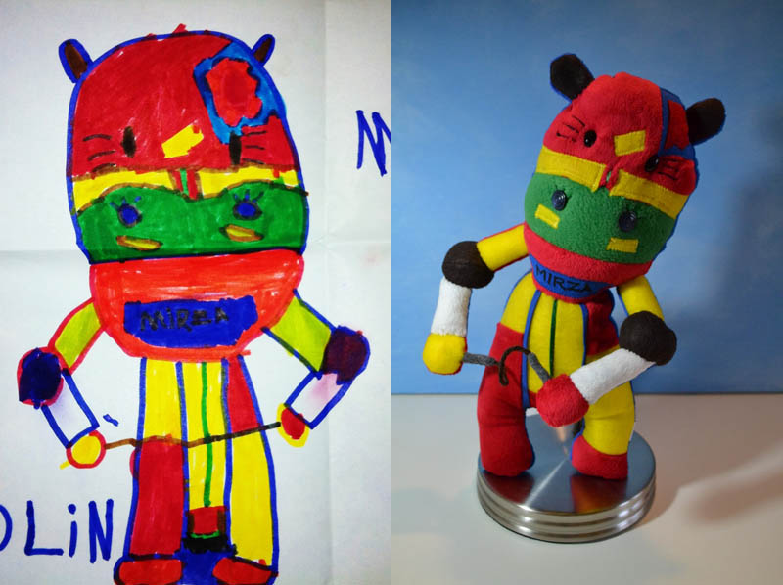
Objective and Success Criteria | Coverage | Key Questions | children should be able to |  | Resources
Appreciation  (context –Kandinsky)  To describe what techniques an artist has used  To explore some of the artist’s techniques in my own work  Big Ideas: S1, S2, S3, A1, A3 | - Find out about the artist’s background.  - Find out what materials and techniques the artist mainly used  - Look at a variety of the artists art work and discuss similarities and differences between the pieces  - Children to discuss what they like and dislike about the art. | - What materials did the artist mainly use?  - Are there any themes within the work?  - What is similar about the art?  - What is difference between the pieces?  - What do you like about the art? Why? | - Say what art medium the artist used  - Say what themes run through the art  - Say what they like about the art giving a reason |  | - Kandinsky – useful background information about the artist  - Kandinsky power point from Twinkl  - Worksheet to structure looking at the artists work  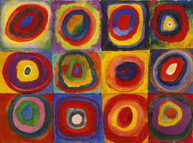
Exploring and developing ideas:  To be able to recognise primary colours and understand they are the basis for all colour theory  To investigate different mark making techniques using brushes  Big Ideas: E1, E3, S3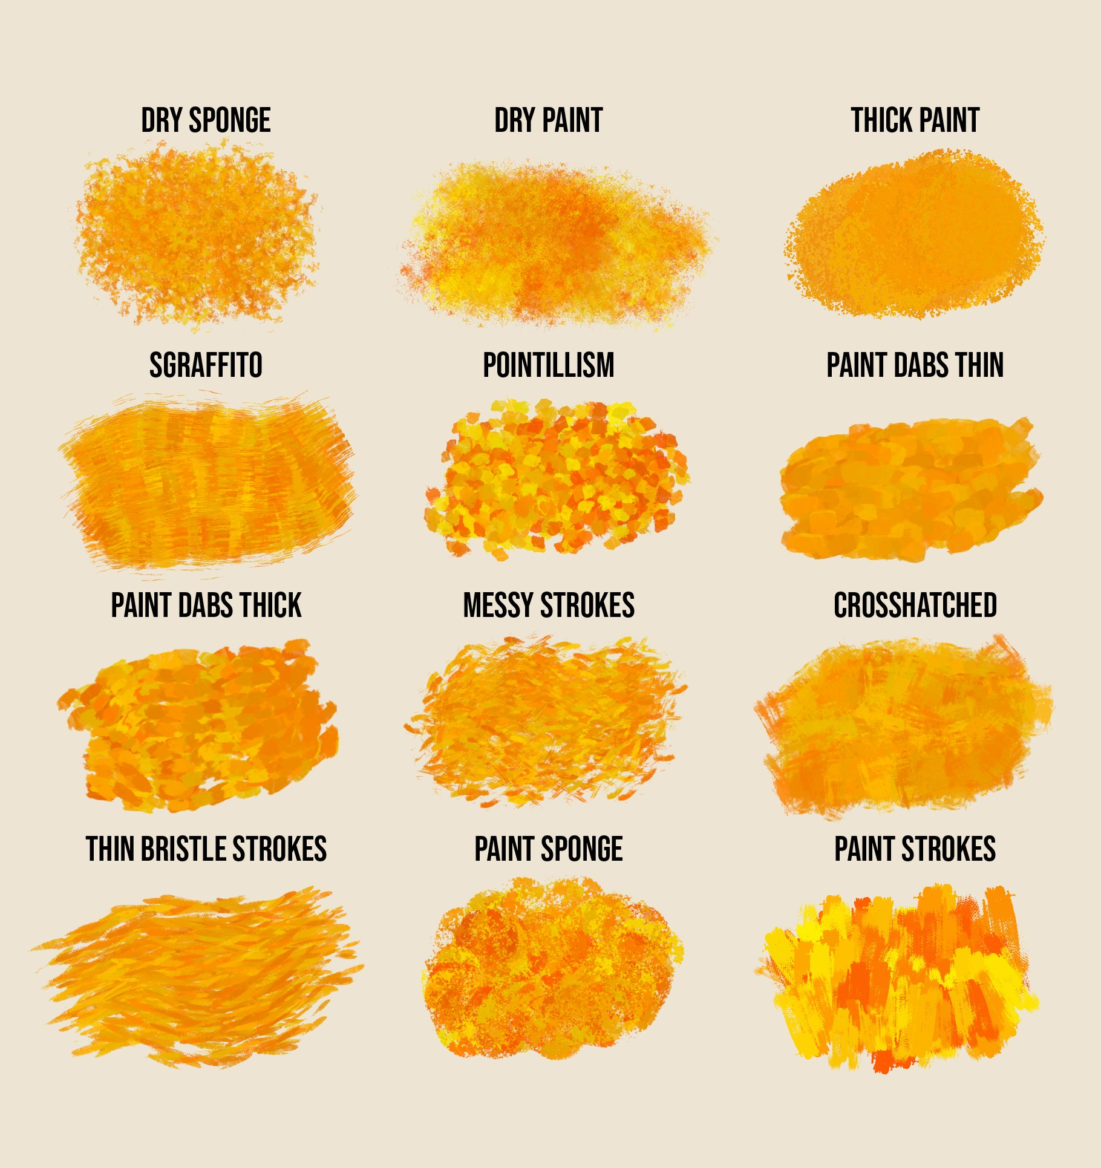 | - Look at Kaninsky’s circles  - Discuss what different colours have been used  - Children to explore paint by using a variety of paint brush thicknesses. Try out different techniques – sweeping, stippling, flicking, try using cotton buds, sponges?  - Children to explore the different types of colours primary and secondary colours.  - Children to add primary colours to their colour wheels in the front of their sketchbooks. | - How do you think the artist created the different colours?  - What different shades of colours are there?  - How do you achieve lighter shades? | - Explain and name what primary colours are  - Know that you can create different shades of these colours and how you could achieve it |  | - Kandinsky circles art work  - Colour wheel template (twinkl)  - Poster paint  - Variety of paint brushes  - Sponges  - Cotton buds
Investigating and making art:  To be able to sketch and paint familiar objects applying mixing and matching skills  Big Ideas: E2, C1, C2 | - Children should draw their favourite toy from first hand observations looking carefully at the shapes of their toy. Children should be encouraged to use light sketching action when completing their picture  - Children to think and plan what colours they will need to complete the picture. | - Which would be best to make a painting of a toy? Why?  - What shapes are there in the outline of your toy?  - How do you use the pencil when you are sketching?  - What colours will you need?  - Do you need different shades of the same colour? How will you achieve it? | - What different effects can be created using the different painting resources  - Say which painting resources they will use and why  - Say what shapes make u their toy they are using  - Say what colours they will need to use and how they plan to make them |  | - Sketching pencils  - Paper  - Favourite toy picture  - Poster paint  - Various painting resources e.g. different sized brushes, sponges etc  - Planning sheet
To create a painting  (Context – favourite toy)  Big Ideas: C1, C2 | - Children to use their first sketch of their toy to draw an outline of their toy ready for painting  - Children to use their plan to decide what would be best to paint first e.g. the details, the background colour  - Children to spend time using the water colours, their plan and their picture of their favourite toy to paint their toy. Children to consider what effects they want to create for different parts of their toy to show the texture of their toy. | - What would be best to paint first? why?  - What brush techniques will you use for each part of your painting? Why?  - How will you make the different colours needed? | - Draw a light outline of their chosen toy  - Use water colours effectively to make the different shades needed for their picture  - Use different brush techniques to create different effects and texture within their painting |  | Thick Paper  Water colours  Various different painting brushes resources  Picture of toy
Evaluating and developing art:  To discuss how you feel about your art work  Big Ideas: A1, A2, A3 | - Discuss what reflection is  - Talk partner work to discuss what things went well, why are you proud of your work?  - Encourage the children to think about why they like a particular aspect of their work relating to what impact it has had on their finished product.  - Discuss how in order to get better at something we now have to reflect on what we could change for next time.  - Talk partner work to discuss one thing that they would do differently next time. Encourage the children to think but why they would change that aspect and impact it would have on their finished product | - What do you like about your finished product? Why?  - What would you do differently next time?  - Would you use the same colours? Brush techniques?  - Did you use the whole page? | - Say what they like about their work and why  - Say with they would do differently next time to improve it and why
Assessment Questions
What Media and techniques is Kandinsky known for?
How are secondary colours made? Why are they known as secondary colours?
How can different tones and shades of colours be made?

Year 1 – Summer – Which animal would you invite to tea?  - To use a range of materials creatively to design and make products  - To use drawing, painting and sculpture to develop and share their ideas, experiences and imagination  - To develop a wide range of art and design techniques in using colour, pattern, texture, line, shape, form and space  - About the work of a range of artists, craft makers and designers, describing the differences and similarities between different practices and disciplines, and making links to their own work. |  |  |  | Artist: | William Morris
 |  |  |  | Media: | Printing
 |  |  |  | Technique: | Block printing
 |  |  |  | Key Vocab: | Print, block, pattern, polystyrene tile, repeat, colour, detail, in boss
 |  |  |  | 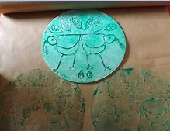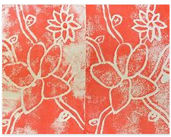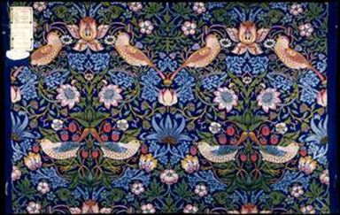
Objective and Success Criteria | Coverage | Key Questions | children should be able to |  |  | Resources
Appreciation  (context –William Morris)  To describe what techniques an artist has used  To explore some of the artist’s techniques in my own work  Big Ideas: S1, S2, S3, A1, A3 | - Find out about the artist’s background.  - Find out what materials and techniques the artist mainly used  - Look at a variety of the artists art work and discuss similarities and differences between the pieces  - Children to discuss what they like and dislike about the art. | - What materials did the artist mainly use?  - Are there any themes within the work?  - What is similar about the art?  - What is difference between the pieces?  - What do you like about the art? Why? | - Say what art medium the artist used  - Say what themes run through the art  - Say what they like about the art giving a reason |  |  | Twinkl William Morris powerpoint  Selection of William Morris art work  Fact sheet about the artist
Exploring and developing ideas:  To make a clean print  To print a repeated pattern  Big Ideas: E1, E3, S3 | - Look William Morris work with animals in. discuss what is similar and different about the pieces  - Children to remind themselves of what printing they did in Foundation. Children to think about what techniques they used to make a print and what the print looked liked.  - In pairs children to explore how to make a good clean print. Children to consider what they need to bear in mind when they make their own print. Children to try pressing into a polystyrene tile and printing with it – testing how much paint they will need/how much pressure to apply/what colours they will use. | - What was similar and different about William Morris art work based on animals?  - How did you make prints in Foundation  - What do you need to remember about using polystyrene when printing? | - identify similarities and differences in William Morris work  - say what technique they have used to make their print  - identify key steps to making a good clear print |  |  | William Morris art work based on animals  Paint  Polystyrene pieces one between 2 or small groups to explore and use.
Investigating and making art:  To choose materials to print own picture and explain reasons for their choices.  Big Ideas: E2, C1, C2 | - Children to identify what animal they want to base their print on and say why they have chosen it  - Children to complete observational drawing from pictures of their chosen animal looking carefully at the shape of the animal. Children to look the animals footprint and draw the shape of the footprint  - children to look at the habitat of the animal too and draw leaves etc from their habitat, again looing carefully at the shape  - children to create a plan of what they would like their print to look like | - What things do you need to consider for your print?  - What animal are you going to use? Why?  - What shape is the animal  - What is their habitat like? | - Say what animal they will use and why  - Say what shape the animal is and any distinctive features e.g. long ears  - say what shapes they will use from their environment  - say why they have design their print the way they have
To create a repeating pattern  (Context – animal print )  Big Ideas: C1, C2 | - Children to use their plan to make their animal print  - use their plan to make the shapes needed on their polystyrene tile making sure to add any key details  - add the background shapes needed to their tile again adding any details and features identified  - use their print to make their repeating pattern using the colours they identified in their plan. | - What shapes and key features am I going to include?  - What colours will I use to make my print?  - How many times will I print my image? | - Produce a clear print of an animal shape that is then used to make a repeated pattern  - Say how they have made their tile and what techniques they have used  - End product should be of high quality |  |  | Polystyrene tiles  Sharp pencils  Printing ink  Cartridge paper  Designs
Evaluating and developing art:  To discuss how you feel about your art work  Big Ideas: A1, A2, A3 | - Discuss what reflection is  - Talk partner work to discuss what things went well, why are you proud of your work?  - Encourage the children to think about why they like a particular aspect of their work relating to what impact it has had on their finished product.  - Discuss how in order to get better at something we now have to reflect on what we could change for next time.  - Talk partner work to discuss one thing that they would do differently next time. Encourage the children to think but why they would change that aspect and impact it would have on their finished product | - What do you like about your finished product? Why?  - What would you do differently next time?  - Would you use the same animal? Why?  - Would you use the same background shape? Why? | - Say what they like about their work and why  - Say with they would do differently next time to improve it and why
Assessment Questions
What Media and techniques is William Morris known for?
What techniques did you use to create your print?
How did you create a repeating pattern?

