Year 2 – Autumn – Was the great fire of London a total disaster?  - To use a range of materials creatively to design and make products  - To use drawing, painting and sculpture to develop and share their ideas, experiences and imagination  - To develop a wide range of art and design techniques in using colour, pattern, texture, line, shape, form and space  - About the work of a range of artists, craft makers and designers, describing the differences and similarities between different practices and disciplines, and making links to their own work. |  |  |  | Artist: | Gunta StÖlzl
 |  |  |  | Media: | Textiles
 |  |  |  | Technique: | Weaving
 |  |  |  | Key vocabulary | weaving, loom, textile, texture, pattern, build, construct, materials, joining, alternate, over, under
 |  |  |  | 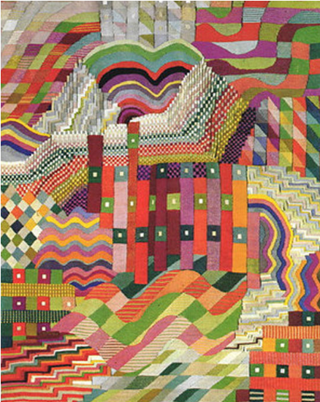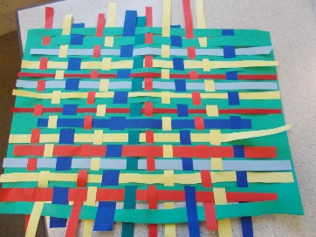
Objective and Success Criteria | Coverage | Key Questions | children should be able to |  |  | Resources
Appreciation  (context – Gunta StÖlzl)  To describe what techniques an artist has used  To consider why a technique has been used to create a specific effect  Big Ideas: S1, S2, S3, A1, A3 | - Find out about the artist’s background.  - Find out what materials and techniques the artist mainly used  - Look at a variety of the artists art work and discuss similarities and differences between the pieces  - Children to discuss what they like and dislike about the art. | - What materials did the artist mainly use?  - Are there any themes within the work?  - What is similar about the art?  - What is difference between the pieces?  - What do you like about the art? Why? | - Say what art medium the artist used  - Say what themes run through the art  - Say what they like about the art giving a reason |  |  | Twinkl Gunta StÖlzl artist fact sheet  Selection of Gunta StÖlzl art work to look at  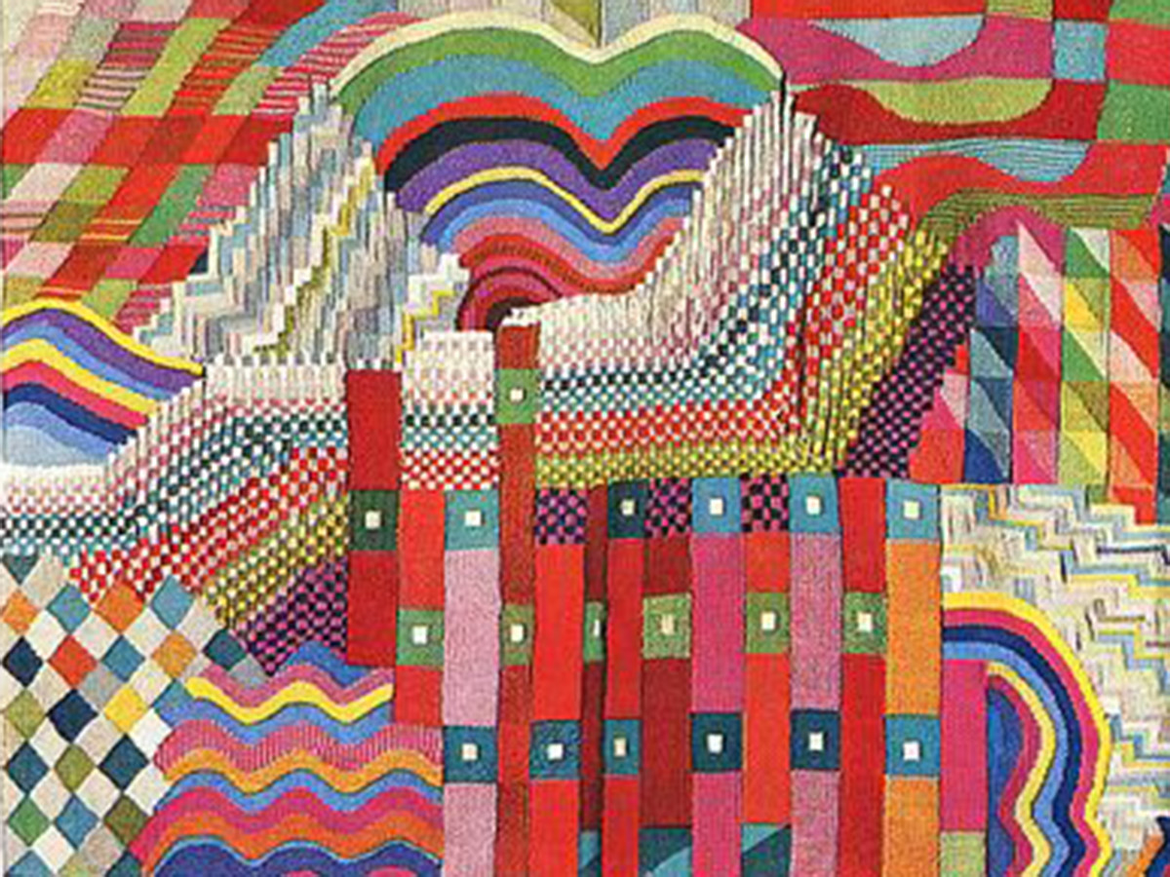
Exploring and developing ideas:  To explore weaving with a variety of materials including paper and found materials  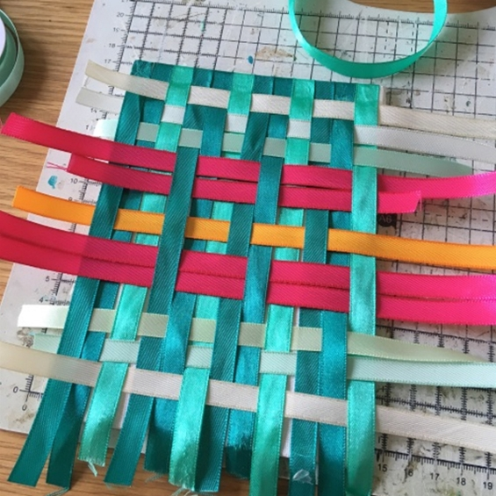  Big Ideas: E1, E3, S3 | - Look at Gunta StÖlzl weavings used for rugs.  https://www.guntastolzl.org/Museums/England/Victoria-and-Albert-Museum/i-XQswRmz This (website has lots of interesting pieces to discuss)  - Discuss what materials the artist used and what effect it created on the weave  - Explore different methods of weaving using a variety of methods e.g. paper weaving to create a check pattern, using a loom to create a simple weave, using natural materials to weave outside | - What different effects can be creating by using different types of weaves?  - Which methods are easy to use? Which ones are harder? | - say what different techniques can be used to weave  - say what different materials can be used to weave |  |  | String  Ribbon  Wool  Paper strips  Natural materials collected e.g. twigs, willow?  Looms  Design sheet
Investigating and making art:  To build and construct textile surfaces  Big Ideas: E2, C1, C2 | - Recap what they found out about weaving so far. Discuss what techniques can be used and what materials could be used.  - Together decide as a class what technique and material they think would be best to use in order to make a woven tile.  - Children to have time to practise the chosen technique. Experiment with paper/ribbon.  - Children to design their woven tile. They will need to include what technique is being used, materials they will use, colours they would like to use etc. Think about how contrast/complimentary colours could be used to create different effects. | - What techniques have we looked at?  - Which materials work best for weaving? Why?  - Which technique and material would be best to make your design?  - What colours will you use in your design? Why? | - Say which techniques are best to make a basket and why  - Say which material is best to make a basket and why
To create a woven composition  (Context – woven tile)  Big Ideas: C1, C2 | - Children to use their design sheet to collect all of the materials and tools they need to complete their design.  - Children to follow their design when making their tile using the correct technique, colours, materials etc to create their woven tile. | - What technique will I use?  - What do I need to remember with this technique?  - What material will I use?  - What colours do I need? | - follow their design to create their final piece |  |  | This will depend on what technique and material you have chosen as a class.
Evaluating and developing art:  To suggest aspects of your work to improve  To explore ways to improve the technique used  Big Ideas: A1, A2, A3 | - Talk partner work to discuss what things went well, why are you proud of your work?  - Encourage the children to think about why they like a particular aspect of their work relating to what impact it has had on their finished product.  - Discuss how in order to get better at something we now have to reflect on what we could change for next time.  - Talk partner work to discuss one thing that they would do differently next time. Encourage the children to think but why they would change that aspect and impact it would have on their finished product | - What do you like about your finished product? Why?  - What would you do differently next time?  - Would you use the technique to weave? Why?  - Would you use the same colours? Why? | - Say what they like about their work and why  - Say with they would do differently next time to improve it and why |  |  | Evaluation sheet
Assessment Questions
What Media and techniques is Gunta StÖlzl known for?
What different techniques can be used to weave? What effectives do they create?
What materials are best to weave with? Why?

Year 2 – Spring – Where in the World would you like to explore?  - To use a range of materials creatively to design and make products  - To use drawing, painting and sculpture to develop and share their ideas, experiences and imagination  - To develop a wide range of art and design techniques in using colour, pattern, texture, line, shape, form and space  - About the work of a range of artists, craft makers and designers, describing the differences and similarities between different practices and disciplines, and making links to their own work. |  |  | Artist: |  | Clarice Cliff
 |  |  | Media: |  | Clay
 |  |  | Technique: |  | Thumb pots
 |  |  | Key vocabulary: |  | Smoothing, pinch, manipulate, soften, roll, patterns, texture, patterns, tools
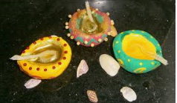
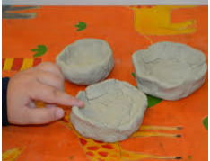
Objective and Success Criteria | Coverage | Key Questions |  | children should be able to |  | Resources
Appreciation  (context – Clarice Cliff)  To describe what techniques an artist has used  To consider why a technique has been used to create a specific effect  Big Ideas: S1, S2, S3, A1, A3 | - Find out about the artist’s background.  - Find out what materials and techniques the artist mainly used  - Look at a variety of the artists art work and discuss similarities and differences between the pieces  - Children to discuss what they like and dislike about the art. | - Can anyone be an artist?  - What does an artist do?  - What materials did the artist mainly use?  - Are there any themes within the work?  - What is similar about the art?  - What is difference between the pieces?  - What do you like about the art? Why? |  | - Say what art medium the artist used  - Say what themes run through the art  - Say what they like about the art giving a reason |  | Twinkl power point  Range of Clarice Cliff art work to look at  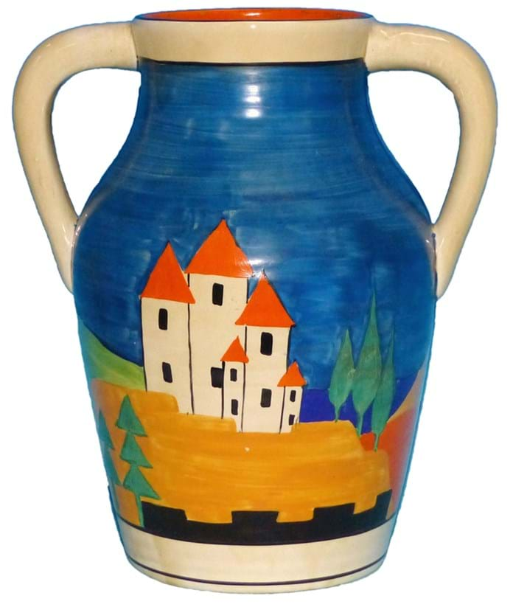
Exploring and developing ideas:  Explore how clay can be manipulated using tools and hands  Big Ideas: E1, E3, S3 | - Look at a variety of pots that Clarice Cliff made. Discuss what shape the pots are and what sort of features have been added. Discuss what material has been used.  - Children to explore where clay comes from and that it is a natural material.  - Children to have some clay to explore. Discuss what it feels like when they first get it. What does it smell like, look like etc Discuss what the children will need to bear in mind when working with this material (e.g. it dries out quickly, malleable to a point but breaks easily and quickly)  - Explore what different things you can do with the clay just using your hands e.g. rolling, smoothing, pinching etc  - Explore using different clay tools and what effect it has on the clay. | - What shapes do pots tend to be?  - How do you think the artist achieved the shapes?  - Where does clay come from?  - What is clay like?  - What do you need to remember about using clay?  - What different effects can be created using the tools? |  | - Say where comes from and what it is like  - Say what different effectives can be created using clay tools and hands |  | Range of Clarice Cliff art work to look at  Clay  Clay tools  Clay boards
Investigating and making art:  Use hands to create a thumb pot  Add texture and pattern using clay tools  Big Ideas: E2, C1, C2 | - Explain that they are going to make a thumb pot and show them the three stages they will complete (rolling into a ball, putting thumb into the middle, pinching round to make the hole bigger), children to practise each skill that they will use to make their pot  - Look at designs of diva lamps to see what patterns they may want to add to their pot. Explore using clay and tools how they might be able to achieve these designs | - How do you smooth the clay using your hands?  - How do you use your hands to create a perfect ball?  - Which tools are best to use to create the designs on a diva lamp? Why?  - What do you need to remember when using clay? |  | - Should be able to talk about the different stages needed to make a thumb pot  - Should be able to discuss what different effects can be created using tools on the clay |  | Clay to explore  Clay tools  Clay boards  Diva lamp designs to look at
To make a clay thumb pot  (Context – diva lamp)  Big Ideas: C1, C2  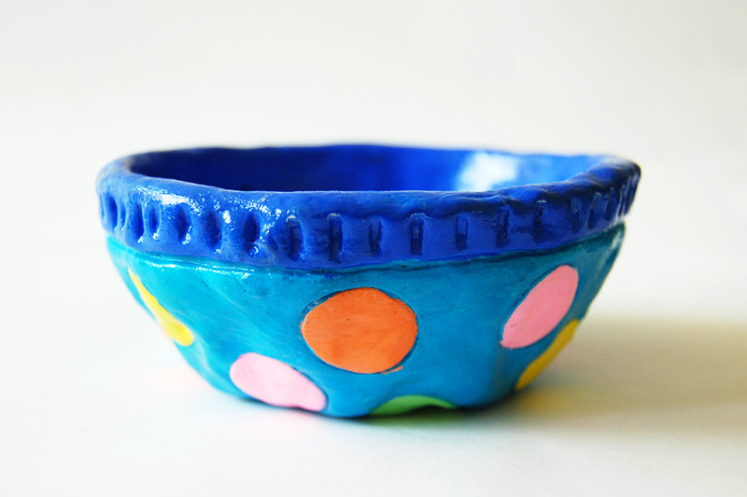 | - Children to design their diva lamp thinking about what decoration (patterns) they will add. Children to think about what tools they will use to achieve their ideas.  - Children to use their designs to make a thumb pot using the techniques taught. Once the shape has been made children to add their chosen patterns using the best tools to help them to achieve their idea. | - What patterns are usually used to decorate a diva?  - How could you create the pattern?  - What techniques are you using? why? |  | - Children should be able to use what they have learnt about diva lamps to influence their design  - Children should be able to say how they will achieve their ideas  - Children should be able to techniques practised to make their thumb pot |  | Clay  Clay tools  Design sheet  Clay boards
Evaluating and developing art:  To suggest aspects of your work to improve  To explore ways to improve the technique used  Big Ideas: A1, A2, A3 | - Talk partner work to discuss what things went well, why are you proud of your work?  - Encourage the children to think about why they like a particular aspect of their work relating to what impact it has had on their finished product.  - Discuss how in order to get better at something we now have to reflect on what we could change for next time.  - Talk partner work to discuss one thing that they would do differently next time. Encourage the children to think but why they would change that aspect and impact it would have on their finished product | - What do you like about your finished product? Why?  - What would you do differently next time?  - Would you use the patterns to decorate? Why?  - Would you use the same tools? Why? |  | - Say what they like about their work and why  - Say with they would do differently next time to improve it and why
Assessment Questions
What Media and techniques is Clarice Cliff known for?
What techniques do you use to make a thumb pot?
How can you add a pattern to a thumb pot? What tools would you use and what effects do the tools create?

Year 2 – Summer – Can we grow our own picnic?  - To use a range of materials creatively to design and make products  - To use drawing, painting and sculpture to develop and share their ideas, experiences and imagination  - To develop a wide range of art and design techniques in using colour, pattern, texture, line, shape, form and space  - About the work of a range of artists, craft makers and designers, describing the differences and similarities between different practices and disciplines, and making links to their own work. |  |  | Artist: |  | Giuseppe Arcimboldo
 |  |  | Media: |  | Pencil
 |  |  | Technique: |  | Sketching
 |  |  | Key vocabulary: |  | Tone, light, sketching, lines, effect, depth, shape, observational, technique, shading
 |  |  | 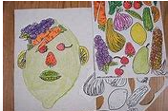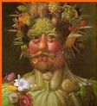
Objective and Success Criteria | Coverage | Key Questions |  | children should be able to |  | Resources
Appreciation  (context – Giuseppe Arcimboldo)  To describe what techniques an artist has used  To consider why a technique has been used to create a specific effect  Big Ideas: S1, S2, S3, A1, A3 | - Discuss what is an artist with the children  - Find out about the artist’s background.  - Find out what materials and techniques the artist mainly used  - Look at a variety of the artists art work and discuss similarities and differences between the pieces  - Children to discuss what they like and dislike about the art. | - Can anyone be an artist?  - What does an artist do?  - What materials did the artist mainly use?  - Are there any themes within the work?  - What is similar about the art?  - What is difference between the pieces?  - What do you like about the art? Why? |  | - Say what art medium the artist used  - Say what themes run through the art  - Say what they like about the art giving a reason |  | Twinkl power point  Range of Giuseppe Arcimboldo art work to look at
Exploring and developing ideas:  To explore ways to use a pencil to create different effects  Big Ideas: E1, E3, S3  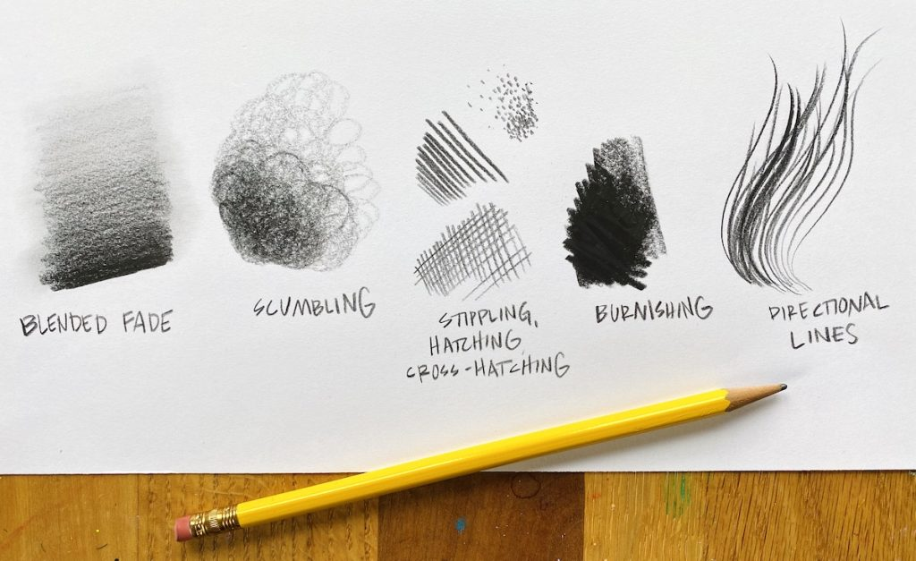 | - Look at a variety of Giuseppe Arcimboldo pieces. Discuss what is similar and different about the pieces.  - Children to explore how to use a sketching pencil. Children to see what happen to a line when you press hard, light etc. Children to listen to music while they take their pencil on a walk. During this time children should use a range of pencil movements, shapes and applying different amounts of pressure.  - Children to explore what happens with colouring pencils when you apply different pressure. Using their first piece children to again listen to music and add colour using different amount of pressure to colour in different shapes in their work.  - Children to explore what happens when you over lay colours together and the effect it creates  - Children should be encouraged to think about how this can be used to draw a still life  - Children to add secondary colours to their colour wheel (stuck in front of art sketchbook) | - What happens to the line when you vary the pressure applied?  - What effect does it create?  - What happens to the colour when you apply a different amount of pressure?  - What effect does it create? |  | - Explain what happens to a single line when different amounts of pressure is applied  - Explain what happens to colour pencil when different amounts of pressure is applied  - explain what happens to colour pencil when you over lay different colours |  | Range of Giuseppe Arcimboldo art work to look at  Sketching pencils  Coloured pencils  Paper music to listen to
Investigating and making art:  To explore how to add tone and depth using pencils  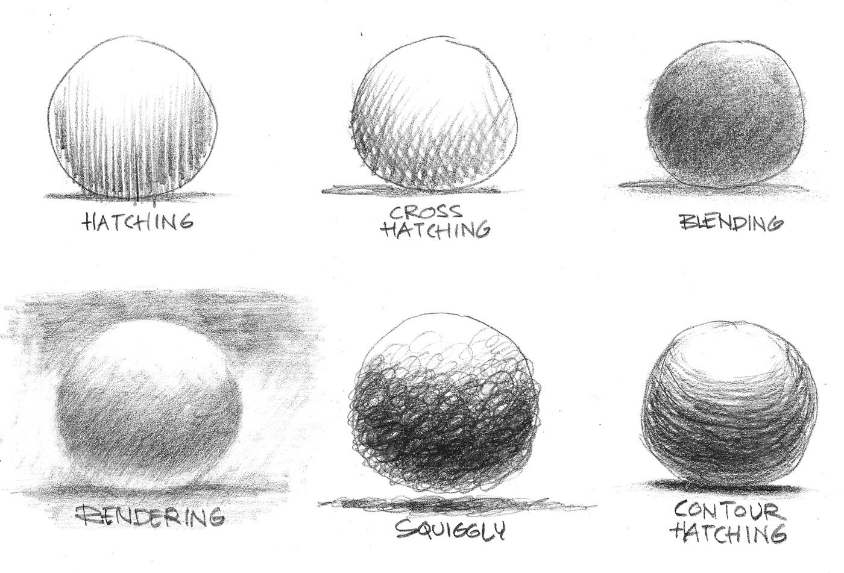  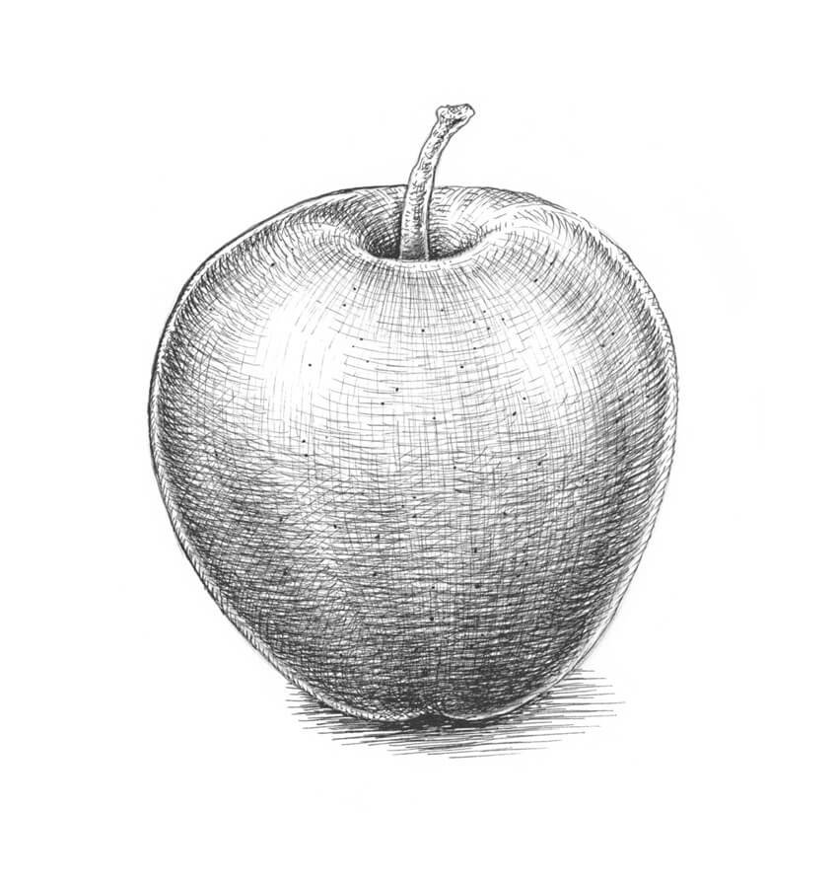  Big Ideas: E2, C1, C2 | - Explain what tone means and depth within a picture  - Children to study a piece of fruit/ vegetable looking carefully to see where the light hits the piece. Children to sketch the outline of the fruit/ vegetable using a light pencil line.  - Children to then add colour carefully looking constantly to see where the colour is deep and where the colours need to be lighter.  - Children to plan their final piece (fruit/ vegetable self-portrait) thinking about what fruits and vegetables they will use in their piece  - Children to use actual fruit and vegetables to plan what they will use where before taking photos to work from. | - What does tone mean?  - What does depth mean?  - How can use vary the colour of the pencil?  - Why is it important to keep looking at your fruit/ vegetable? |  | - explain what tone is  - explain how to add depth to a picture  - produce a good observational drawing of a fruit/ vegetable |  | Fruit/ vegetables  Paper  Sketching pencils  Coloured pencils  Large picture of themselves
To create a picture with tone and depth  (Context –fruit and vegetable self-portrait)  Big Ideas: C1, C2 | - Children to use their design to help them to plan out how they will achieve the final piece. Children to consider what steps they will need to complete and what order to do it in.  - children to complete the steps they have identified to achieve their fruit/ vegetable self -portrait (outline of face, fill outline with chosen fruit/ vegetables, add colour remembering about tone and depth within the piece) | - What steps will I complete in what order?  - What colours will I need to use?  - Where are the lightest parts of pieces of fruit?  - Where are the darkest parts of the pieces of fruit?  - what techniques will I use to achieve tone and depth? |  | - use their detailed plan to help them to achieve their vision  - use the techniques explored to add tone and depth to their final piece |  | Fruit/ vegetables  Paper  Sketching pencils  Coloured pencils  Large picture of themselves
Evaluating and developing art:  To suggest aspects of your work to improve  To explore ways to improve the technique used  Big Ideas: A1, A2, A3 | - Discuss what reflection is  - Talk partner work to discuss what things went well, why are you proud of your work?  - Encourage the children to think about why they like a particular aspect of their work relating to what impact it has had on their finished product.  - Discuss how in order to get better at something we now have to reflect on what we could change for next time.  - Talk partner work to discuss one thing that they would do differently next time. Encourage the children to think but why they would change that aspect and impact it would have on their finished product | - What do you like about your finished product? Why?  - What would you do differently next time?  - Would you use the same pieces of fruit/ vegetables for the different parts? Why?  - Have you added tone and depth to your piece? |  | - Say what they like about their work and why  - Say with they would do differently next time to improve it and why
Assessment Questions
What Media and techniques is Giuseppe Arcimboldo known for?
What techniques can be used to create tone and depth in a drawing?
How were you inspired by the artist?

