Year 3 – Autumn –What did prehistoric people yabba dabba do?  - To create sketch books to record their observations and use them to review and revisit ideas  - To improve their mastery of art and design techniques, including drawing, painting and sculpture with a range of materials [for example, pencil, charcoal, paint, clay]  - About great artists, architects and designers in history. |  |  |  | Artist: |  | Da Vinci
 |  |  |  | Media: |  | Sketching
 |  |  |  | Key vocabulary: |  | Medium, sketching pencils, blackness, hardness, line, tone, texture, blending, depth
Previous Experience: | In Year 2, the children will have had experience with line drawings and improving motor control. Children will build upon their understanding of drawing what they observe rather than what they imagine.
Previous Experience: |  |  |  | 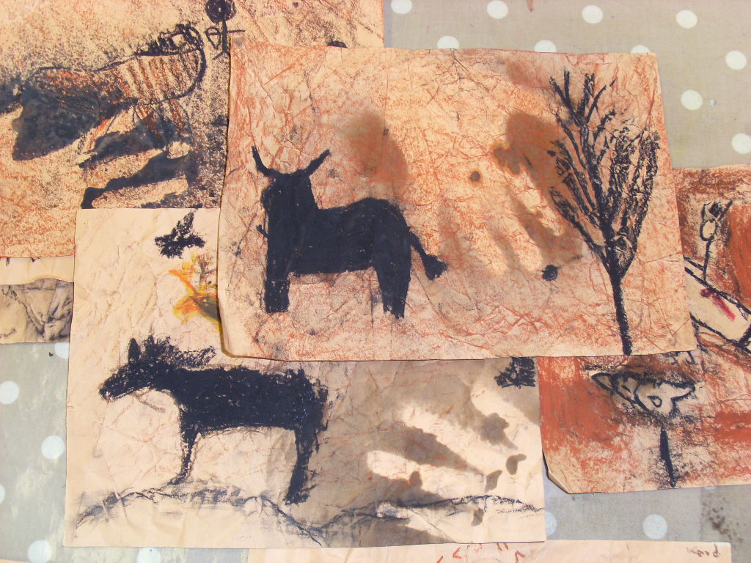
Objective and Success Criteria |  | Coverage | Key Questions |  | Children should be able to |  | Resources
Appreciation  (context –Da Vinci Line Drawings and Lascaux Cave Paintings) – 2 lessons  To describe how a piece of art makes you feel giving reasons  Big Ideas: S1, S2, S3, A1, A3 |  | - Find out about the artist’s background.  - Find out what materials and techniques the artist mainly used  - Look at a variety of the artists art work and discuss similarities and differences between the pieces  - Children to discuss what they like and dislike about the art.  - Children to consider what the mood of a piece of art is by considering how it makes them feel when they are looking at it. Do they like the way the art makes them feel? | - What do you like about the art? Why?  - How does the art create an atmosphere?  - What materials did the artist mainly use?  - Are there any themes within the work?  - What is similar about the art?  - What is difference between the pieces? |  | - Say what art medium the artist used  - Say what themes run through the art  - Say what different moods are created in the work  - Say what they like about the art giving a reason |  | Sketchbooks  Examples of Da Vinci line drawings  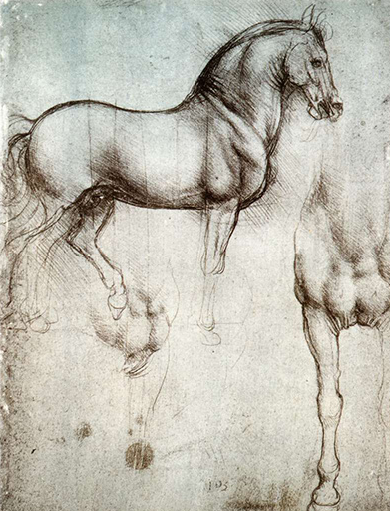  Think about how line is used to show texture of skin (folds) and shadows are used to add depth.  Twinkl ppt on Cave Paintings
Exploring and developing ideas:  To explore sketching techniques using different pencils – B/H/HB  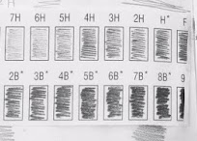  To explore how to use charcoal and chalk pastels to create tone  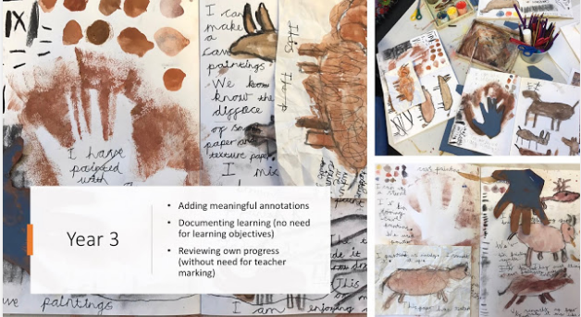  Big Ideas: E1, E3, S3 |  | - Look at some examples of Da Vinci sketches. Discuss what is really noticeable about the pieces. What lines are used? How do you think the piece was made?  - Introduce the fact that they are going to create line drawings in the style of a cave painting.  - Children to explore making marks on paper using different types of sketching pencil – B and H. Explore using different techniques. What effects are created by the different pencils? Explain that H is hardness and B is blackness of a pencil.  - Children to explore how charcoal and chalk pastels works by blending, varying pressure, and smudging. Spend time thinking about how you can create sharp lines and blended lines.  - Children to explore completing simple sketches in their sketch book using the techniques discussed. Remind the children that they used sketching pencils in year 2 so they already know how to use light quick lines to achieve a sketch. | - What techniques can be used to create a design?  - What different effects can be created with the pencils?  - How can you create different tones with the pencils? |  | - Say what techniques can be used to create a different tones with a pencil  - Explain what different effects the pencils can create |  | Sketchbooks  Sketching pencils  Art aprons
Investigating and making art:  To design a cave painting using sketching techniques with pencil  Big Ideas: E2, C1, C2 |  | - Look at cave painting and what they tell us now. Look at the different images used to create the picture.  - Decide as a class what you would like to show in your picture that will be created. What will be shown? What images will be used to show this scene?  - In small groups children to design their scene, thinking about each individual image and how they will come together. | - What images are we going to include?  - What colours will we use?  - What techniques will I use to create images? |  | - Say what scene they will create in their group |  | Cave paintings  Design sheet
To create a final cave painting using coloured chalks and charcoal  (Context create own cave using chalk and charcoal)  Big Ideas: C1, C2 |  | - Children to follow their designs to create their chosen scene.  - Once the pieces have been created photograph and stick into sketchbooks |  |  | - Say how they have achieved their plan  - Say what techniques they have used and why |  | Coloured Chalk  Charcoal  Cartridge paper – A3
Evaluating and developing art:  (this could just be a plenary at the end of a lesson)  To identify similarities and differences between own work and others  To identify aspects that could be improved and suggest solutions  Big Ideas: A1, A2, A3 |  | - Talk partner work to discuss what things went well, why are you proud of your work?  - Encourage the children to think about why they like a particular aspect of their work relating to what impact it has had on their finished product.  - Talk partner work to discuss what things they would do differently next time. Children to give reasons for the things they would change. What impact would it have on the finished product? How could they achieve it? Different techniques? Different paint brushes? Different effects with the paint? | - What do you like about your finished product? Why?  - What would you do differently next time?  - Would you use the same paint effects?  - Would you use the same medium?  - Would you use the same techniques?  - Would you create the same mood/ atmosphere? |  | - Say what they like about their work and why  - Say what they would do differently next time to improve it and why
Assessment Questions
What Media and techniques is Da Vinci known for?
What different techniques can be used to create a sketch?

Year 3 – Spring – How has water shaped our world?  - To create sketch books to record their observations and use them to review and revisit ideas  - To improve their mastery of art and design techniques, including drawing, painting and sculpture with a range of materials [for example, pencil, charcoal, paint, clay]  - About great artists, architects and designers in history. |  |  |  | Artist: |  | Monet
 |  |  |  | Media: |  | Watercolour
 |  |  |  | Technique: |  | Painting
 |  |  |  | Key vocabulary: |  | View point, images, tone, shades, blending, colour, mixing, primary, secondary
Previous Experience: | Year 1 the children will have looked at primary colours, Year 2 they will have mixed secondary colours. The children will have began learning how to sketch in Summer term Year 2 and Autumn term Year 3. Children will have been exposed to poster paints, but this is their first experience with watercolours.
Previous Experience: |  |  |  | 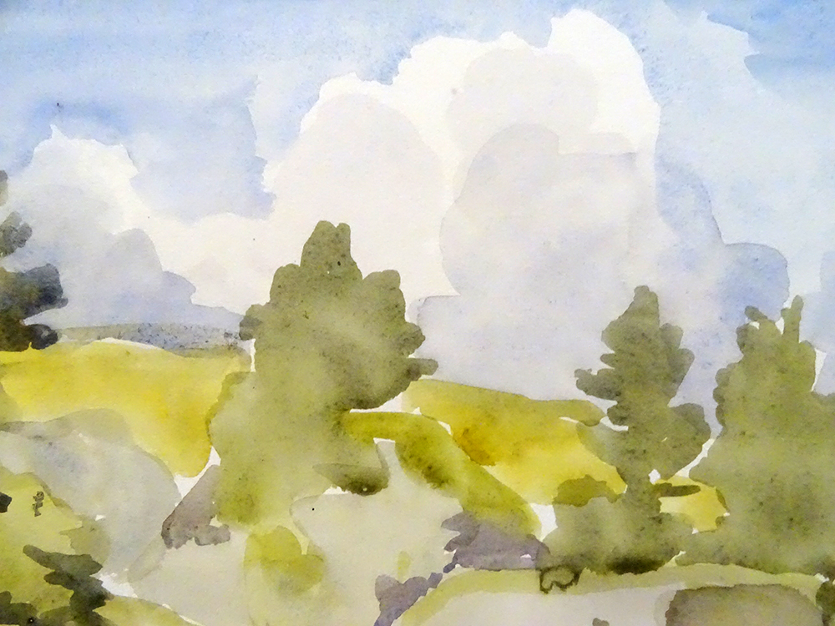
Objective and Success Criteria |  | Coverage | Key Questions |  | Children should be able to |  | Resources
Appreciation  (context–Monet and David Harmer, a local artist) – 2 lessons  To describe how a piece of art makes you feel giving reasons  Big Ideas: S1, S2, S3, A1, A3 |  | - Find out about the artist’s background.  - Find out what materials and techniques the artist mainly used  - Look at a variety of the artists art work and discuss similarities and differences between the pieces  - Children to discuss what they like and dislike about the art.  - Children to consider what the mood of a piece of art is by considering how it makes them feel when they are looking at it. Do they like the way the art makes them feel?  - Look at a variety of pieces of art that Monet made. Discuss how Monet found completing a detailed sketch of what he intended to paint or pastel helped him to create the pieces he set out to achieve. Look at a variety of drawings. Discuss how he used the pencil when drawing. Are the lines all the same? How has he achieved tone using the pencil? What sketching techniques do you think have been used? | - What materials did the artist mainly use?  - Are there any themes within the work?  - What is similar about the art?  - What is difference between the pieces?  - What do you like about the art? Why?  - How does the art create an atmosphere? |  | - Say what art medium the artist used  - Say what themes run through the art  - Say what different moods are created in the work  - Say what they like about the art giving a reason |  | Twinkl PowerPoint  Photo pack of example work  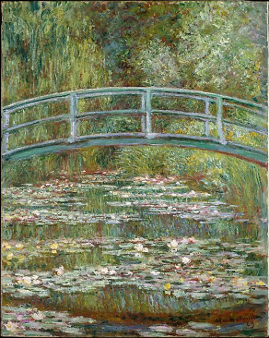  http://davidharmerwatercolour.co.uk/art-gallery/  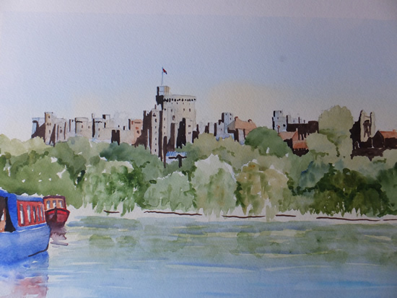
Exploring and developing ideas:  To explore using water colours  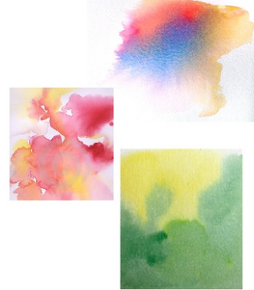  Big Ideas: E1, E3, S3 |  | - Children to explore using water colours and investigating the different techniques they can use: Wet on wet, glazing, dry brushing (follow slides on slideshare). 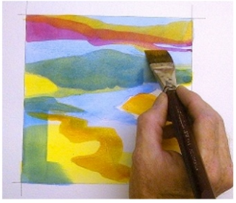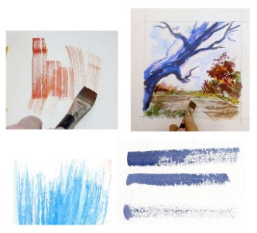 | - What sort of textures can you create?  - How could you create shades of the same colour?  - What happens when you add more/less water? |  | - Say how watercolour can be used to create different effects  - Say how to create different tones/shades with watercolour  - Say what moods effects are being created |  | Sketch books  Watercolours  Fine paintbrushes  https://pt.slideshare.net/emilyvalenza/watercolor-experimentation-16008198/5
Investigating and making art:  To sketch a landscape using pencil  Big Ideas: E2, C1, C2 |  | - Explain what a viewfinder is. Discuss why it is important to have a focus in sketching so that it can be more detailed.  - Children to complete two observational drawings at Dinton Pastures. Explain that they will need to draw what they see and not what they think.  - (1 in black and white, 1 with coloured pencils) | - What part of the place catches your attention? Why?  - What different features are there to be included in your drawing?  - What shapes make up your selected view?  - What mood do you need to create? How will you achieve it? |  | - Say what a view finder is and why they are useful  - Make detailed first hand observational drawing of places  - Use tone and bring their drawing to life |  | Pictures of Dinton Pastures  Sketch books  Sketching Pencils  Coloured pencils  Viewfinders
To create a new image based on first hand observations  (Context - Observational drawing of Southlake and Dinton Pastures)  Big Ideas: C1, C2 |  | - Children to use their investigative images created of Southlake and Dinton to create a new picture.  - Children to add tone and colour using watercolours and what they learnt in the exploratory stage. | - Which view will you choose?  - What tones and mood will you create?  - What techniques would be useful to use? |  | - Say what view they have chosen and why  - Say what techniques they have used and why  - Say what mood and atmosphere they were trying to create |  | Pictures of Dinton Pastures and Southlake  Watercolour paper  Watercolours
Evaluating and developing art:  To identify similarities and differences between own work and others  To identify aspects that could be improved and suggest solutions  Big Ideas: A1, A2, A3 |  | - Talk partner work to discuss what things went well, why are you proud of your work?  - Encourage the children to think about why they like a particular aspect of their work relating to what impact it has had on their finished product.  - Discuss how in order to get better at something we now have to reflect on what we could change for next time.  - Talk partner work to discuss what things they would do differently next time. Children to give reasons for the things they would change. What impact would it have on the finished product? How could they achieve it? Different techniques? Different view? Combine the two images differently? Different mood/ atmosphere? | - What do you like about your finished product? Why?  - What would you do differently next time?  - Would you use the same views?  - Would you combine the views in the same way?  - Would you use the same techniques?  - Would you create the same mood/ atmosphere? |  | - Say what they like about their work and why  - Say what they would do differently next time to improve it and why
Assessment Questions
What Media and techniques is Monet known for?
Why is a view finder useful for artists to use?
How can you add tone to a drawing?

Year 3 – Summer – How can we help protect our planet?  - To create sketch books to record their observations and use them to review and revisit ideas  - To improve their mastery of art and design techniques, including drawing, painting and sculpture with a range of materials [for example, pencil, charcoal, paint, clay]  - About great artists, architects and designers in history. |  |  |  | Artist: |  | Eduardo Kobra
 |  |  |  | Media: |  | Mixed-media/collage
 |  |  |  | Technique: |  | Paper and paste
 |  |  |  | Key vocabulary: |  | Layering, tissue paper, texture, smooth, transparent, shape form, technique, torn, cut
Previous Experience: | Year 1 children would have explored how to use paper and paste in the context of Matisse to create a paper collage of a tree. This unit will build upon their understanding of colour by layering tissue paper to form new colours.
Previous Experience: |  |  |  | 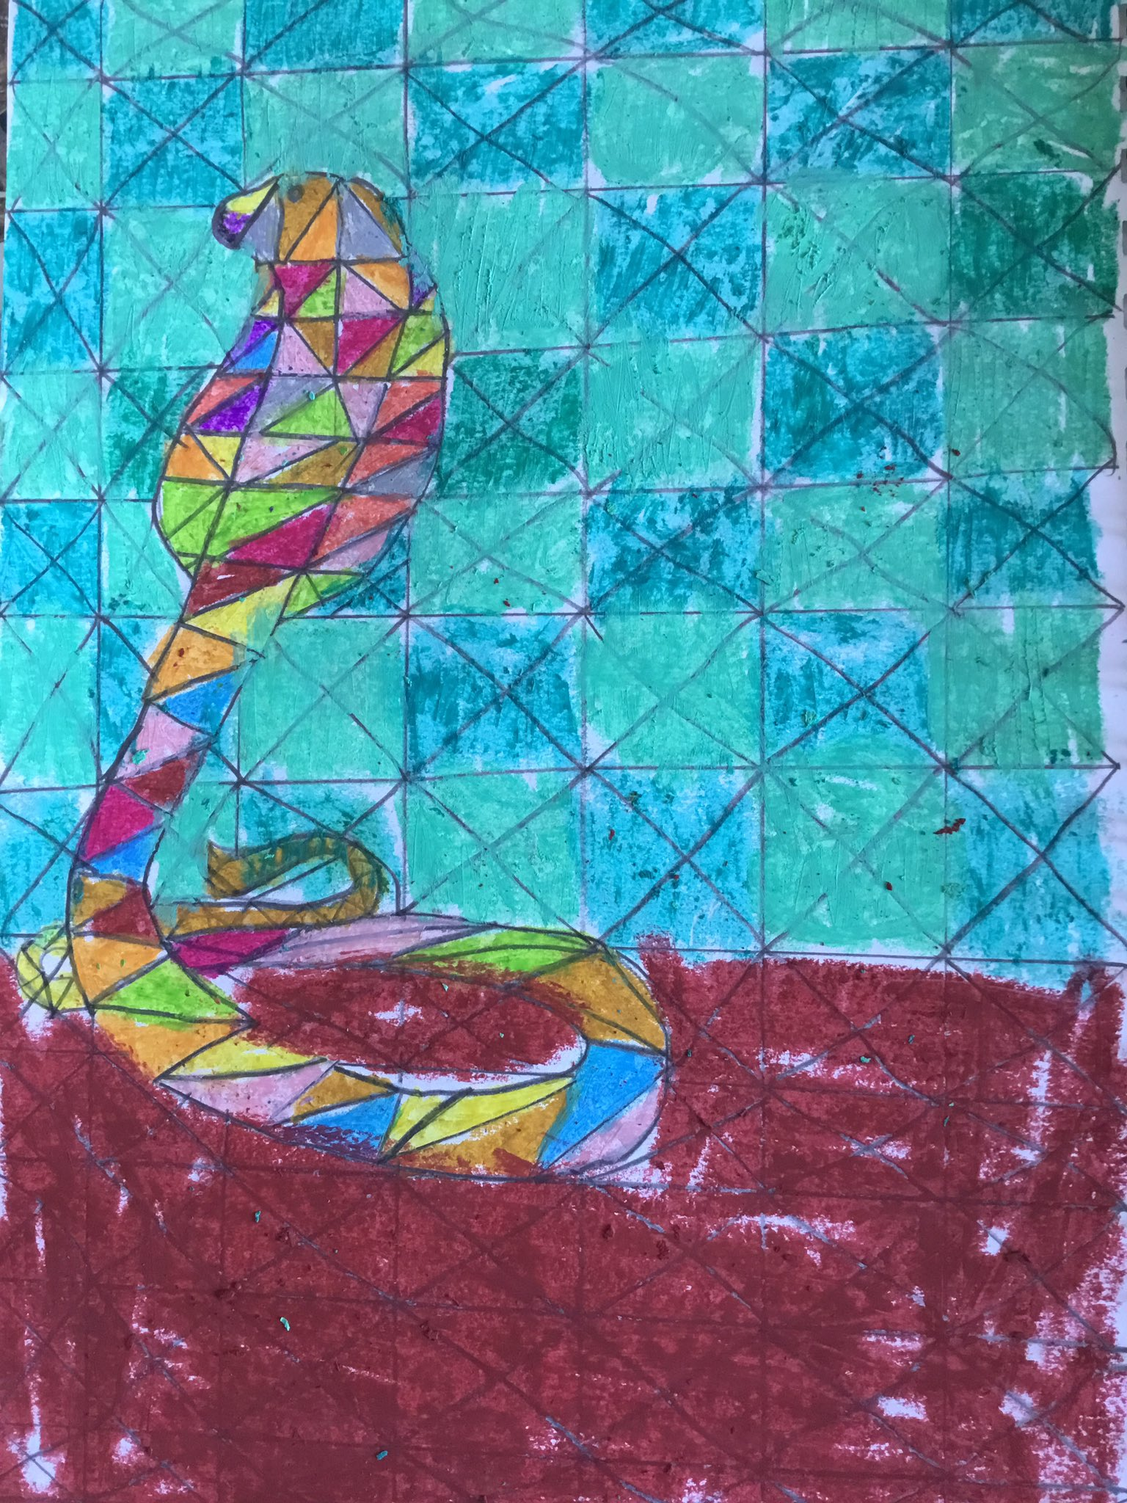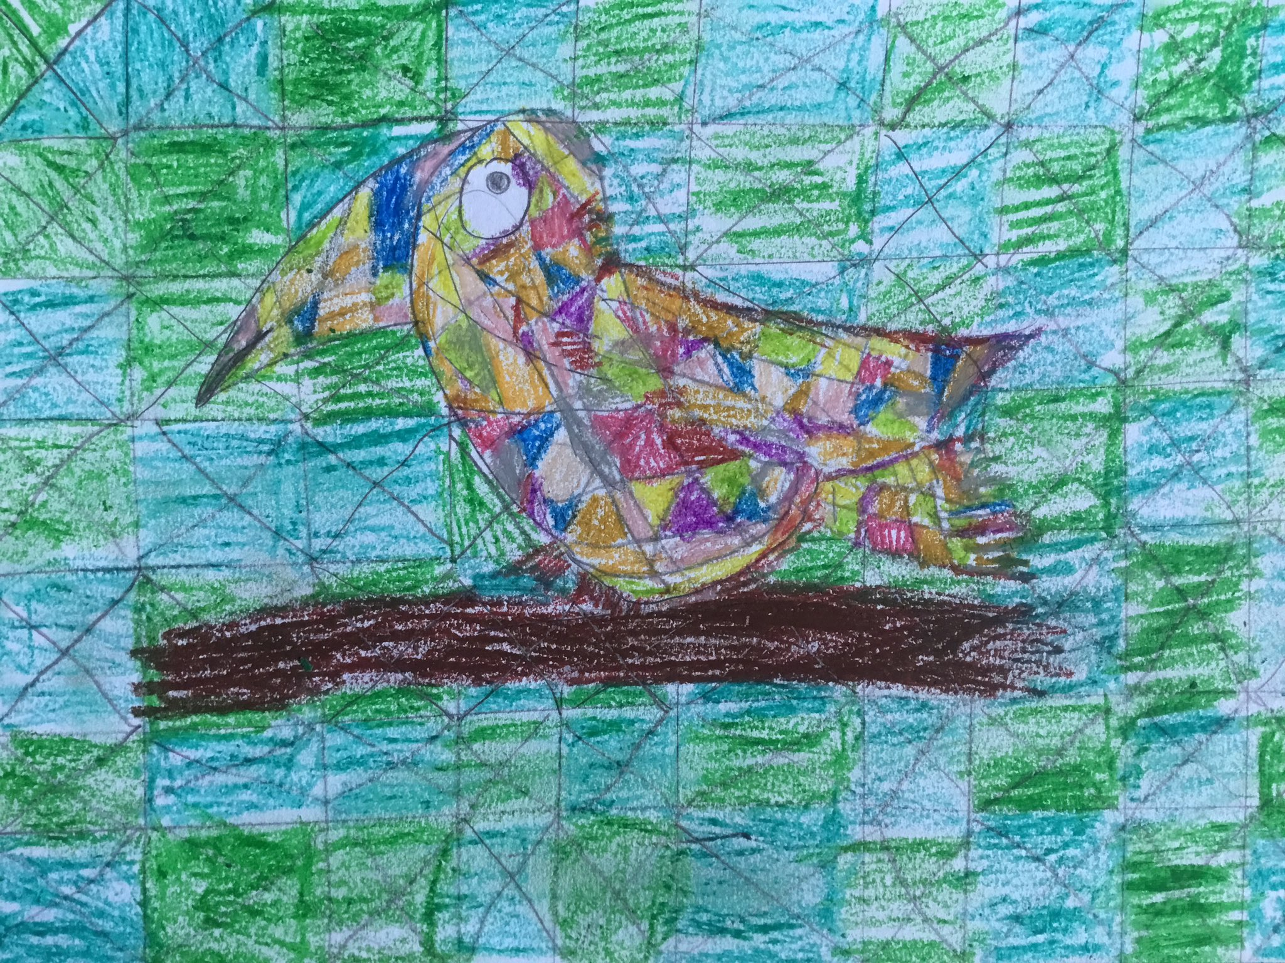
Objective and Success Criteria |  | Coverage | Key Questions |  | children should be able to |  | Resources
Appreciation  (context – Eduardo Kobra)  To describe how a piece of art makes you feel giving reasons  Big Ideas: S1, S2, S3, A1, A3 |  | - Find out about the artist’s background.  - Find out what materials and techniques the artist mainly used  - Look at a variety of the artists art work and discuss similarities and differences between the pieces  - Children to discuss what they like and dislike about the art.  - Children to consider what the mood of a piece of art is by considering how it makes them feel when they are looking at it. Do they like the way the art makes them feel? | - What materials did the artist mainly use?  - Are there any themes within the work?  - What is similar about the art?  - What is difference between the pieces?  - What do you like about the art? Why?  - How does the art create an atmosphere |  | - Say what art medium the artist used  - Say what themes run through the art  - Say what different moods are created in the work  - Say what they like about the art giving a reason |  | Examples of Eduardo Kobra’s work  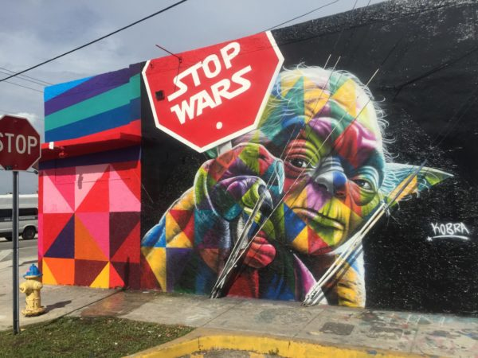  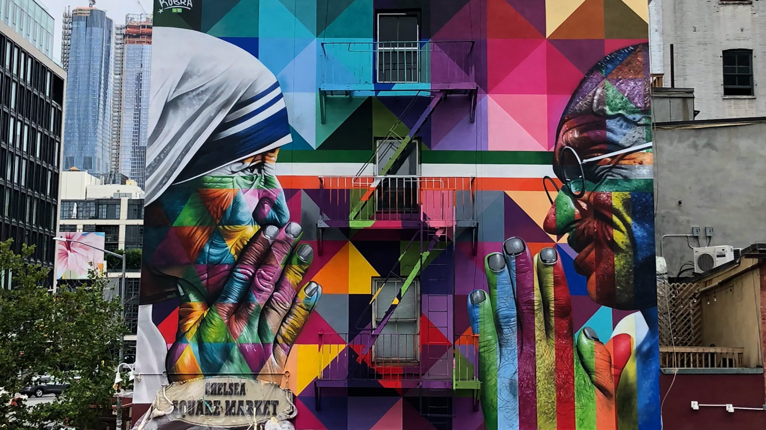  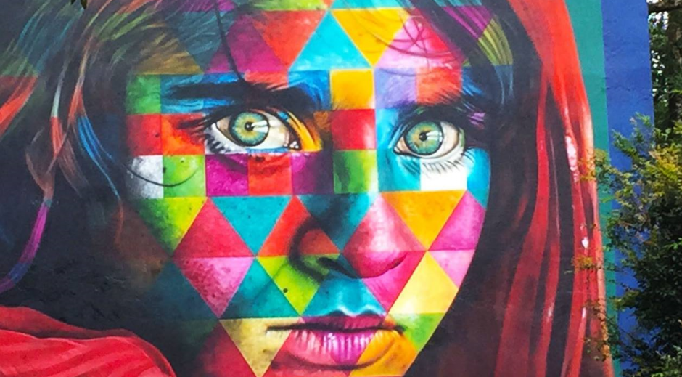
Exploring and developing ideas:  To explore the effect of layering up tissue paper to mix colours  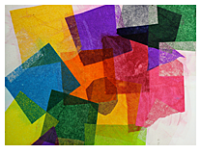  To explore the effect of mixing coloured pencils/oil pastels  Big Ideas: E1, E3, S3 |  | - Look at Eduardo Kobra’s work and discuss how the image stands out from the background (e.g. muted colours for the background – bold for the image)  - Recap with the children about primary colours and secondary colours (you should have their colour wheels from yr 2)  - Experiment with layering two different colours of tissue paper together to see what colour they make (repeat this process). Refer to secondary colour wheels from Year 2 to make both informed and random decisions.  - Experiment with mixing coloured pencils/oil pastels of different shades for the background. | - What atmosphere is created through Eduardo Kobra’s paintings?  - What happens to the colours when tissue paper is layered? |  | - Say what moods effects are being created  - Explain what happens to the tissue paper when different colours are layered |  | Tissue paper  PVA glue
Investigating and making art:  To sketch a rainforest animal  Big Ideas: E2, C1, C2 |  | - Using what they have learnt through their investigation time children should plan their final piece considering what colours they will need  - Children to sketch out a rainforest animal that will form the foreground image of their final piece. Explain that the image needs to fill the page.  - When children are happy with final drawing, outline in black marker so that it will show through the tissue paper. | - How are different colours made?  - What effects and techniques can you use to help you create these features? |  | - Sketch out animal  - Plan colours for background |  | Sketching pencils  Black marker pens
To create art work in the same style as an artist  (Context - collage of a rainforest animal)  Big Ideas: C1, C2 |  | - Children to mix coloured pencils and create their background for their final piece,  - Children to layer tissue paper over their planned sketch to create their final piece – cut out animal and stick to background, ensuring that their animal is sat on something (ground or tree branch) – this will give the piece context. | - What different steps will I need to complete?  - What order would be best to follow?  - What different effects, colours, tones, shades will I use? How will I achieve it? |  | - Use tissue paper to create a collage effect |  | Tissue paper – cut into right-angled triangles  PVA glue  Cartridge paper  Colour pencils/oil pastels
Evaluating and developing art:  To identify similarities and differences between own work and others  To identify aspects that could be improved and suggest solutions  Big Ideas: A1, A2, A3 |  | - Talk partner work to discuss what things went well, why are you proud of your work?  - Encourage the children to think about why they like a particular aspect of their work relating to what impact it has had on their finished product.  - Discuss how in order to get better at something we now have to reflect on what we could change for next time.  - Talk partner work to discuss what things they would do differently next time. Children to give reasons for the things they would change. What impact would it have on the finished product? How could they achieve it? Different techniques? Different paint brushes? Different effects with the paint? Different habitat? | - What do you like about your finished product? Why?  - What would you do differently next time?  - Would you use the same paint effects?  - Would you use the same Habitat?  - Would you use the same techniques?  - Would you create the same mood/ atmosphere? |  | - Say what they like about their work and why  - Say what they would do differently next time to improve it and why
Assessment Questions
What Media and techniques is Eduardo Kobra known for?
How can different effects be created with tissue paper? How can these effects be used within a mixed media collage?

