Year 5 – Autumn – Has our Planet finished evolving?  - To create sketch books to record their observations and use them to review and revisit ideas  - To improve their mastery of art and design techniques, including drawing, painting and sculpture with a range of materials [for example, pencil, charcoal, paint, clay]  - About great artists, architects and designers in history. |  |  |  | Artists: |  | Michael Caroll  Peter Thorpe  Jackson Pollock
 |  |  |  | Media: |  | Painting
 |  |  |  | Technique: |  | Texture and tone
 |  |  |  | Key vocabulary: |  | Surfaces, techniques, refine, tone, effect, mixing, shade, natural, mood, emotion, manmade
Previous Experience: | Year 1: children used water colours to learn how to create secondary colours. They looked at how to create different tones and shapes by adding white, black and water to colours. They drew their favourite toy and completed a water colour painting of it.  Year 3: children recapped secondary colours then learnt about tertiary colours and how to make them. They also explored different ways of applying paint with different brushes and tool to create different colours. They also explored adding texture to paint by adding things like sawdust, sand, glue etc
Previous Experience: |  |  |  | 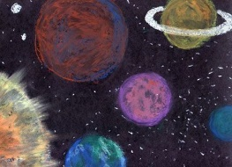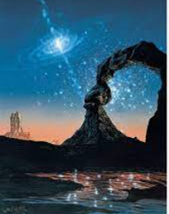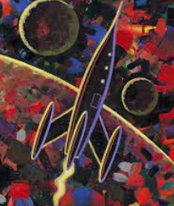
Objective and Success Criteria |  | Coverage | Key Questions |  | children should be able to |  | Resources
Appreciation  (context: Michael Caroll)  To consider the purpose of the art  To use art as a stimulus for their own art explaining where inspiration was sought from  Big Ideas: S1, S2, S3, A1, A3 |  | - Find out about the artist’s background.  - Find out what materials and techniques the artist mainly used  - Look at a variety of the artists art work and discuss similarities and differences between the pieces  - Children to discuss what they like and dislike about the art.  - Children to consider what the mood of a piece of art is by considering how it makes them feel when they are looking at it. Do they like the way the art makes them feel? | - Can anyone be an artist?  - What does an artist do?  - What materials did the artist mainly use?  - Are there any themes within the work?  - What is similar about the art?  - What is difference between the pieces?  - What do you like about the art? Why?  - How does the art create an atmosphere |  | - Say what art medium the artist used  - Say what themes run through the art  - Say what different moods are created in the work  - Say what they like about the art giving a reason |  | Small samples of Michael Caroll’s work to stick in sketch book and annotate
Exploring and developing ideas:  Explore different painting techniques to express mood or emotion  Big Ideas: E1, E3, S3 |  | Listen to Mars and Venus from ‘The Planets’ by Holst. Match colours and words describing the moods of the pieces in sketch books. | - How can mood and atmosphere be created using paint?  - How can you create different tones of colours?  - What do you need to remember about using acrylic paint? |  | - Say how mood and atmosphere can be created with paint |  | Pastels to blend into mood colours. Pictures of Holst, instruments and the planets Mars and Venus to add to sketch book pages
Investigating and making art:  Use a range of tools to apply paint to different surfaces  Investigate the effect of light and colour, texture and tone on natural and manmade objects  Big Ideas: E2, C1, C2 |  | - Explore and evaluate different media for creating texture with paint: Sponge, a thick brush (stippling and brushing), tin foil and a roller  - Comment and annotate likes and dislikes of above media  - Explore splatter painting and the work of Jackson Pollock  - Explore the work of Peter Thorpe. Comment on mood, colour, texture and likes/dislikes | - What tools are best to apply acrylic paint? Why?  - What different effects can be created with the tools?  - How can light and dark be added to a picture?  - How can shade and tone be created? |  | - discuss different ways of applying paint and say what effects they create  - say how to add light and dark to a piece using a range of media  - say how to create texture and tone using a range of media |  | Planets art work by Michael Caroll, Jackson Pollock and Peter Thorpe  Sponge, thick brushes, tin foil and roller  Acrylic paint  Various Paint brushes  Paint trays  Cartridge paper
To create a landscape painting  (Context – space scene of the planets )  Big Ideas: C1, C2 |  | Create a space scene using the different paint application techniques that have been explored: dark background (poss. splatter painting)and textured lighter colour planets in foreground.  - Children should be encouraged to consider…  - the size of the planets in their piece in relation to each other  - colours and tones needed to create the atmosphere desired  - what techniques they will use to apply the paint | - What atmosphere do I want to create in my piece?  - What techniques and tools will I use? Why?  - What colours will I use? Why?  - Where will the light be coming form in my piece? |  | - Say what atmosphere they wanted to created  - say what techniques and tools they have used |  | Design sheet  Acrylic paint  Tools to apply paint  Paint trays  Cartridge paper
Evaluating and developing art:  To explain and give reasons why art techniques were chosen  To refine and adapt work to reflect the intended purpose  Big Ideas: A1, A2, A3 |  | - Discuss what reflection is  - Talk partner work to discuss what things went well, why are you proud of your work?  - Encourage the children to think about why they like a particular aspect of their work relating to what impact it has had on their finished product.  - Discuss how in order to get better at something we now have to reflect on what we could change for next time.  - Talk partner work to discuss what things they would do differently next time. Children to give reasons for the things they would change. What impact would it have on the finished product? How could they achieve it? Different tools? Different techniques? | - What do you like about your finished product? Why?  - What would you do differently next time?  - Would you use the same design? Why?  - Would you use the same tools? Why? |  | - Say what they like about their work and why  - Say what they would do differently next time to improve it and why |  | Evaluation sheet – self and peer evaluation
Assessment Questions
How can light and dark be added to a painting?
How can different tones, shades and textures be created with paint?

Year 5 – Spring – Is Invasion ever justified?  - To create sketch books to record their observations and use them to review and revisit ideas  - To improve their mastery of art and design techniques, including drawing, painting and sculpture with a range of materials [for example, pencil, charcoal, paint, clay]  - About great artists, architects and designers in history. |  |  | Artist: |  | Archibald Knox  Anon: Celtic patterns
 |  |  | Media:  Technique: |  | Paint and string or lino  Printing
Previous Experience: | Year 1 summer term - children would have used polystyrene tiles to print  Year 4 spring term – children will have used stamps to create prints |  | Key vocabulary: |  | Line, pattern, print, positive, negative, stencil/stamp
Previous Experience: |  |  | 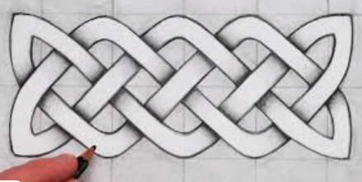
Objective and Success Criteria | Coverage | Key Questions |  | Children should be able to…. |  | Resources
Appreciation  (context –Archibald Knox and anonymous Celtic Patterns)  To consider the purpose of the art  To use art as an stimulus for their own art explaining where inspiration was sought from  Big Ideas: S1, S2, S3, A1, A3 | - Find out about the artist’s background.  - Find out what materials and techniques the artist mainly used  - Look at a variety of the artists art work and discuss similarities and differences between the pieces  - Children to discuss what they like and dislike about the art.  - Children to consider what the mood of a piece of art is by considering how it makes them feel when they are looking at it. Do they like the way the art makes them feel?  - Children to think about the Celtic designs used by Knox in his work and how he has brought a design technique from the Iron Age into modern history (work for Liberty) | - What materials did the artist mainly use?  - Are there any themes within the work?  - What is similar about the art?  - What is difference between the pieces?  - What do you like about the art? Why?  - How does the art create an atmosphere |  | - Say what art medium the artist used  - Say what themes run through the art  - Say what different moods are created in the work  - Say what they like about the art giving a reason |  | Examples of Knox’s work  Examples of Celtic patterns  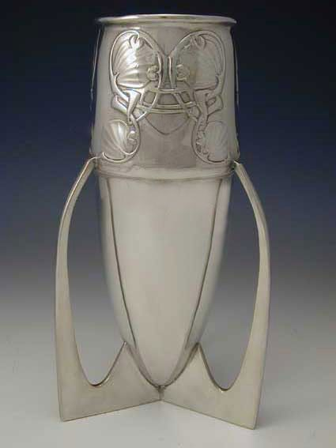
Exploring and developing ideas:  To design an image to use for printing  Big Ideas: E1, E3, S3 | - Look at different Celtic patterns and consider what they all have in common – line, colour etc.  - Children to create four different Celtic patterns, taking inspiration from anonymous artwork. Explore different colours, shapes, lines.  - Children to reflect on their designs and choose one for their final piece. | - What do all Celtic patterns have in common?  - How is line used in the artwork?  - How could you vary your design to make it more visually interesting? |  | - Describe similarities between Celtic patterns  - Recognise that line was important during that era of artwork |  | Lots of different Celtic patterns to look at  Sketchbooks  Sketching pencils  Coloured pencils
Investigating and making art:  To use string to print a positive image and explore colour  Big Ideas: E2, C1, C2 | - Discuss what a positive print is (it is the image that gets printed rather than the background e.g. like a stamp)  - Using PVA glue stick string to pieces of card in different patterns. The children will need to draw their design on the card first so that they can trace the string over it. Once dry apply paint thickly to the card and use as a stamp for printing.  - Children should be able to explore how their stamp can be used multiple times to create a repeating pattern. Give children the opportunity to experiment in colour and see which effect they like the most.  - After reflecting, children to make their stencil using string and cardboard ready for their final design. | - Which design was most the successful?  - How have you varied colour?  - What do you notice about the clarity of the image as you print? |  | - Explain what a positive print is  - Start to create repeated patterns  - Recognise that printing is a useful technique to use when creating repeated patterns |  | PVA glue  String  Cardboard  Sketchbooks  Poster paint
To create a repeated Celtic print  (Context- Celtic patterns)  Big Ideas: C1, C2 | - Children to use what they have learnt about printing to create a repeated pattern.  - Children to use their plan and stencil to create their design – a repeated Celtic Pattern | - How have you achieved your design?  - What colours have you used? Why? |  | - Say what colours they have used and why  - Explain why they chose that particular design |  | Design sheets  Cartridge paper  Stencils (made of cardboard, string and PVA glue)  Poster paint
Evaluating and developing art:  To explain and give reasons why art techniques were chosen  To refine and adapt work to reflect the intended purpose  Big Ideas: A1, A2, A3 | - Talk partner work to discuss what things went well, why are you proud of your work?  - Encourage the children to think about why they like a particular aspect of their work relating to what impact it has had on their finished product.  - Discuss how in order to get better at something we now have to reflect on what we could change for next time.  - Talk partner work to discuss what things they would do differently next time. Children to give reasons for the things they would change. What impact would it have on the finished product? How could they achieve it? Different techniques? Different type of paper? Different type of glue? | - What do you like about your finished product? Why?  - What would you do differently next time?  - Would you use the same techniques? Why?  - Would you use all of the types of paper again? Why?  - Did your choice of glue work? Why? |  | - Say what they like about their work and why  - Say what they would do differently next time to improve it and why |  | Evaluation sheet
Assessment Questions
What Media and techniques is Archibald Knox known for?
What are the benefits of printing when creating patterns?
What is a positive print?

Year 5 – Summer – Are Heroes and Villains so different?  - To create sketch books to record their observations and use them to review and revisit ideas  - To improve their mastery of art and design techniques, including drawing, painting and sculpture with a range of materials [for example, pencil, charcoal, paint, clay]  - About great artists, architects and designers in history. |  |  |  | Artist: |  | Ikuto Iwamoto
 |  |  |  | Media: |  | Clay
 |  |  |  | Technique: |  | Coiling to make pots
 |  |  |  | Key vocabulary: |  | Case, coil, wrap, smooth, form, join, roll, manipulate, texture, tools
Previous Experience: | Year 2 children made thumb pots. They explored where clay comes from and what it is like. They explored how to change the shape of clay using their hands and what different effects can be created using the tools. Children also thought about what the bear in mind when working with clay (that it dries out when you handle it for a long time)
Previous Experience: |  |  |  | 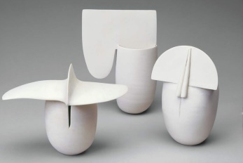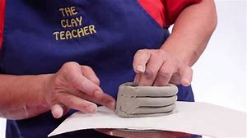
Objective and Success Criteria |  | Coverage | Key Questions |  | children should be able to |  | Resources
Appreciation  (context – Ikuto Iwamoto)  To consider the purpose of the art  To use art as a stimulus for their own art explaining where inspiration was sought from  Big Ideas: S1, S2, S3, A1, A3 |  | - Find out about the artist’s background.  - Find out what materials and techniques the artist mainly used  - Look at a variety of the artists art work and discuss similarities and differences between the pieces  - Children to discuss what they like and dislike about the art.  - Children to consider what the mood of a piece of art is by considering how it makes them feel when they are looking at it. Do they like the way the art makes them feel? | - Can anyone be an artist?  - What does an artist do?  - What materials did the artist mainly use?  - Are there any themes within the work?  - What is similar about the art?  - What is difference between the pieces?  - What do you like about the art? Why?  - How does the art create an atmosphere |  | - Say what art medium the artist used  - Say what themes run through the art  - Say what different moods are created in the work  - Say what they like about the art giving a reason
Exploring and developing ideas:  Explore different joining techniques  Explore how to smooth clay skilfully  Big Ideas: E1, E3, S3 |  | - Look at a variety of pieces of art that Ikuto Iwamoto made. Discuss what shape the pieces are and what sort of features have been added. Discuss what material has been used. Children to consider why the artist has used the material for the piece. Would it have worked with a different material? Children to think about how the piece has been finished. Has it been varnished? Has it been painted?  - What do you think inspired the artist to make the piece? What name would you give it? Why?  - Remind the children where clay comes from and that it is a natural material. Discuss what the children will need to bear in mind when working with this material (e.g. it dries out quickly, malleable to a point but breaks easily and quickly)  - Recap with the children that they have already learnt how to create a thumb pot (yr 2). Explain that this time we are going to make a vase using the clay. Recap how to adhere pieces of clay together when you want to join two pieces together. Children to practice joining two small pieces together using the technique shown.  - Looking back at Ikuto Iwamoto’s work ask how she achieved a smooth finished after joining the pieces together? Children to explore how to smooth the surface of the two pieces they have just joined together.  - Explore how to make good long coils ready for making the vase. What things do you need to remember when making a coil? | - What shapes do pots tend to be?  - How do you think the artist achieved the shapes? Effects?  - Where does clay come from?  - What do you need to remember about using clay?  - How can we join two pieces of clay together?  - How do you create a coil? |  | - explain how to make a coil  - explin how to join 2 pieces of clay together  - explain how to smooth clay together to achieve a good finish |  | https://www.bing.com/videos/search?q=ruth+duckworth+ceramics+techniques&docid=607988217093162760&mid=816151316E739FB339F6816151316E739FB339F6&view=detail&FORM=VIRE (not sure if all of it is appropriate for the children but gives you an insight into the artist)  Clay  Clay boards
Investigating and making art:  To combine techniques taught to create a vase  To skilfully design a pattern and texture  Big Ideas: E2, C1, C2 |  | - Children to practise making a couple of coils and joining them together using the above techniques taught then smoothing them to create a smooth finish.  - Explore the clay tools to remind them what effects can be created with the different tools.  - Discuss that Greek vases usually depict heroes and villains on them. Explain that a story is told.  - Using sketching techniques design a Greek vase story in sketchbooks – could use crayons and etch into the wax as an extension. | - How do you create a coil pot?  - How do you smooth clay to create a good finish surface?  - Which tools are best to use to create the designs on a vase? Why?  - What do you need to remember when using clay?  - How can you add extra clay to your design? How will you make it adhere? |  | - Explain how to make coils, join them together and smooth together to make a good finished surface.  - Should be able to discuss what different effects can be created using tools on the clay  - Should be able to say how to add extra clay to a tile and how to adhere it |  | Clay to explore  Clay tools  Clay boards  Design sheet  SC for vase
To create a vase  (Context – link to heroes and villains)  Big Ideas: C1, C2 |  | - Children to use their designs to make a coil vase using the techniques taught. Children to paint the pots using a similar colour palette to ancient Greek pottery. | - What steps do I need to follow to make the coil vase?  - What tools would be best to use? Why?  - What techniques are you using? why?  - If adding clay to the design how will you adhere it? |  | - Children should be able to say how they will achieve their ideas  - Children should be able to apply techniques practised to make their coil vase |  | Clay  Clay tools  Design sheet  Clay boards
Evaluating and developing art:  To explain and give reasons why art techniques were chosen  To refine and adapt work to reflect the intended purpose  Big Ideas: A1, A2, A3 |  | - Talk partner work to discuss what things went well, why are you proud of your work?  - Encourage the children to think about why they like a particular aspect of their work relating to what impact it has had on their finished product.  - Discuss how in order to get better at something we now have to reflect on what we could change for next time.  - Talk partner work to discuss what things they would do differently next time. Children to give reasons for the things they would change. What impact would it have on the finished product? How could they achieve it? Different tools? Different techniques? | - What do you like about your finished product? Why?  - What would you do differently next time?  - Would you use the same design? Why?  - Would you use the same tools? Why? |  | - Say what they like about their work and why  - Say what they would do differently next time to improve it and why
Assessment Questions
What Media and techniques is Ikuto Iwamoto known for?
What techniques are used to make a coil pot?
How can a design be added to a vase/ pot/ slab?

