Year 6 – Autumn – Does change always lead to progress?  - To create sketch books to record their observations and use them to review and revisit ideas  - To improve their mastery of art and design techniques, including drawing, painting and sculpture with a range of materials [for example, pencil, charcoal, paint, clay, printing]  - About great artists, architects and designers in history. |  |  | Artist: |  | William Morris
 |  |  | Media: |  | Textiles
Previous Experience: | Year 2 Autumn term – Children will have had experience with weaving as a textiles technique. They will have understood the concept of weaving material in and out to create patterns.  Year 4 DT – Children will have learnt how to sew a running stitch and cross-stitch. They will build upon their knowledge of how to sew basic stitches to move onto more complicated ones. |  | Technique: |  | Basic stitches on binca
Previous Experience: |  |  | Key vocabulary: |  | Needle, thread, cotton, binca, embroidery, stitches, running, back, cross, chain, blanket, lazy daisy
Previous Experience: |  |  | 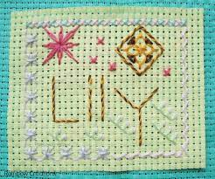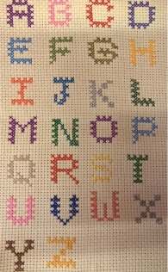
Objective and Success Criteria | Coverage | Key Questions |  | Children should be able to…. |  | Resources
Appreciation  (context – William Morris)  To understand how artists work has developed  To understand where artists inspiration has come from and how this has influenced their own  To understand the importance of sewing during the Industrial Revolution  (cross-curricular link with History)  Big Ideas: S1, S2, S3, A1, A3 | - Find out about the artist’s background.  - Find out what materials and techniques the artist mainly used  - Look at a variety of the artists art work and discuss similarities and differences between the pieces  - Children to discuss what they like and dislike about the art.  - Children to consider what the mood of a piece of art is by considering how it makes them feel when they are looking at it. Do they like the way the art makes them feel?  - Find out about needlework during the Industrial revolution – a women’s world  - Explore how the industrial revolution changed the way women sewed – invention of sewing machines  - Children to discuss how developments would have changed this art-form for the average woman | - What materials did the artist mainly use?  - Are there any themes within the work?  - What is similar about the art?  - What is difference between the pieces?  - What do you like about the art? Why?  - How does the art create an atmosphere |  | - Say what art medium the artist used  - Say what themes run through the art  - Say what different moods are created in the work  - Say what they like about the art giving a reason |  | https://www.vam.ac.uk/articles/introducing-william-morris Examples of work  https://www.vam.ac.uk/collections/william-morris  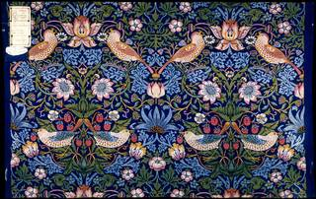  https://www.vam.ac.uk/blog/news/a-stitch-in-time-home-sewing-before-1900
Exploring and developing ideas:  To understand how to thread a needle and create a basic running stitch  To explore different embroidery stitches and the patterns created by them  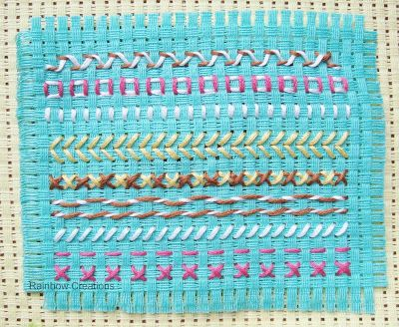  Big Ideas: E1, E3, S3 | - Teacher to model and recap how to thread a needle and tie off the thread.  - Use video to recap with children how to create a basic running stitch.  - Children to practice and explore different ways of creating a running stitch – e.g. colour of thread, length of stitches, gaps between stitches. Extension is to try and create a shape using a running stitch.  - Children to explore other types of stitches. Use videos to model how to create these stitches.  - Outcome – all children to have a piece of binca with a variety of stitches on. Stick into sketchbook and label stitches. Children to evaluate which they liked the best/found easiest to sew/think is the most visually interesting. | - How can stitch length/size of gaps between stitches make a piece of sewing more interesting?  - How could you vary a stitch?  - What might be the most appropriate stitch for text embroidery? How about an image? |  | - Thread a needle  - Say how to create a running stitch  - Sew at least three different stitches successfully  - Create a simple design using a running stitch |  | https://www.google.com/search?safe=strict&rlz=1C1GCEA_enGB909GB909&q=running+stitch+on+binca&spell=1&sa=X&ved=2ahUKEwj30q3DyLXxAhXEnVwKHcGdDXUQBSgAegQIARAx&biw=1440&bih=757#kpvalbx=_VkHXYLrfBpyJ1fAP6om_2AQ77  https://www.youtube.com/watch?v=TXa88M5_ke0  https://www.youtube.com/watch?v=GcYh-d9eWGE  Binca  Cotton thread  Needles  Scissors
Investigating and making art:  To select appropriate stitches to achieve a specific effect  Big Ideas: E2, C1, C2 | - Children to choose a stitch for their final piece – a name label.  - Children to choose this by investigating different ways of sewing the first letter of their name.  - Vary colour, stitch type, size of stitch, decoration around the letter.  - Children to sketch out their final design on a piece of paper to then sew in following lesson. | - To make your name legible what will you need to do?  - What designs might you have around the label?  - What colours will you choose and why? |  | - Choose final stitch for their label (or a combination)  - Sketch out their design |  | Binca  Cotton thread  Needles  Scissors  Sketchbooks  Pencils
To create name label  (Context- stitching an embroidered name label)  Big Ideas: C1, C2 | - Children to spend time sewing a name label using their chosen stitch and thread colour.  - Children can decorate their label with designs around the outside. | - How will I ensure my name can be read?  - What techniques will I use?  - What stitches will I use? |  | - Explain their thought process for their final piece |  | Binca  Cotton thread  Needles  Scissors
Evaluating and developing art:  To discuss the overall effect of the finished product  To describe the design process and justify why techniques and effects were used  Big Ideas: A1, A2, A3 | - Discuss what reflection is  - Talk partner work to discuss what things went well, why are you proud of your work?  - Encourage the children to think about why they like a particular aspect of their work relating to what impact it has had on their finished product.  - Discuss how in order to get better at something we now have to reflect on what we could change for next time.  - Talk partner work to discuss what things they would do differently next time. Children to give reasons for the things they would change. What impact would it have on the finished product? How could they achieve it? Different techniques? Different combination of techniques? Different colours? | - What do you like about your finished product? Why?  - What would you do differently next time?  - Would you use the same techniques? Why?  - Would you use the same colours? Why? |  | - Say what they like about their work and why  - Say what they would do differently next time to improve it and why |  | Evaluation sheet
Assessment Questions
What Media and techniques is William Morris known for?
What is a running stitch?
How has sewing changed through time?

Year 6 – Spring –What would a World without War look like?  - To create sketch books to record their observations and use them to review and revisit ideas  - To improve their mastery of art and design techniques, including drawing, painting and sculpture with a range of materials [for example, pencil, charcoal, paint, clay, printing]  - About great artists, architects and designers in history. |  |  | Artist: |  | Andy Warhol
 |  |  | Media: |  | Printing
Previous Experience: | Year 1 summer term – children would have completed a block print using polystyrene. They would have used pencils to press their design into the polystyrene block. They would have used 1 colour to print their design  Year 3 Autumn term – children would have used lino to make a block print. They would have used cutting tools to cut their design into the lino circle and one colour to print their design. |  | Technique: |  | Screen printing
Previous Experience: |  |  | Key vocabulary: |  | Squeegee, negative image, positive image, pressure, screen, print, stencil, image, effect, colour, contrast, message
Cross curricular link: | Link with Blue Coats |  | 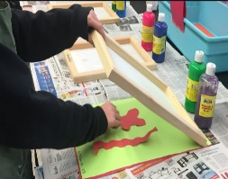  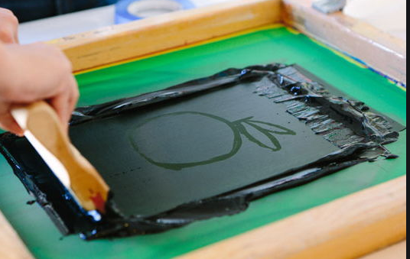
Objective and Success Criteria | Coverage | Key Questions |  | Children should be able to…. |  | Resources
Appreciation  (context –Andy Warhol)  To understand how artists work has developed  To understand where artists inspiration has come from and how this has influenced their own  To consider propaganda as a form of art  Big Ideas: S1, S2, S3, A1, A3 | - Find out about the artist’s background.  - Find out what materials and techniques the artist mainly used  - Look at a variety of the artists art work and discuss similarities and differences between the pieces  - Children to discuss what they like and dislike about the art.  - Children to consider what the mood of a piece of art is by considering how it makes them feel when they are looking at it. Do they like the way the art makes them feel?  - Children to research and think about propaganda as a form of art that was used to spread a message during WW2.  - Children to discuss how colour is used, what text is used on the posters, how images are used to support the message being told etc. | - What materials did the artist mainly use?  - Are there any themes within the work?  - What is similar about the art?  - What is difference between the pieces?  - What do you like about the art? Why?  - How does the art create an atmosphere  - How does the poster convey a message?  - How is colour used in the propaganda posters?  - What message will the reader be left with? |  | - Say what art medium the artist used  - Say what themes run through the art  - Say what different moods are created in the work  - Say what they like about the art giving a reason  - Discuss how art can be used as a form of propaganda  - Understand that propaganda has a message |  | Andy Warhol presentation (see folder)  Andy Warhol fact file (see folder)  Examples of propaganda posters during WW2
Exploring and developing ideas:  Investigate the different effectives of working negatively and positively  Big Ideas: E1, E3, S3 | - Look at an Andy Warhol print that uses a negative image and one that uses a positive image. Children to consider how the different prints have been created and what the effect of both pieces are.  - Introduce the idea of either a having a positive print or a negative print. Children to explore how to make both types of prints and consider what the different effects are and how they could be used. Children to use paper to create their stencils to be used e.g. simple shapes like hearts, flowers etc (See printing techniques for more information about screen printing). | - How do you make a negative image?  - How do you make a positive image?  - What effect is created with a negative image?  - What effect is created with a positive image? |  | - Say what different effects can be created using a negative and positive image  - Say how to create a positive and negative image |  | Paper  Scissors  Screens  Acrylic paint  Squeegees
Investigating and making art:  To create a clean edge print  Explore making a repeating pattern  Big Ideas: E2, C1, C2 | - Children to explore the best way to create a clean edge ready for printing.  - Children to create a simple shape using the best paper they have identified to create a simple repeated pattern using one colour at first. Children can the explore how to introduce a second colour into their design. | - What method is best to create a crisp clean edge?  - What do you need to remember when introducing another colour?  - What colours work best together?  - What effect has been created by using 2 colours? |  | - Say how to create a crisp clean edge  - Say how to introduce a second colour into a print  - Say what colours look best together to create a specific effect |  | Paper  Scissors  Screens  Acrylic paint  Squeegees
To create a 2-colour screen print  (Context- Propaganda Posters)  Big Ideas: C1, C2 | - Children to look at a variety of propaganda posters from the war. Children to make a list of the features and what sort of themes run through them.  - Children to take what they have learnt from exploring screen printing and looking at the posters to help them to design their own propaganda poster. Children should be able to state what their poster purpose it and how they intend to achieve it.  - Children to use their design to help them to design and make their blocks ready for printing their poster | - What themes run through the posters?  - What colours tend to be used?  - Which form of print are you going to use? Positive? Negative? A mixture of the two? Why?  - What colours are you going to use? Why? |  | - Say what type of print has been created (negative/ positive)  - Say how they achieved their print  - Say what effect they have achieved through their work |  | Paper  Scissors  Screens  Acrylic paint  Squeegees
Evaluating and developing art:  To discuss the overall effect of the finished product  To describe the design process and justify why techniques and effects were used  Big Ideas: A1, A2, A3 | - Talk partner work to discuss what things went well, why are you proud of your work?  - Encourage the children to think about why they like a particular aspect of their work relating to what impact it has had on their finished product.  - Discuss how in order to get better at something we now have to reflect on what we could change for next time.  - Talk partner work to discuss what things they would do differently next time. Children to give reasons for the things they would change. What impact would it have on the finished product? How could they achieve it? Different techniques? Different type of print? Different colour combination? | - What do you like about your finished product? Why?  - What would you do differently next time?  - Would you use the same techniques? Why?  - Would you use the same image? Why?  - Would you use the same colour combination? Why? |  | - Say what they like about their work and why  - Say what they would do differently next time to improve it and why |  | Evaluation sheet
Assessment Questions
What Media and techniques is Andy Warhol known for?
What is the difference between a negative print and a positive print?
How do you create print with 2 different colours?

Year 6 – Summer – What is the secret to success?  - To create sketch books to record their observations and use them to review and revisit ideas  - To improve their mastery of art and design techniques, including drawing, painting and sculpture with a range of materials [for example, pencil, charcoal, paint, clay, printing]  - About great artists, architects and designers in history. |  |  | Artist: |  | Leonardo da Vinci
 |  |  | Media: |  | Sketching
Previous Experience: | Year 2 summer term – Children will experience sketching and prior knowledge on how to use a pencil to build up colour.  Year 3 autumn term – Children will have prior knowledge on how to vary pressure when using a pencil, and will have some experience of using charcoal to add texture.  Year 4 summer term – Children will have gained experience with chalks to add texture and build up colour within a sketch. |  | Technique: |  | Pencil and Charcoal
Previous Experience: |  |  | Key vocabulary: |  | Tone, texture, shading, line, graphite, depth, detail, pencil, charcoal, chalk, blending, cross-hatching
Previous Experience: |  |  | 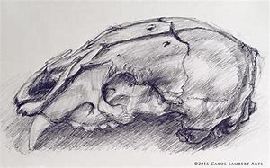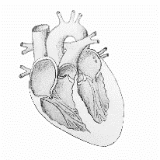
Objective and Success Criteria | Coverage | Key Questions |  | Children should be able to…. |  | Resources
Appreciation  (context – Sketching – Leonardo da Vinci)  To understand how artists work has developed  To understand where artists inspiration has come from and how this has influenced their own  To use art as an stimulus for their own art explaining where inspiration was sought from  Big Ideas: S1, S2, S3, A1, A3 | - Find out about the artist’s background.  - Find out what materials and techniques the artist mainly used  - Look at a variety of the artists art work and discuss similarities and differences between the pieces  - Children to discuss what they like and dislike about the art.  - Children to consider what the mood of a piece of art is by considering how it makes them feel when they are looking at it. Do they like the way the art makes them feel? | - What materials did the artist mainly use?  - Are there any themes within the work?  - What is similar about the art?  - What is difference between the pieces?  - What do you like about the art? Why?  - How does the art create an atmosphere |  | - Say what art medium the artist used  - Say what themes run through the art  - Say what different moods are created in the work  - Say what they like about the art giving a reason |  | Examples of work
Exploring and developing ideas:  To explore how blending can add tone, shadow and depth to a picture  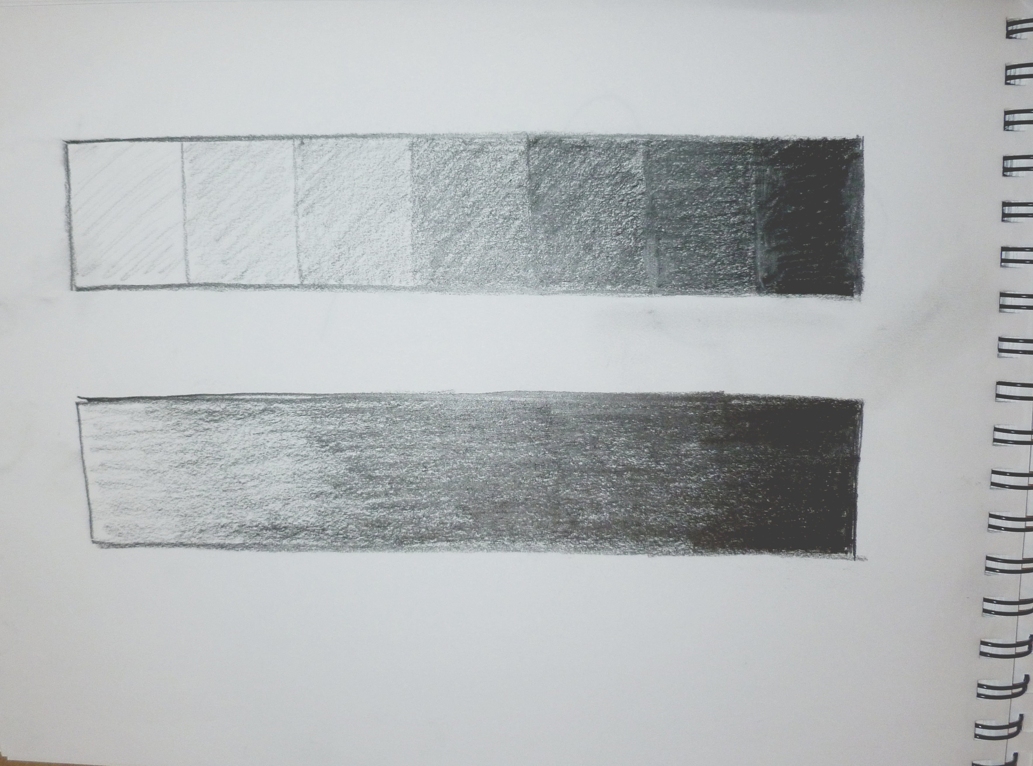  To explore how to create different textures using hatching, cross-hatching, stippling, swirls etc.  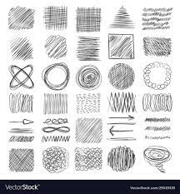  Big Ideas: E1, E3, S3 | - Look closely at some example pieces by the artist paying attention to how the pencil has been used. Discuss the effect that has been created due to the use of the pencil.  - Children to have time to explore using pencils (coloured and sketching) to investigate how colours can be blended together to create deeper tone.  - Children to also have time to explore the different ways that texture and depth can be built up e.g. cross-hatching, blending, small lines, swirls etc. | - How has the artist used the pencil to bring the object alive?  - How have the colours been blended together?  - Why is this a good technique to use? What is the effect created? |  | - Say how to blend colours together  - Explain what effect it creates  - Explain how to create different textures in sketching |  | Examples of pencil drawings  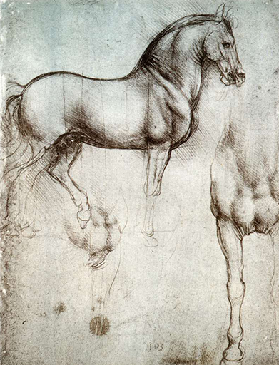  coloured pencils  sketching pencil  cartridge paper
Investigating and making art:  To explore different styles of observational sketching  Big Ideas: E2, C1, C2 | - Discuss what an observational drawing is and why it is an important part of the art world. Children will need to understand the importance of drawing what you see rather than what you think.  - Children to complete four sketches of a heart – 1 line drawing using pencil, 1 sketch focussing on tone using pencil, 1 sketch focussing on texture using pencil, 1 charcoal sketch – use a range of paper to sketch on e.g. cartridge, brown paper, newspaper  - Children to reflect on what they like the best and how they will use it in their final piece | - What is an observational drawing?  - How can we build up tone and texture in our art?  - Which technique did you choose to use and why?  - What suited your sketching style the best? |  | - Explain which sketch they liked completing the best. |  | Graphite pencils  Charcoal  Sketchbooks  Brown paper  Newspaper
To create a large observational drawing of an anatomical heart  (Context- looking at the circulatory system in science)  Big Ideas: C1, C2 | - Children to use what they have learnt to create a large scale anatomically correct sketch of a heart. Children can choose which media they wish to draw with and on. | - How will I achieve my sketch?  - How will I scale my drawing up so that it fills the page?  - What medium am I going to use? |  | - say how they were able to achieve their design |  | Graphite pencils  Charcoal  Cartridge paper
Evaluating and developing art:  To discuss the overall effect of the finished product  To describe the design process and justify why techniques and effects were used  Big Ideas: A1, A2, A3 | - Talk partner work to discuss what things went well, why are you proud of your work?  - Encourage the children to think about why they like a particular aspect of their work relating to what impact it has had on their finished product.  - Discuss how in order to get better at something we now have to reflect on what we could change for next time.  - Talk partner work to discuss what things they would do differently next time. Children to give reasons for the things they would change. What impact would it have on the finished product? How could they achieve it? Different techniques? Different combination of techniques? Different colours? | - What do you like about your finished product? Why?  - What would you do differently next time?  - Would you use the same techniques? Why?  - Would you use the same colours? Why? |  | - Say what they like about their work and why  - Say what they would do differently next time to improve it and why |  | Evaluation sheet
Assessment Questions
Why did Leonardo da Vinci use sketching?
What techniques can be used to create tone and texture in a sketch?
What is an observational drawing?

