THE BIG IDEAS OF MATHS
At Highwood, our Mathematics curriculum is designed to ensure that all pupils:
- become fluent in the fundamentals of mathematics, including through varied and frequent practice with increasingly complex problems over time, so that pupils develop conceptual understanding and the ability to recall and apply knowledge rapidly and accurately.
- reason mathematically by following a line of enquiry, conjecturing relationships, and generalisations, and developing an argument, justification or proof using mathematical language.
- can solve problems by applying their mathematics to a variety of routine and non-routine problems with increasing sophistication, including breaking down problems into a series of simpler steps and persevering in seeking solutions.
We achieve this by sequencing our learning on a repetitive and progressive cycle, using White Rose Hub to support teachers in their teaching, knowledge, and planning.
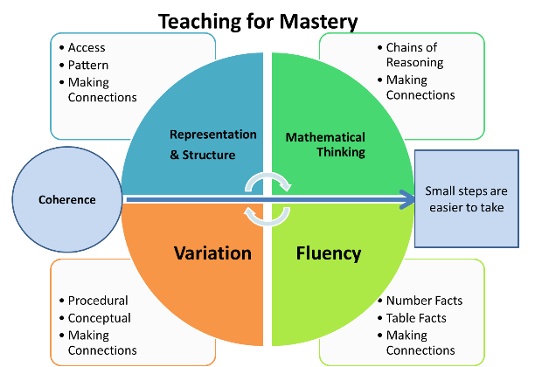
Teaching for Mastery Principles
At Highwood, we use the NCTEM 5 Big Ideas for Teaching for Mastery when planning and teaching our children Maths. White Rose adopts the Teaching for Mastery Principles, helping us to align all of our approaches.
        - Teaching for mastery is fundamentally built on the ethos that all children are capable of understanding and doing maths, given sufficient time and small enough steps (coherence)
        - By building on the 5 Big Ideas for Mastery, pupils can make rich connections between concepts and ideas. Challenge is provided through depth, rather than accelerating onto new content
        - It is not just about memorising facts or procedures but involves knowing ‘why’ as well as knowing ‘that’ and knowing ‘how’ to use knowledge appropriately, flexibly, and creatively to apply it in new and unfamiliar situations.
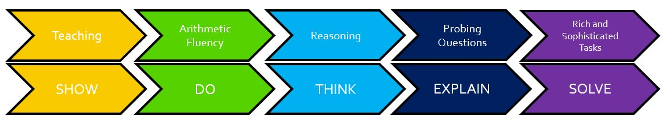
The Mastery Flow
Our philosophy of Teaching for Mastery is achieved through the focus on deep learning of each concept by exposing children to the following lesson flow.
The process encourages pupils to become fluent in the fundamentals of maths through frequent practice with increasing complexity over time. All children move through the flow at their own pace e.g., some children might be on ‘do’, while other children could be on explain. At all stages of the mastery flow, children have the opportunity to develop well thought mathematical reasoning. During each objective, the main teaching happens during the ‘show’ part of the lesson. This is where children have the opportunity to move through the concreate, pictorial and abstract concepts, as well as having practical opportunities to explore the learning. Throughout this part of the lesson, teachers also oracy to help develop children’s understanding, as well as to help build up reasoning skills to enable our children to reason, explain, and justify their learning.

Mental Maths is prioritised either at the start of a maths lesson or timetabled appropriately. In EYFS, the focus is on number recognition and counting; KS1 developing a full grasp of number bonds and the 2, 5 and 10 times table through the use of the NCETM Mastering Number programme and KS2 a full grasp of all times tables as well as quick fire strategies to solve arithmetic style questions.

