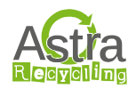


Astra Textile Recycling

Highwood Primary School has an Astra Recycling textile collection bank. Items placed in here are regularly collected by Astra Recycling and we receive funds for every kilo collected.

Astra Recycling work to promote textile recycling, reduce waste to landfill and give schools and organisations an opportunity to raise funds from donations.

The textiles collected are either sent to Eastern Europe or Africa to be used again or are converted into insulation materials and industrial cleaning wipes.

Please see below for details of what can and cannot be put in the clothing bank. Please note that all items must be in bags.
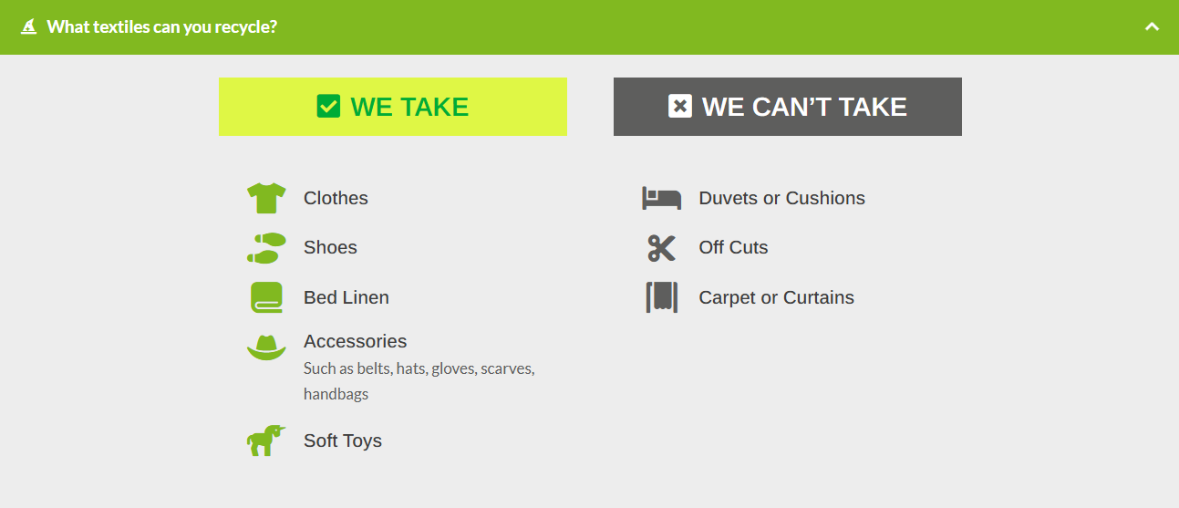
If you are having a clear out, please do consider donating the relevant textile items here. The money raised is used to support and enhance our provision for all the children in school.

For more information about Astra Recycling and this scheme please see their website https://astrarecycling.co.uk/.

For school uniform, especially branded items, the Friends of Highwood have a donation box in the main school office.

